

Government House

Canberra ACT 2600

6 December 2017

His Excellency the Governor-General directs it to be notified, for general information, that:

1. He has revoked the appointment of:

* The Honourable Malcolm Bligh Turnbull MP as Minister for Agriculture and Water Resources

1. He has made the following appointment:

* The Honourable Barnaby Thomas Gerard Joyce MP as Deputy Prime Minister and Minister for Agriculture and Water Resources.

By His Excellency’s Command

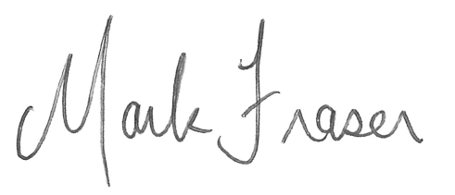

**Mark Fraser LVO OAM**

Official Secretary to the Governor-General