***Customs Act 1901***

**Notice under Subsection 15(1)(a)**

**Port Notice of Revocation and Appointment (No.2600)**

I, William Ries, delegate of the Comptroller-General of Customs, under subsection 15(1)(a) of the *Customs Act 1901* and subsection 33(3) of the *Acts Interpretation Act 1901*:

1. REVOKE the notice published in the Commonwealth of Australia Gazette on 9 October 2015 appointing the port known as the Port of Weipa in the State of Queensland and fixing its limits; and
2. APPOINT as a port the Port of Weipa in the State of Queensland; and
3. FIX as the limits of that port the area shaded in pink, indicating the limits of the ‘Port Boundary’ in **Attachment A** to this notice.

Dated 19 day of April 2017.

Commander

Operational Strategies Branch

Border Management Division

Australian Border Force

Department of Immigration and Border Protection

Port of Weipa

Department of Immigration and Border Protection

S15 of *Customs Act 1901* Port Appointment (No 2600)

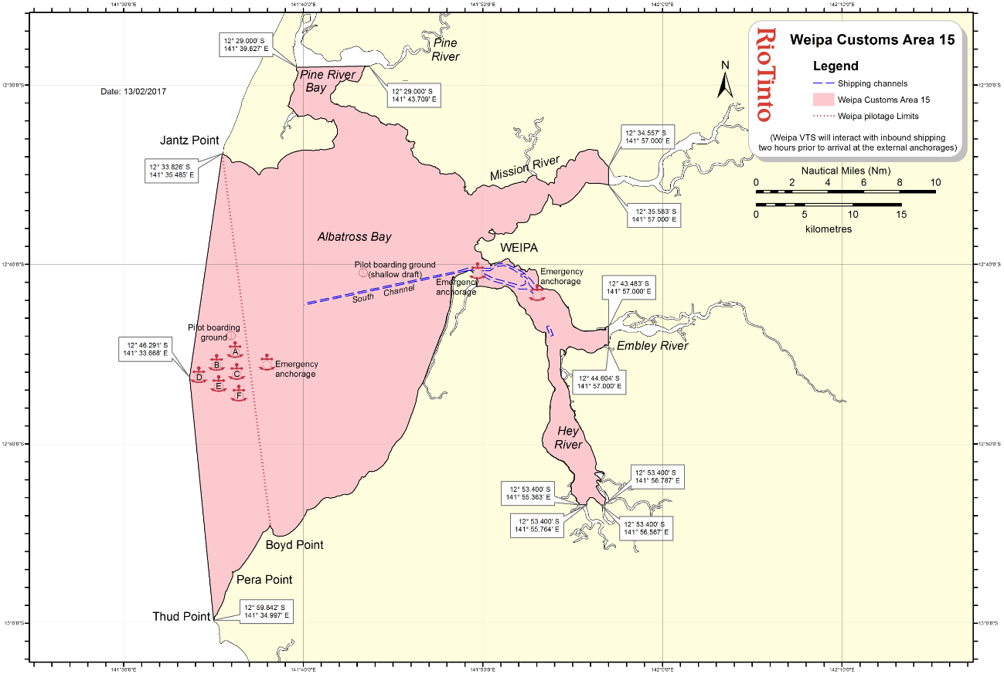

Map Name Prepared by: Date:13/02/2017

001 Ben Lowes (G&I)

Limits of the Port Boundary appointed under s15(1) (a) *of the Customs Act 1901.*

**Section 15(1)(a) of the *Customs Act 1901* Port Limits**