
Government House
Canberra ACT 2600

24 January 2017
His Excellency the Governor-General directs it to be notified, for general information, that:
- He has revoked the appointments of:
- The Honourable Gregory Andrew Hunt MP as Minister for Industry, Innovation and Science
- The Honourable Sussan Penelope Ley MP as Minister for Health and Aged Care and Minister for Sport
- Senator the Honourable Arthur Sinodinos AO as Cabinet Secretary
- The Honourable Kenneth George Wyatt AM MP as Parliamentary Secretary to the Minister for Health and Aged Care
- The Honourable Dr David Arthur Gillespie MP as Parliamentary Secretary to the Minister for Health and Aged Care

- He has sworn in as an Executive Councillor:

- Mr Michael Sven Sukkar MP
- He has made the following appointments:

- The Honourable Gregory Andrew Hunt MP as Minister for Health and Minister for Sport
- Senator the Honourable Arthur Sinodinos AO as Minister for Industry, Innovation and Science
- The Honourable Kenneth George Wyatt AM MP as Minister for Aged Care and Minister for Indigenous Health
- The Honourable Dr David Arthur Gillespie MP as Parliamentary Secretary to the Minister for Health
- The Honourable Michael Sven Sukkar MP as Parliamentary Secretary to the Treasurer

By His Excellency’s Command
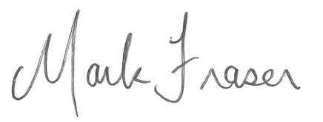
Mark Fraser LVO OAM
Official Secretary to the Governor-General

