***LANDS ACQUISITION ACT 1989***

**PRE-ACQUISITION DECLARATION**

1. **Acquisition**

In accordance with the *Lands Acquisitions Act 1989,* I am considering the acquisition of the interests in land specified in paragraph 3 for the public purpose described in paragraph 4. The Murray-Darling Basin Authority is the acquiring authority.

### The land

The land is the property described as "Carlingford", in Lot 1 in Title Plan LP202754L, located in the County of Bogong in the Parish of Bonegilla, Victoria, identified in Schedules 1-3. This property is located adjacent to the River Murray, approximately 6.5 kilometres downstream from Hume Dam, and approximately 4.7 kilometres south east of Albury, as set out in Schedule 1.

### The interests in the land

This declaration relates to the acquisition of an easement for flooding identified as "E-1" in Schedules 1-3, in the land specified in paragraph 2.

### The public purpose

The public purpose of the acquisition is to enable the Murray-Darling Basin Authority to give directions for, and to manage, the release of water from the Hume Dam into the River Murray to meet the water requirements of NSW, Victoria and South Australia.

### Suitability for development for use for a public purpose

The land is located on an anabranch of the River Murray and forms part of the natural flow path and floodplain of the river system. As a result, it is suitable for the public purpose described in paragraph 4.

### Particulars of proposed development for use

The proposed releases will be from Hume Dam into the River Murray at a rate of up to, but not exceeding, 25,000 megalitres in any period of 24 hours measured at the Doctors Point.

### Reasons why the land appears to be suitable for the proposed development for use

The land specified in paragraph 2 is suitable for the use described in paragraph 6 because it is a part of or is adjacent to an anabranch of the River Murray that is inundated when water is released from Hume Dam at flow rates of up to 25,000 megalitres in any period of 24 hours measured at the Doctors Point.

Dated this day of September 13, 2016.

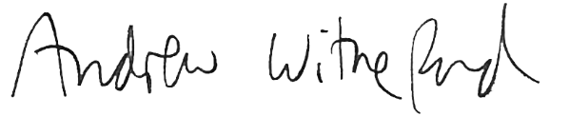

Delegate of the Special Minister of State Director, Land Acquisition Act Administration Policy Legislation and Advice Branch Department of Finance

**Schedule 1**

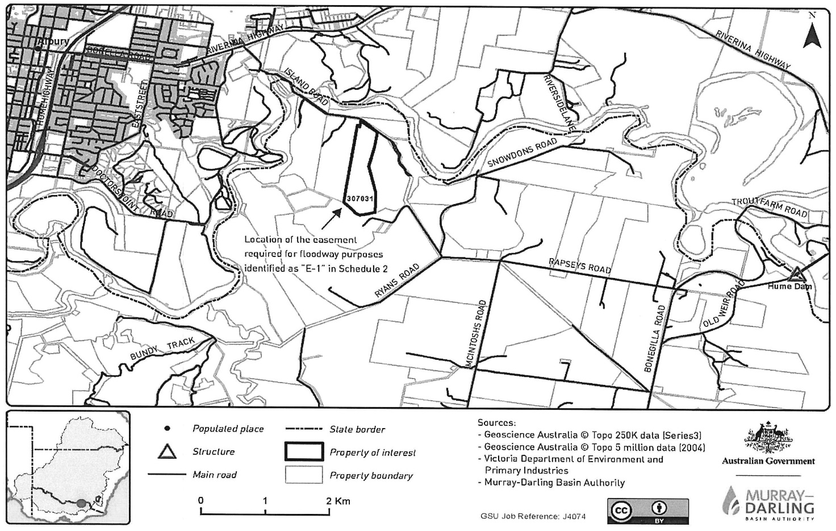

**Schedule 2**

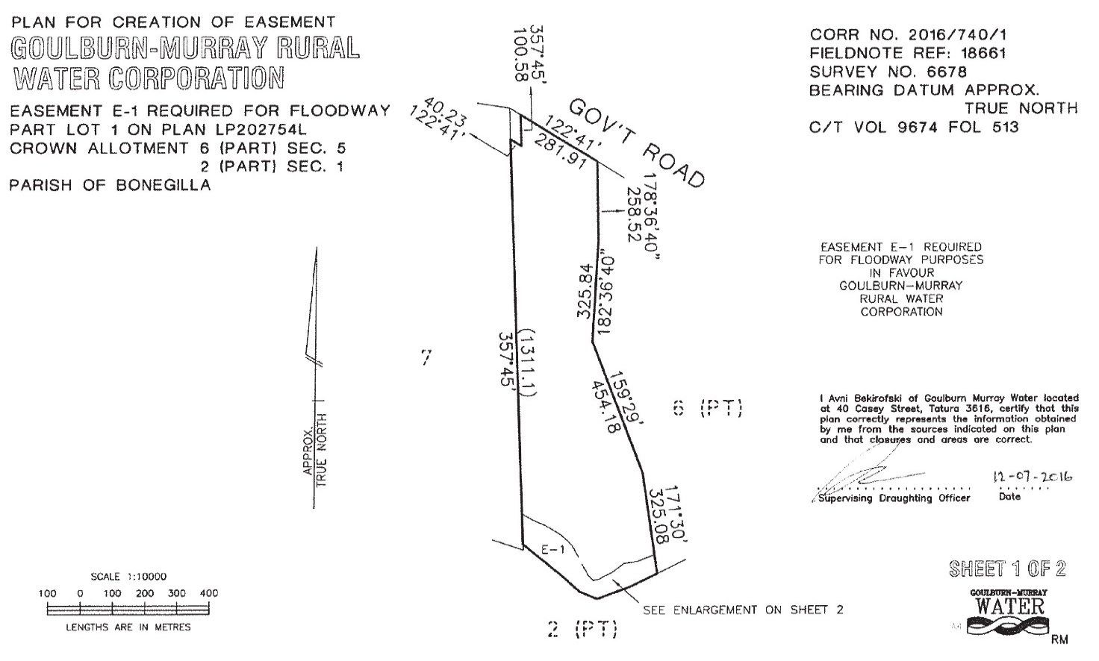

**Schedule 3** 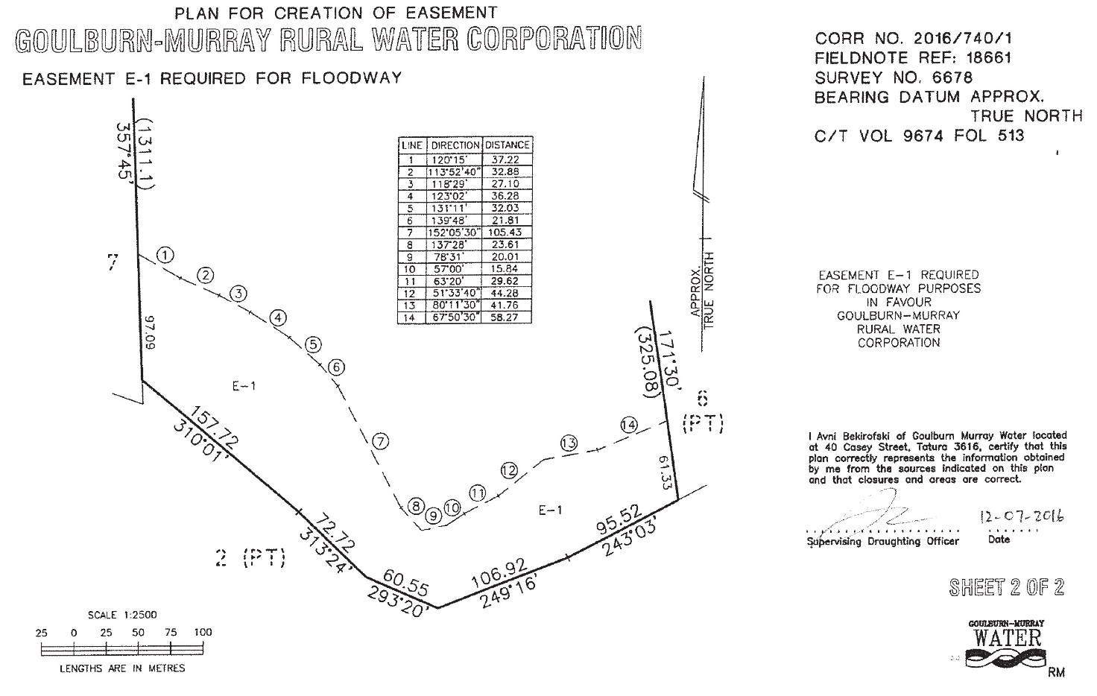

**Note: This Pre-Acquisition Declaration signifies that the Murray-Darling Basin Authority is considering an acquisition of the interest in land specified in paragraph 3. It does NOT mean the interest in land has been acquired.**

