

**Government House**

**CANBERRA ACT 2600**

**17 August 2016**

**AUSTRALIAN BRAVERY DECORATIONS**

**The Governor-General is pleased to announce the following Bravery Decorations:**

Star of Courage (SC)

Bravery Medal (BM)

Commendation for Brave Conduct

Group Bravery Citation

Please Note: A comprehensive list of recipients can be found at [www.gg.gov.au](http://www.gg.gov.au).

**By His Excellency’s Command**

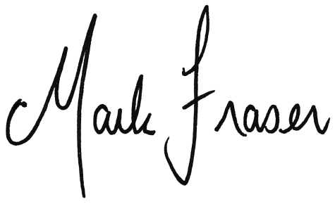

### Mark Fraser LVO OAM

Official Secretary to the Governor-General