AUSTRALIAN ELECTORAL COMMISSION

*Aboriginal and Torres Strait Islander Act 2005*

Section 143G

*Torres Strait Regional Authority Election Rules 1996*

Rule 134A

**APPROVED FORMS FOR THE PURPOSES OF THE TORRES STRAIT REGIONAL AUTHORITY ELECTIONS**

I, TOM ROGERS, Electoral Commissioner, referred to in section 18 of the *Commonwealth Electoral Act 1918* exercising of the power under Rule 134A of the *Torres Strait Regional Authority Election Rules 1996* (TSRA Election Rules), do hereby:

1. **APPROVE** the forms that appear in the Schedule to this instrument to be approved forms for the purposes of:
   1. Rule 22(1) Undertaking by Scrutineers form (TSRA 023);
   2. Rule 22(1) Undertaking by Officers and Employees form (TSRA 021);
   3. Rule 77 (2)(a) Liaison officer objection form (TSRA 006);

of the TSRA Election Rules for the 2016 Torres Strait Regional Authority election.

1. **DECLARE** that this instrument takes effect upon execution.

Tom Rogers

Electoral Commissioner

11 July 2016

Undertaking by Scrutineer Form (TSRA023) **SCHEDULE**

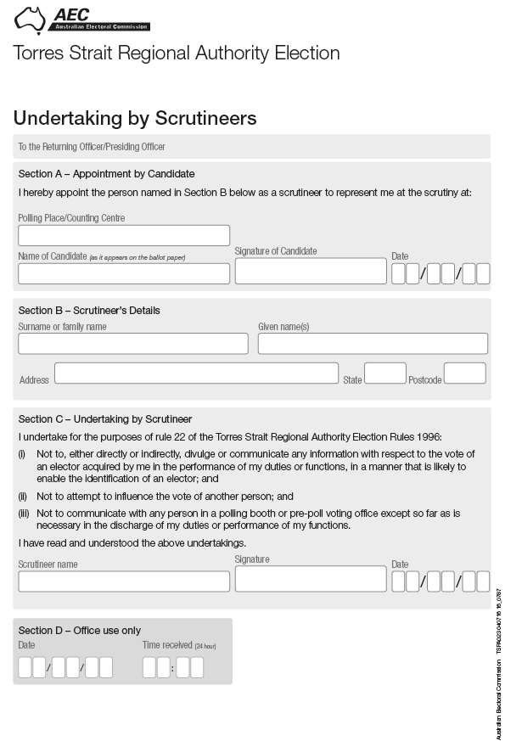

Undertaking by Officers and Employees Form (TSRA021) pg 1

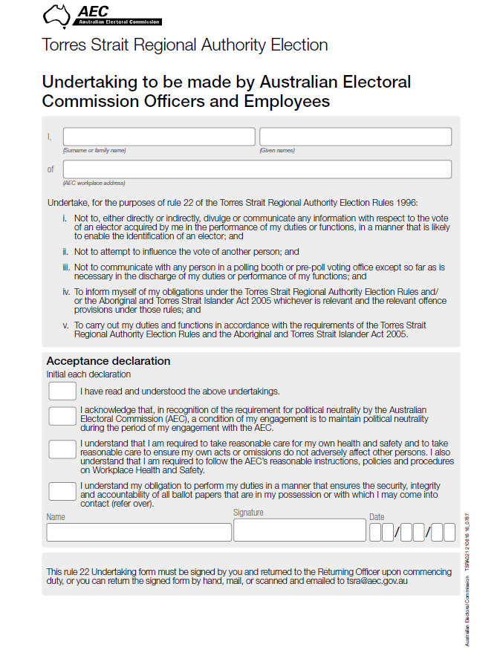

Undertaking by Officers and Employees Form (TSRA021) pg 2

Covers AEC Ballot Paper Principles 
Expected Bahaviours to uphold the ballot paper principles relating to secutiry, integrity and accountability

Record of Liaison Officer’s Objection and Voter’s Request for Review Form (TSRA006), pg1

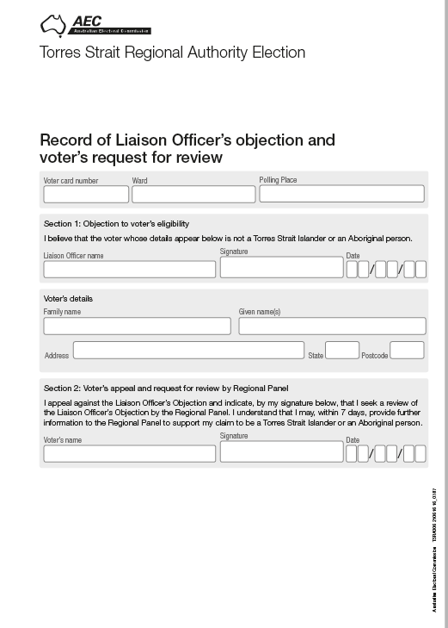

Record of Liaison Officer’s Objection and Voter’s Request for Review Form (TSRA 006), pg 2

