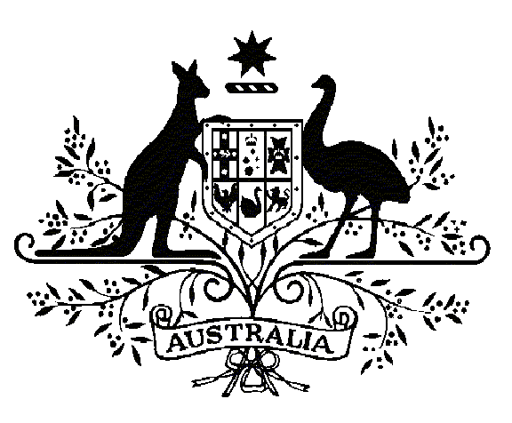

Specialist Medical Review Council

Declarations

*Section 196W  
Veterans’ Entitlements Act 1986*

**Re: Statements of Principles Nos. 75 and 76 of 2015**

**in respect of myasthenia gravis**

Request for Review Declaration No. 29

In relation to the Repatriation Medical Authority (the RMA) Statement of Principles **No. 75** and **No. 76** **of 2015** concerning **Myasthenia Gravis**, made under subsection 196B of the *Veterans' Entitlements Act 1986* (the VEA), the Specialist Medical Review Council (the Council) under subsection 196W(5) of the VEA:

DECLARES that there was no sound medical-scientific evidence on which the RMA could have relied to amend either of the Statements of Principles to include a factor or factors for exposure to ionising radiation and the clinical onset and/or clinical worsening of myasthenia gravis.

|  |  |  |  |
| --- | --- | --- | --- |
|  |  |  |  |
| Lin Fritschi  Presiding Councillor | John Worthington  Councillor | Rick Tinker  Councillor |  |

|  |  |  |  |
| --- | --- | --- | --- |
| |  |  | | --- | --- | | The Common Seal of the ) Specialist Medical Review ) Council was affixed by )  authority of the Council in )  the presence of: ) |  | |  |

|  |
| --- |
|  |
| Jan Bowman  Registrar, SMRC |
| Dated this ***twenty third*** day of ***May*** 2016 |