Government House
CANBERRA ACT 2600

21 April 2016

The Governor-General is pleased to announce the following honorary award within the General Division of the Order of Australia:

ORDER OF AUSTRALIA

Honorary Medal (OAM) in the General Division

Mr Benoit MOTTRIE

Vaubanstraat 52, 8900 Ypres, Belgium
For service to Australian-Belgian relations.

By His Excellency’s Command

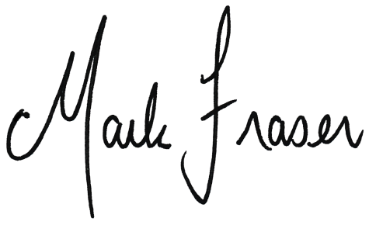

Mark Fraser LVO OAM

Official Secretary to the Governor-General

AWARDED AN HONORARY MEDAL (OAM)

IN THE GENERAL DIVISION OF THE ORDER OF AUSTRALIA

Mr Benoit MOTTRIE, Vaubanstraat 52, 8900 Ypres, Belgium
For service to Australian-Belgian relations.

Mr Benoit Mottrie is Chairman of the Last Post Association, a volunteer group founded more than 80 years ago, in leper, Belgium. The association’s principal activity is to play the Last Post at the Menin Gate in leper every single evening of the year in memory of allied soldiers who died in the Ypres Salient during the first World War.

Mr Mottrie has been a member of the Last Post Association since 1990 and Chairman since 2006. As Chairman he oversees the nightly Last Post ceremony, including provision of buglers and ushers, coordinating performances by visiting bands and choirs, and arranging the attendance of dignitaries from around the world. He secures donations and recruits new members to support the Association’s activities.

Mr Mottrie has been especially generous to Australian visitors. He has organised visits by his buglers to Australia and helped facilitate Australia’s proposal to return the Menin Lions to leper for one year in 2017 to commemorate the Battle of Passchendaele, in which Australia suffered 50,000 casualties. He is a strong supporter of other Australian commemorative events in Belgium.

Phone No: 0032 477 270 061

