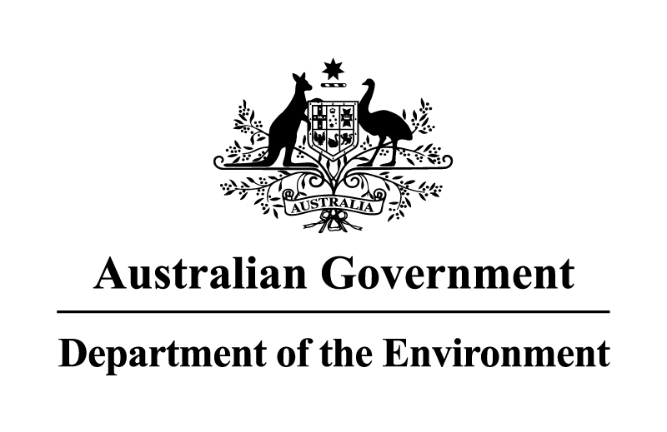

**NOTICE OF APPLICATION RECEIVED UNDER THE *HAZARDOUS WASTE (REGULATION OF EXPORTS AND IMPORTS) ACT 1989***

Pursuant to section 33 of the *Hazardous Waste (Regulation of Exports and Imports) Act 1989*, notice is given that application AUH15-080 has been received from Newline Metals International Pty Ltd, 17 Judge Street, Sunshine, Victoria, 3020, Telephone: +61 3 8338 9065.

The application relates to the export of up to 8 000 tonnes of e-waste (Basel Code A1180) to Singapore for recovery operation R4 - Recycling/reclamation of metals and metal compounds at Cimelia Resource Recovery Pte Ltd.

Written comments on the permit application may be lodged with the Department within 28 days of publication of this notice. Comments should be addressed to the Director, Hazardous Waste Section, Department of the Environment, GPO Box 787 CANBERRA ACT 2601, or forwarded by email to hwa@environment.gov.au. Respondents should be aware that comments will be shared with the Applicant and should not contain commercial-in-confidence information.

Andrew McNee

Delegate to the Minister

Assistant Secretary

Chemicals and Waste Branch

18 February 2016