NORFOLK ISLAND

ENVIRONMENT REGULATIONS 1990

Regulations No 9 of 1990

I, Herbert Bruce Mac Donald, Administrator of Norfolk Island, acting in accordance with the advice of the Executive Council of Norfolk Island, hereby make the following Regulations, under section 150 of the Environment Act 1990, prescribing the Norfolk Island Planning Code.
Dated this twenty-eighth day of December 1990

H.B. Mac Donald Administrator

By His Honour's Command
W. A. Blucher
Minister for Immigration and Commerce

Short title
  - These regulations may be cited as the Environment Regulations 1990.
Interpretation
  - In these regulations, unless the contrary intention appears, "Act" means the Environment Act 1990.
Norfolk Island Planning Code
  - For the purposes of section 150 of the Act, the Norfolk Island Planning Code is prescribed to be as set out in the Schedule.

SCHEDULE Regulation 3
NORFOLK ISLAND PLANNING CODE
CHAPTER 4 - SANITATION
Introduction
- This chapter relates to Division 1 of Part VI of the Act, which is about sanitation.
- This chapter is divided into two subchapters dealing respectively with (A) plumbing and drainage, and (B) septic tanks.
SUBCHAPTER A - PLUMBING AND DRAINAGE
Information for applications
- An application for approval of the construction, erection or alteration of a permitted sanitary facility (other than a septic tank facility) must include or be accompanied by 2 copies of plans and specifications of the work proposed to be undertaken.
- The plans must be drawn in ink to a specified scale, must be legible and must include -
    - a site plan showing the position of all buildings on the site, the distances between buildings and site boundaries, the locations of all existing and proposed external drainage lines, inspection openings, gullies and vents; and
    - where the application relates to an existing or proposed building - a floor plan of the building showing all rooms, the overall size of the building, the location and description of all internal plumbing and drainage fittings and all other fittings such as floor wastes, vents and traps.
- The specifications must show the size and grade of all pipes and other fittings.
- An application for approval of the use of a permitted sanitary facility (other than a septic tank facility) for the disposal of trade waste must include or be accompanied by -
- 2 copies of plans and specifications of the works (if any) proposed to be undertaken in relation to the use of the facility for the disposal of trade waste; and
- details of any apparatus to be used in relation to the use of the facility for the disposal of trade waste; and
- details of the nature of the trade waste, the anticipated quantity of the waste and the anticipated rate or rates of discharge of the waste.
Minimum standards
- The minimum standards for approval of the construction, erection or alteration of a permitted sanitary facility (other than a septic tank facility) are that the construction, erection or alteration, and any work in relation to the construction, erection or alteration, is to comply with either of -
- Australian Standard AS 3500.2-1990, National Plumbing and Drainage Code, Part 2:
- Sanitary plumbing and sanitary drainage; or
- the Drainage and Plumbing Regulations 1978, made under the Health Act 1956 of New Zealand,
- as in force on the date of commencement of this chapter.
SUBCHAPTER B - SEPTIC TANKS
Information for applications
- An application for approval of the construction, erection or alteration of a septic tank facility must include or be accompanied by 2 copies of plans and specifications of the work proposed to be undertaken.
- The plans must be drawn in ink to a specified scale, must be legible and must include -
- a site plan showing the position of the existing or proposed septic tank facility, and all existing or proposed buildings, driveways, easements, streams and underground tanks; and
- where the application septic tank facility proposed septic tank; and
- a plan of any proposed effluent disposal trenches, or other proposed disposal system, showing distances from site boundaries, buildings and driveways.
- The specifications must include -
- where the application relates to a new septic tank facility - details (including a section drawing) of the proposed septic tank; and
- details of any proposed effluent disposal trenches or other proposed disposal system; and
- a statement of the number of persons resident or ordinarily present in, or proposed to be resident or ordinarily present in, any building or proposed building in relation to which approval is sought.
Minimum standards
- The minimum standards for approval of the construction, erection or alteration of a septic tank facility are that the construction, erection or alteration, and any work in relation to the construction, erection or alteration, is to comply with the following clauses of this subchapter.
Minimum capacities
- The minimum capacity of a septic tank is to be as ascertained in accordance with the Table.
TABLE
Domestic use (excluding use in relation to a waste disposal unit)
Where: n = number of persons likely to be living in, or visiting, the premises
L = number of litres of flush.
Domestic use (excluding use in relation to a waste disposal unit)
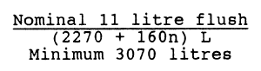
Where: n = number of persons likely to be living in, or visiting, the premises
L = number of litres of flush.
Medium density use
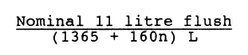
Where: n = number of persons likely to be living in, or visiting, the premises
L = number of litres of flush.

Minimum constructional standards
- All septic tanks are to be designed and constructed so that there will be no structural failure or undue distortion under hydrostatic pressure when empty or full, and so that the tank is protected from any other loading likely to be imposed.
- All septic tanks cast on-site are to be structurally sound, internally smooth and water-tight, and are, as nearly as possible, to comply with the Table and Figure.
TABLE
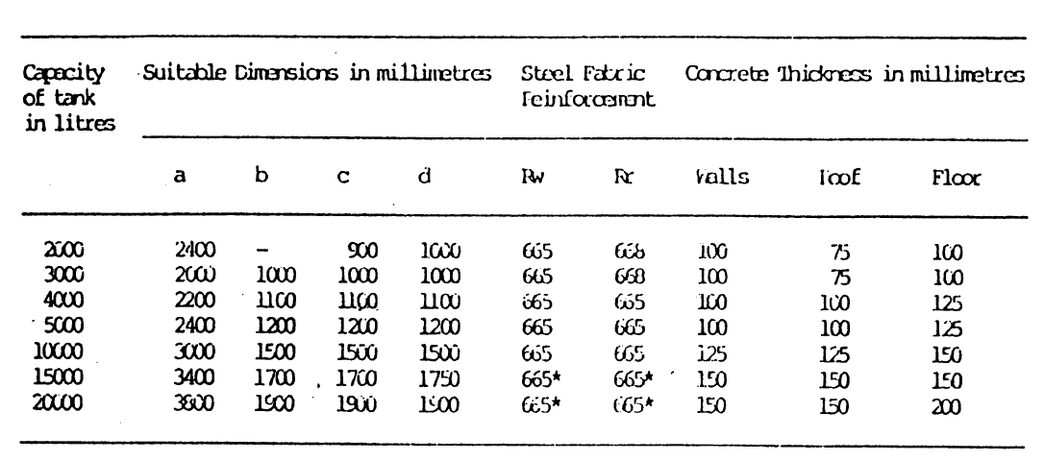
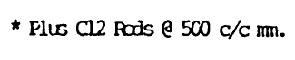
FIGURE
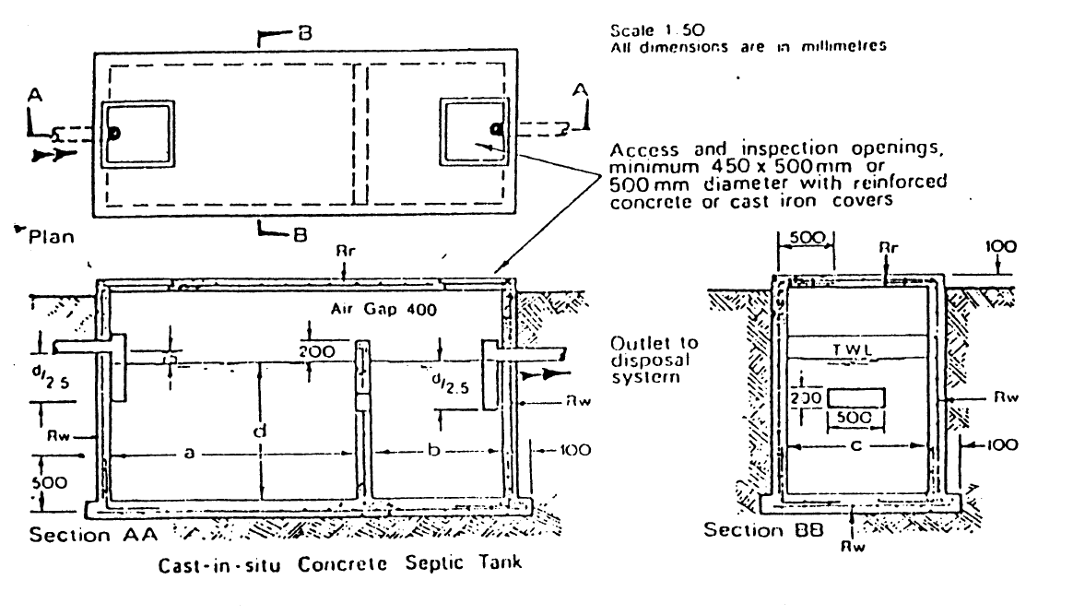
- All domestic precast septic tanks are to comply with Australian Standard AS 1546, Specification and Code for Small Septic Tanks, as in force on the date of commencement of this chapter, and are, as nearly as possible to comply with the Figure.

FIGURE
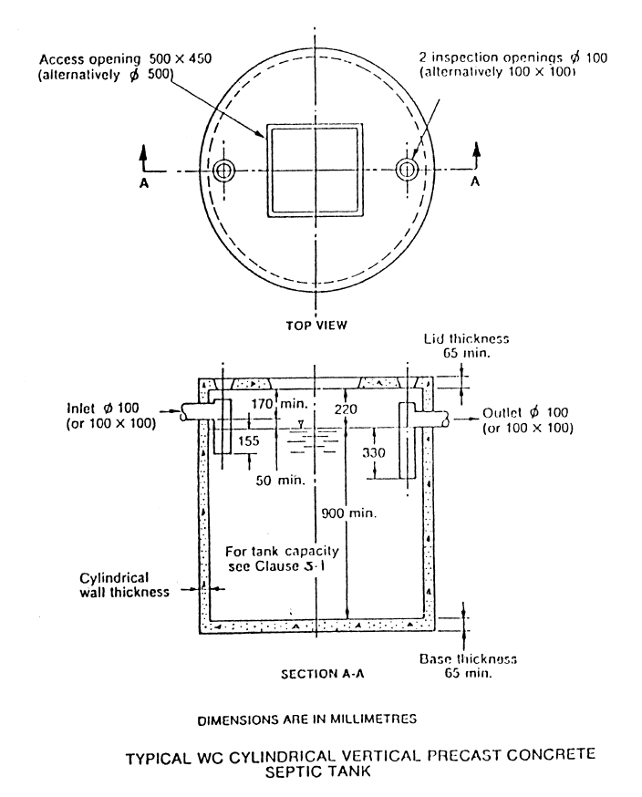
- Concrete used in the manufacture of a cylindrical precast concrete septic tank is to have a compressive strength, before leaving the manufacturer's plant, of not less than 200 MPa.
- 17 The base slab of a septic tank is to be cast integrally with the body of the tank, reinforced with not less than 665 reinforcing fabric cut to the shape of the tank and tied to the cylindrical reinforcement. The longitudinal reinforcement of the cylinder wall is to be bent 90 degrees and radially into the base slab to provide a minimum lap of 150mm with the base reinforcement.
- Top slabs of vertical tanks are to be either in accordance with clause 17, relating to base slabs, or are to be provided separately in 1 or 2 sections, with 665 reinforcing fabric cut to the shape of the individual sections, which are to be keyed and mortared to each other and to the body of the tank in order to give a watertight joint.
Minimum standards for absorption trenches
- The minimum overall length of an effluent trench is to be 20 metres.
- The trench is to be laid along a contour so as to achieve a level bottom and top.
- If trenches are to be divided, a clear edge-to-edge distance of 2 metres is to be provided between the trenches.
- Vehicular traffic is to be excluded from the disposal area.
- Surface water drainage is to be directed away from the disposal area.
- Effluent trenches are not to be located -
- on the high side of underground water storage tanks;
- less than 15 metres from underground water storage tanks; or
- less than 2 metres from the high boundary of a Portion, or 4.5 metres the low side boundary of a Portion.
Minimum standards for holding tanks
- Holding tanks are to be constructed in precast concrete, or concrete cast on-site, and are to be designed or constructed so that there will be no structural failure or undue distortion under external hydrostatic ground water pressure when empty.
- Holding tanks are to be either protected from, or designed to withstand, vehicle loads or other loads likely to be imposed.
- Precast concrete holding tanks are to be of the same structural standard as for septic tanks.
- Holding tanks are relevant septic tank so tanks is laid on natural filled ground.
- A pumping line is to be provided and placed in the holding tank 225mm from the bottom of the tank. The pumping line is to rise in grade throughout its whole length from the inlet to the point of termination. The pumping line is to be laid in a position accessible to a pump-out tanker. At the point of termination the line is to be fitted with a standard coupling equipped with a removable cap attached to a chain. The pipe is to be adequately supported throughout its entire length.
- The minimum air gap measured from the underside of the lid or roof of a holding tank to the invent of the inlet is to be 220mm.
- When a holding tank is connected to a septic tank, the induct vent is to be installed in the lid of the holding tank. The vent is to be mosquito proof.
- Two 100mm diameter inspection openings are to be provided in the lid of each holding tank.
- A dipstick marked at 150mm intervals is to be provided in the lid of the holding tank. The dipstick is to be fitted with a suitable sealing cap.
- Where 2 or more holding tanks are necessary, a common base f 150mm of reinforced concrete is to be provided.
- The minimum capacity of a holding tank is to be not less than 4500 litres.

CHAPTER 9 SULLAGE CARTS
Introduction
- This chapter relates to Division 3 of Part VII of the Act, which is about licences to operate sullage carts.
Information for applications
- An application for the issue of a sullage cart licence must include -
- a brief, description of the vehicle in respect of which the licence is sought, including the vehicle's registration number; and
- details of where the vehicle is proposed to be parked when not in use.
Minimum standards
- The minimum standards to be complied with for the issue of a sullage cart licence in relation to a vehicle are that -
- the vehicle must be in a sound, roadworthy and clean condition; and
- the vehicle's sullage tank and associated fittings are to be in condition and free from leaks; and
- the pump system is to be capable of preventing the spillage of effluent when the tank is full; and
- a parking place on private property is to be available for the vehicle; and
- the vehicle's sullage tank must display a sign, readily visible at a distance of 10 metres, in the following terms -
"DANGER, this tank contains contaminated water"; and
- the vehicle is not intended to be used for any purpose other than the carting of sullage.

Notified Gazette No 58, 29 December 1990
Commenced 31 December 1990 (Gazette No 58, 29 December 1990)
Printed on the authority of the Administrator

