NORFOLK ISLAND

ENDANGERED SPECIES ACT 1980

[Consolidated as at 5 October 2012
on the authority of the Administrator
and in accordance with
the Enactments Reprinting Act 1980]

TABLE OF PROVISIONS
Section
1. Short title
2. Commencement
3. Interpretation
4. Importation of a specimen of a species in Appendix 1 or 2
5. Introduction from the sea of a specimen of a species in Appendix 1 or 2
6. Exportation of a specimen of a species in Appendix 1 or 2
7. Re-exportation of a specimen of a species in Appendix 1 or 2
8. Artificially propagated plants
9. Personal and household effects
10. Exemptions
11. Waiver
12. Act not to affect other law
13. Offences
14. Penalties
15. Delegation
16. Forfeited specimens
17. Regulations
Schedule
Appendices 1 and 2
Appendix 3

NORFOLK ISLAND

ENDANGERED SPECIES ACT 1980

_______________________________________________________________________

An Act relating to the protection of endangered species of wild fauna and flora

Short Title
1. This Act may be cited as the Endangered Species Act 1980.
Commencement
2. This Act shall come into operation on a date fixed by the Administrator by notice published in the Gazette.
Interpretation
3. (1) In this Act, unless the contrary intention appears⎯
“Appendix” means an Appendix to the Convention;
“designated authority” means the Minister of State for Science and the Environment;
“the Convention” means the Convention on International Trade in Endangered Species of Wild Fauna and Flora done at Washington in the United States of America on 3 March 1973, as amended and in force on 28 June 1979, a copy of which in the English language is set out in the Schedule.
(2) Unless the contrary intention appears, words and expressions used in this Act have the same respective meanings as in the Convention.
(3) A reference to the relevant authority of a country shall be read as a reference⎯
(a) where the country is a party to the Convention-to a Management Authority of that country; or
(b) where the country is not a party to the Convention-to the competent authorities of the country within the meaning of Article 10 of the Convention,
(4) A reference to a permit or certificate granted by the relevant authority of a country, other than a country that is a party to the Convention, shall be read as a reference to comparable documentation within the meaning of Article 10 of the Convention issued by the relevant authority.
(5) A reference in paragraph 4(2)(a) or (b), 4(3)(a), 5(2)(a), 5(3)(a), 6(2)(a) or 6(3)(a) to the designated authority shall be read as including a reference to a person authorised in writing by the designated authority for the purposes of that paragraph to exercise the powers of the designated authority under that paragraph.
Importation of a specimen of a species in Appendix 1 or 2
4. (l) The importation into Norfolk Island, not being an importation by way of introduction from the sea, of a specimen of a species included in Appendix 1 or Appendix 2 is prohibited unless the importer holds an import permit granted by the Administrator in respect of the specimen.
(2) The Administrator shall not grant an import permit under subsection (1) in respect of a specimen of a species included in Appendix 1 unless ⎯
(a) the designated authority has informed him that ⎯
(i) the importation of the specimen will be for purposes that are not detrimental to the survival of that species; and
(ii) having regard to those purposes, the specimen, if imported, would not be likely to affect adversely the survival of any other species included in Appendix 1 or Appendix 2;
(b) where the specimen is a living specimen, the designated authority is satisfied that the proposed recipient of the specimen is suitably equipped to house and care for the specimen; and
(c) the Administrator is satisfied ⎯
(i) that the specimen is not to be used for primarily commercial purposes; and
(ii) that an export permit or re-export certificate in respect of the specimen has been granted by the relevant authority of the country from which the specimen has been, or is proposed to be, exported or re-exported to Norfolk Island.
(3) The Administrator shall not grant an import permit under sub-section (1) in respect of a specimen of a species included in Appendix 2 unless⎯ (a) the designated authority has informed him that, having regard to the purposes for which it is intended to import the specimen, the specimen, if imported, would not be likely to affect adversely the survival of any other species included in Appendix 1 or Appendix 2; and
(b) the Administrator is satisfied that an export permit or re- export certificate in respect of the specimen has been granted by the relevant authority of the country from which the specimen has been, or is proposed to be, exported or re- exported.
(4) An application for an import permit under subsection (1) shall be made in writing and lodged with the Administrator.
Introduction from the sea of a specimen of a species in Appendix 1 or 2
5. (1) The importation into Norfolk Island by way of introduction from the sea of a specimen of a species included in Appendix 1 or Appendix 2 is prohibited unless the importer holds a certificate granted by the Administrator permitting the importation of the specimen.
(2) The Administrator shall not grant a certificate under subsection (1) in respect of a specimen of a species included in Appendix 1 unless⎯
(a) the designated authority has informed him that ⎯
(i) the importation of the specimen will not be detrimental to the survival of that species; and
(ii) the specimen, if imported, would not be likely to affect adversely the survival of any other species included in Appendix 1 or Appendix 2; and
(b) the Administrator is satisfied⎯
(i) where the specimen is a living specimen, that the proposed recipient is suitably equipped to house and care for the specimen; and
(ii) that the specimen is not to be used for primarily commercial purposes.
(3) The Administrator shall not grant a certificate under subsection (1) in respect of a specimen of a species included in Appendix 2 unless⎯
(a) the designated authority has informed him that the importation of the specimen will not be detrimental to the survival of that species; and
(b) where the specimen is a living specimen, the Administrator is satisfied that the specimen will be handled so that the risk of injury, damage to health or cruel treatment is minimised.
(4) An application for a certificate under subsection (1) shall be made in writing and lodged with the Administrator.
Exportation of a specimen of a species in Appendix 1 or 2
6. (1) The exportation from Norfolk Island of a specimen of a species included in Appendix 1 or Appendix 2 is prohibited unless the exporter holds an export permit granted by the Administrator in respect of the specimen.
(2) The Administrator shall not grant an export permit under subsection (1) in respect of a specimen of a species included in Appendix 1 unless⎯
(a) the designated authority has informed him that the exportation of the specimen will not be detrimental to the survival of that species; and
(b) the Administrator is satisfied⎯
(i) that the specimen was not obtained in contravention of any law of the Commonwealth or of a State or Territory relating to the protection of fauna or flora;
(ii) where the specimen is a living specimen, that it will be prepared and shipped so that the risk of injury, damage to health or cruel treatment is minimised; and
(iii) that an import permit in respect of the specimen has been granted by the relevant authority of the country to which the specimen is proposed to be exported.
(3) The Administrator shall not grant an export permit under subsection (1) in respect of a specimen of a species included in Appendix 2 unless⎯
(a) the designated authority has informed him that the exportation of the specimen will not be detrimental to the survival of that species; and
(b) the Administrator is satisfied⎯
(i) that the specimen was not obtained in contravention of any law of the Commonwealth or of a State or Territory relating to the protection of fauna or flora; and
(ii) where the specimen is a living specimen, that it will be prepared and shipped so that the risk of injury, damage to health or cruel treatment is minimised.
(4) An application for an export permit under subsection (1) shall be made in writing and lodged with the Administrator.
Re-exportation of a specimen of a species in Appendix 1 or 2
7. (1) The re-exportation from Norfolk Island of a specimen of a species included in Appendix 1 or Appendix 2 is prohibited unless the exporter produces to the Collector of Customs a re-export certificate granted by the Administrator in respect of the specimen.
(2) The Administrator shall not grant a re-export certificate under subsection (1) in respect of a specimen of a species included in Appendix 1 unless he is satisfied⎯
(a) where the specimen is a living specimen⎯
(i) that it will be prepared and shipped so that the risk of injury, damage to health or cruel treatment is minimised; and
(ii) that an import permit in respect of the specimen has been granted by the relevant authority of the country to which the specimen is proposed to be re-exported; and
(b) where the specimen was imported into Norfolk Island after the commencement of this Act that the specimen was so imported in accordance with the provisions of the Convention.
(3) The Administrator shall not grant a re-export certificate under subsection (1) in respect of a specimen of a species included in Appendix 2 unless he is satisfied⎯
(a) where the specimen is a living specimen, that it will be prepared and shipped so that the risk of injury, damage to health or cruel treatment is minimised; and
(b) where the specimen was imported into Norfolk Island after the commencement of this Act, that the specimen was so imported in accordance with the provisions of the Convention.
(4) An application for a re-export certificate under subsection (1) shall be made in writing and lodged with the Administrator.
Artificially propagated plants
8. (1) A specimen of a plant species included in Appendix 1 that has been artificially propagated for commercial purposes shall be deemed, for the purposes of this Act, to be a specimen of a species included in Appendix 2 and not a specimen of a species included in Appendix 1.
(2) A certificate given by the relevant authority of a country from which a specimen of a plant species included in Appendix 1 or Appendix 2 is exported or re-exported to the effect that the relevant authority is satisfied that⎯
(a) the specimen was artificially propagated;
(b) the specimen is a part of a specimen of a plant species that was artificially propagated; or
(c) the specimen is derived from a specimen of a plant species that was artificially propagated,
shall be taken, for the purposes of subsection 4(1), to be an import permit granted by the Administrator in respect of the specimen.
(3) A certificate given by the Administrator in respect of a specimen of a plant species included in Appendix 1 or Appendix 2 to the effect that he is satisfied that⎯
(a) the specimen was artificially propagated;
(b) the specimen is a part of a specimen of a plant species that was artificially propagated; or
(c) the specimen is derived from a specimen of a plant species that was artificially propagated,
shall be taken⎯
(d) for the purposes of subsection 6(1) - to be an export permit granted by the Administrator in respect of the specimen; and
(e) for the purposes of subsection 7(1) - to be a re-export certificate granted by the Administrator in respect of the specimen.
(4) An application for a certificate referred to in subsection (3) shall be made in writing and lodged with the Administrator.
Personal and household effects
9. (1) Except as provided by subsection (2), sections 4 and 5 do not apply to or in relation to the importation into Norfolk Island by a person of a specimen of a species included in Appendix 1 or Appendix 2 that is included in the personal or household effects of that person.
(2) Sections 4 and 5 apply to and in relation to the importation into Norfolk Island by a person whose usual place of residence is in Norfolk Island of⎯
(a) a specimen of a species included in Appendix 1 that⎯
(i) is included in the personal or household effects of the person; and
(ii) was acquired by that person in a place other than Norfolk Island; or
(b) a specimen of a species included in Appendix 2 that⎯
(i) is included in the personal or household effects of the person; and
(ii) was acquired by the person in a country other than Norfolk Island in which removal of the specimen from the wild occurred, being a country the laws of which required the prior grant of an export permit in respect of the exportation from that country of that specimen,
unless the Administrator is satisfied that the specimen was acquired before the provisions of the Convention applied to specimens of that species.
(3) Sections 6 and 7 do not apply to or in relation to the exportation or re-exportation from Norfolk Island by a person of a specimen of a species that is included in the personal or household effects of that person.
Exemptions
10. Sections 4, 5, 6 and 7 do not apply to or in relation to the non-commercial loan, donation or exchange in accordance with paragraph 6 of Article 7 of the Convention of herbarium specimens, other preserved, dried or embedded museum specimens or live plant material.
Waiver
11. (1) Notwithstanding section 4, 5, 6 or 7, the Administrator may authorise in writing the importation into, or exportation or re-exportation from, Norfolk Island of any specimen that is part of a travelling zoo, circus, menagerie, plant exhibition or other travelling exhibition where⎯
(a) full particulars of the specimen are furnished to the Administrator;
(b) the specimen⎯
(i) was acquired before the date on which the provisions of the Convention applied to the specimen;
(ii) is a specimen of an animal species that was bred in captivity or is part of such an animal; or
(iii) is a specimen of a plant species that was artificially propagated or is part of such a plant; and
(c) if the specimen is a living specimen, the Administrator is satisfied that the specimen will be transported and cared for so that the risk of injury, damage to health or cruel treatment is minimised.
(2) An application for an authority under sub-section (1) shall be made in writing and lodged with the Administrator.
Act not to affect other law
12. The provisions of this Act are in addition to, and do not affect the operation of, the provisions of any law relating to quarantine or any other law in force in Norfolk Island.
Offences
13. A person who does anything that is prohibited by this Act is guilty of an offence against this Act.
Penalties
14. A person convicted of an offence against this Act is punishable⎯
(a) in the case of body corporate⎯by a fine not exceeding 20 penalty units; and
(b) in any other case ⎯ by a fine not exceeding 10 penalty units.
Delegation
15. (1) The Administrator may, either generally or as otherwise provided in the instrument of delegation, by writing signed by him, delegate to a person any of his powers under this Act other than this power of delegation.
(2) A power so delegated, when exercised by the delegate, shall, for the purposes of this Act, be deemed to have been exercised by the Administrator.
(3) A delegation under this section is revocable at will and does not prevent the exercise of a power by the Administrator.
Forfeited specimens
16. A specimen of a species included in Appendix 1 or Appendix 2 imported into, or exported or re-exported from, the Territory in contravention of a provision of this Act is forfeited to the Administration.
Regulations
17. The Minister may make Regulations, not inconsistent with this Act, prescribing all matters required or permitted by this Act to be prescribed, or necessary or convenient to be prescribed for giving effect to this Act or to the Convention.

SCHEDULE
Section 3
CONVENTION ON INTERNATIONAL TRADE IN ENDANGERED SPECIES OF WILD FAUNA AND FLORA

PREAMBLE
The Contracting States,
Recognising that the wild fauna and flora in their many beautiful and varied forms are an irreplaceable part of the natural systems of the earth which must be protected for this and the generations to come;

Conscious of the ever-growing value of wild fauna and flora from aesthetic, scientific, cultural, recreational and economic points of view;

Recognising that peoples and States are and should be the best protectors of their own wild fauna and flora;

Recognising, in addition, that international cooperation is essential for the protection of certain species of wild fauna and flora against over-exploitation through international trade;

Convinced of the urgency of taking appropriate measures to this end;

Have agreed as follows:

ARTICLE 1
Definitions
For the purposed of the present Convention, unless the context otherwise requires:
(a) “Species” means any species, subspecies, or geographically separate population thereof’;
(b) “specimen” means:
(i) any animal or plant, whether alive or dead;
(ii) in the case of an animal: for species included in Appendices 1 and 2, any readily recognisable part or derivative thereof; and for species included in Appendix 3, any readily recognisable part or derivative thereof specified in Appendices 2 and 3 in relation to the species;
(c) “Trade” means export, re-export, import and introduction from the sea;
(d) “Re-export” means export, of any specimen that has previously been imported;
(e) “Introduction from the sea” means transportation into a State of specimens of any species which were taken in the marine environment not under the jurisdiction of any State;
(f) “Scientific Authority” means a national scientific authority designated in accordance with Article 9;
(g) “Management Authority” means a national management authority designated in accordance with Article 9;
(h) “Party” means a State for which the present Convention has entered into force.

ARTICLE 2
Fundamental Principles
1. Appendix 1 shall include all species threatened with extinction which are or any be affected by trade. Trade in specimens of these species must be subject to particularly strict regulation in order not to endanger further their survival and must only be authorised in exceptional circumstances.
2. Appendix 2 shall include⎯
(a) all species which although not necessarily now threatened with extinction may become so unless trade in specimens of such species is subject to strict regulation in order to avoid utilisation incompatible with their survival; and
(b) other species which must be subject to regulation in order that trade in specimens of certain species referred to in subparagraph (a) of this paragraph may be brought under effective control.
3. Appendix 3 shall include all species which any party identifies as being subject to regulation within its jurisdiction for the purpose of preventing or restricting exploitation, and as needing the cooperation of other parties in the control of trade.
4. The Parties shall not allow trade in specimens of species included in appendices 1, 2 and 3 except accordance with the provisions of the present Convention.

ARTICLE 3
Regulation of Trade in Specimens of Species included in Appendix 1
1. All trade in specimens of species included in Appendix 1 shall be in accordance with the provisions of this Article.
2. The export of any specimen of a species included in Appendix 1 shall require the prior grant and presentation of an export permit. An export permit shall only be granted when the following conditions have been met:
(a) a Scientific Authority of the State of export has advised that such export will not be detrimental to the survival of that species;
(b) a Management authority of the State of export is satisfied that the specimen was not obtained in contravention of the laws of that State for the protection of fauna and flora:
(c) a Management Authority of the State of export is satisfied that any living specimen will be so prepared and shipped as to minimize the risk of injury, damage to health or cruel treatment; and
(d) a Management Authority of the State of export is satisfied that an import permit has been granted for the specimen.
3. The import of any specimen of a species included in Appendix 1 shall require the prior grant and presentation of an import permit and either an export permit or a re-export certificate. An import permit shall only be granted when the following conditions have been met:
(a) a Scientific Authority of the State of import has advised that the import will be for purposes which are not detrimental to the survival of the species involved;
(b) a Scientific Authority of the State of import is satisfied that the proposed recipient of a living specimen is suitably equipped to house and care for it; and
(c) a Management Authority of the State of import is satisfied that the specimen is not to be used for primarily commercial purposes.
4. The re-export of any specimen of a specified included in Appendix 1 shall require the prior grant and presentation of a re-export certificate. A re-export certificate shall only be granted when the following conditions have been met:
(a) a Management authority of the State of re-export is satisfied that the specimen was imported into that State in accordance with the provisions of the present Convention.
(b) a Management authority of the State of re-export is satisfied that any living specimen will be so prepared and shipped as to minimize the risk of injury, damage to health or cruel treatment; and
(c) a Management Authority of the State of re-export is satisfied that an import permit has been granted for any living specimen.
5. The introduction from the sea of any specimen of a species included in Appendix 1 shall require the prior grant of a certificate from a Management authority of the State of introduction. A certificate shall only be granted when the following conditions have been met:
(a) a Scientific Authority of the State of introduction advises that the introduction will not be detrimental to the survival of the species involved;
(b) a Management Authority of the State of introduction is satisfied that the proposed recipient of a living specimen is suitably equipped to house and care for it; and
(c) a Management Authority of the State of introduction is satisfied that the specimen is not to be used for primarily commercial purposes.

ARTICLE 4
Regulation of Trade in Specimens of Species included in Appendix 2
1. All trade in specimens of species included in Appendix 2 shall be in accordance with the provisions of this Article.
2. The export of any specimen of a species included in Appendix 2 shall require the prior grant and presentation of an export permit. An export permit shall only be granted when the following conditions have been met:
(a) a Scientific Authority of the State of export has advised that such export will not be detrimental to the survival of that species;
(b) a Management Authority of the State of export is satisfied that the specimen was not obtained in contravention of the laws of that State for the protection of fauna and flora; and
(c) a Management Authority of the State of export is satisfied that any living specimen will be so prepared and shipped as to minimise the risk of injury, damage to health or cruel treatment.
3. A Scientific Authority in each Party shall monitor both the export permits granted by that State for specimens of species included in Appendix 2 and the actual exports of such specimens. Whenever a Scientific Authority determines that the export of specimens of any such species should be limited in order to maintain that species throughout its range at a level consistent with its role in the ecosystems in which it occurs and well above the level at which that species might become eligible for inclusion in Appendix 1, the Scientific Authority shall advise the appropriate Management Authority of suitable measures to be taken to limit the grant of export permits for specimens of that species.
4. The import of any specimen of a species included in Appendix 2 shall require the prior presentation of either an export permit or a re-export certificate.
5. The re-export of any specimen of a species included in Appendix 2 shall require the prior grant and presentation of a re-export certificate. A re-export certificate shall only be granted when the following conditions have been met:
(a) a Management Authority of the State of re-export is satisfied that the specimen was imported into that State in accordance with the provisions of the present Convention; and
(b) a Management Authority of the State of re-export is satisfied that any living specimen will be so prepared and shipped as to minimise the risk of injury, damage to health or cruel treatment.
6. The introduction from the sea of any specimen of a species included in Appendix 2 shall require the prior grant of a certificate from a Management Authority of the State of introduction. A certificate shall only be granted when the following conditions have been met:
(a) a Scientific Authority of the State of introduction advises that the introduction will not be detrimental to the survival of the species involved; and
(b) a Management Authority of the State of introduction is satisfied that any living specimen will be so handled as to minimise the risk of injury, damage to health or cruel treatment.
7. Certificates referred to in paragraph 6 of this Article may be granted on the advice of a Scientific Authority, in consultation with other national scientific authorities or, when appropriate, international scientific authorities, in respect of periods not exceeding one year for total numbers of specimens to be introduced in such periods

ARTICLE 5
Regulation of Trade in Specimens of Species included in Appendix 3
1. All trade in specimens of species included in Appendix 3 shall be in accordance with the provisions of this Article.
2. The export of any specimen of a species included in Appendix 3 from any State which has included that species in Appendix 3 shall require the prior grant and presentation of an export permit. An export permit shall only be granted when the following conditions have been met:
(a) a Management Authority of the State of export is satisfied that the specimen was not obtained in contravention of the law of that State for the protection of fauna and flora; and
(b) a Management Authority of the State of export is satisfied that any living specimen will be so prepared and shipped as to minimise the risk of injury, damage to health or cruel treatment.
3. The import of any specimen of a species included in Appendix 3 shall require, except in circumstances to which paragraph 4 of this Article applies, the prior presentation of a certificate of origin and, where the import is from a State which has included that species in Appendix 3, an export permit.
4. In the case of re-export, a certificate granted by the Management Authority of the State of re-export that the specimen was processed in that State or is being re-exported shall be accepted by the State of import as evidence that the provisions of the present Convention have been complied with in respect of the specimen concerned.

Article 6
Permits and Certificates
1. Permits and certificates granted under the provisions of Articles, 3, 4 and 5 shall be in accordance with the provisions of this Article.
2. An export permit shall contain the information specified in the model set forth in Appendix 4, and may only be used for export within a period of six months from the date on which it was granted.
3. Each permit or certificate shall contain the title of the present Convention, the name and any identifying stamp of the Management Authority granting it and a control number assigned by the Management Authority.
4. Any copies of a permit or certificate issued by a Management Authority shall be clearly marked as copies only and no such copy may be used in place of the original except to the extent endorsed thereon.
5. A separate permit or certificate shall be required for each consignment of specimens.
6. A Management Authority of the State of import of any specimen shall cancel and retain the export permit or re-export certificate and any corresponding import permit presented in respect of the import of that specimen.
7. Where appropriate and feasible a Management Authority may affix a mark upon any specimen to assist in identifying the specimen. For these purposes “mark” means any indelible imprint, lead seal or other suitable means of identifying a specimen, designed in such a way as to render its imitation by unauthorised persons as difficult as possible.

Article 7
Exemptions and Other Special Provisions Relating to Trade
1. The provisions of Articles 3, 4 and 5 shall not apply to the transit or trans-shipment of specimens through or in the territory of a Party while the specimens remain in Customs control.
2. Where a Management Authority of the State of export or re-export is satisfied that a specimen was acquired before the provisions of the present Convention applied to that specimen, the provisions of Articles 3, 4 and 5 shall not apply to specimens that are personal or household effects. This exemption shall not apply where:
3. The provisions of Articles 3, 4 and 5 shall not apply to specimens that are personal or household effects. This exemption shall not apply where:
(a) in the case of specimens of a species included in Appendix 1, they were acquired by the owner outside his State of usual residence, and are being imported into that State; or
(b) in the case of specimens of species included in Appendix 2:
(i) they were acquired by the owner outside his State of usual residence and in a State where removal from the wild occurred;
(ii) they are being imported into the owner’s State of usual residence; and
(iii) the State where removal from the wild occurred requires the prior grant of export permits before any export of such specimens.
unless a Management Authority is satisfied that the specimens were acquired before the provisions of the present Convention applied to such specimens.
4. Specimens of an animal species included in Appendix 1 bred in captivity for commercial purposes, or of a plant species included in Appendix 1 artificially propagated for commercial purposes, shall be deemed to be specimens of species included in Appendix 2.
5. Where a Management Authority of the State of export is satisfied that any specimen of an animal species was bred in captivity or any specimen of a plant species was artificially propagated, or is a part of such an animal or plant or was derived therefrom, a certificate by that Management Authority to that effect shall be accepted in lieu of any of the permits or certificates required under the provisions of Articles 3, 4 or 5.
6. The provisions of Articles 3, 4 and 5 shall not apply to the non-commercial loan, donation or exchange between scientists or scientific institutions registered by a management Authority of their State, of herbarium specimens, other preserved, dried or embedded museum specimens, and live plant material which carry a label issued or approved by a Management Authority.
7. A Management Authority of any State may waive the requirements of Articles 3, 4 and 5 and allow the movement without permits or certificates or specimens which form part of a traveling zoo, circus, menagerie, plant exhibition or other traveling exhibition provided that;
(a) the exporter or importer registers full details of such specimens with that Management Authority;
(b) the specimens are in either of the categories specified in paragraphs 2 or 5 of this Article; and
(c) the Management Authority is satisfied that any living specimen will be so transported and cared for as to minimize the risk of injury, damage to health or cruel treatment.

Article 8
Measures to be taken by the Parties
1. The Parties shall take appropriate measures to enforce the provisions of the present Convention and to prohibit trade in specimens in violation thereof. These shall include measures:
(a) to penalise trade in, or possession of, such specimens, or both; and
(b) to provide for the confiscation or return to the State of export of such specimens.
2. In addition to the measures taken under paragraph 1 of this Article, a Party may, when it deems it necessary, provide for any method of internal reimbursement for expenses incurred as a result of the confiscation of a specimen traded in violation of the measures taken in the application of the provisions of the present Convention.
3. As far as possible, the Parties shall ensure that specimens shall pass through any formalities required for trade with a minimum of delay. To facilitate such passage, a Party may designate ports of exit and ports of entry at which specimens must be presented for clearance. The Parties shall ensure further that all living specimens, during any period of transit, holding or shipment, are properly cared for so as to minimise the risk of injury, damage to health or cruel treatment.
4. Where a living specimen is confiscated as a result of measures referred to in paragraph 1 of this Article;
(a) the specimen shall be entrusted to a Management Authority of the State of confiscation;
(b) the Management Authority shall, after consultation with the State of export, return the specimen to that State at the expense of that State, or to a rescue center or such other places as the Management Authority deems appropriate and consistent with the purposes of the present Convention; and
(c) the Management Authority may obtain the advice of a Scientific Authority, or may, whenever it considers it desirable, consult the Secretariat in order to facilitate the decision under subparagraph (b) of this paragraph, including the choice of a rescue centre or other place.
5. A rescue centre as referred to in paragraph 4 of this Article means an institution designated by a Management Authority to look after the welfare of living specimens, particularly those that have been confiscated.
6. Each Party shall maintain records of trade in specimens of species included in Appendices 1, 2 and 3 which shall cover:
(a) the names and addresses of exporters and importers; and
(b) the number and type of permits and certificates granted; the States with which such trade occurred; the numbers or quantities and types of specimens, names of species as included in Appendices 1, 2 and 3 and, where applicable, the size and sex of the specimens in question.
7. Each Party shall prepare periodic reports on its implementation of the present Convention and shall transmit to the Secretariat:
(a) an annual report containing a summary of the information specified in subparagraph (b) of paragraph 6 of this Article; and
(b) a biennial report on legislative, regulatory and administrative measures taken to enforce the provisions of the present Convention.
8. The information referred to in paragraph 7 of this Article shall be available to the public where this is not inconsistent with the law of the Party concerned.

Article 9
Management and Scientific Authorities
1. Each party shall designate for the purposes of the present convention:
(a) one or more Management Authorities competent to grant permits or certificates on behalf of that Party; and
(b) one or more Scientific Authorities.
2. A State depositing an instrument of ratification, acceptance, approval or accession shall at that time inform the Depositary Government of the name and address of the Management Authority authorised to communicate with other Parties and with the Secretariat.
3. Any changes in the designations or authorisations under the provisions of this Article shall be communicated by the Party concerned to the Secretariat for transmission to all other Parties.
4. Any Management Authority referred to in paragraph 2 of this Article shall if so requested by the Secretariat of the Management Authority of another Party, communicate to it impression of stamps, seals or other devices used to authenticate permits or certificates.

Article 10
Trade with States not Party to the Convention
Where export or re-export is to, or import is from, a State not a party to the present Convention, comparable documentation issued by the competent authorities in that State which substantially conforms with the requirements of the present Convention for permits and certificates may be accepted in lieu thereof by any Party.

Article 11
Conference of the Parties
1. The Secretariat shall call a meeting of the Conference of the Parties not later than two years after the entry into force of the present Convention.
2. Thereafter the Secretariat shall convene regular meetings at least once every two years, unless the conference decides otherwise, and extraordinary meetings at any time on the written request of at least one-third of the Parties.
3. At meetings, whether regular or extraordinary, the Parties shall review the implementation of the present convention and may:
(a) make such provisions as may be necessary to enable the Secretariat to carry out its duties;
(b) consider and adopt amendments to Appendices 1 and 2 in accordance with Article 15;
(c) review the progress made towards the restoration and conservation of the species included in Appendices 1, 2 and 3;
(d) receive and consider any reports presented by the Secretariat or by any Party; and
(e) where appropriate, make recommendations for improving the effectiveness of the present Convention.
4. At each regular meeting, the Parties may determine the time and venue of the next regular meeting to be held in accordance with the provisions of paragraph 2 of this Article.
5. At any meeting, the Parties may determine and adopt rules of procedure for the meeting.
6. The United Nations, its Specialised Agencies and the International Atomic Energy Agency, as well as any State not a Party to the present Convention, may be represented at meetings of the Conference by observers, who shall have the right to participate but not to vote.
7. Any body or agency technically qualified in protection, conservation or management of wild fauna and flora, in the following categories, which has informed the Secretariat of its desire to be represented at meetings of the Conference by observers, shall be admitted unless at least one-third of the Parties present object:
(a) international agencies or bodies, either governmental or non- governmental, and national governmental agencies and bodies; and
(b) national non-governmental agencies or bodies which have been approved for this purpose by the State in which they are located. Once admitted, these observers shall have the right to participate but not to vote.

Article 12
The Secretariat
1. Upon entry into force of the present Convention, a Secretariat shall be provided by the Executive Director of the United Nations Environment Program. To the extent and in the manner he considers appropriate, he may be assisted by suitable inter-government or non-governmental, international or national agencies and bodies technically qualified in protection, conservation and management of wild fauna and flora.
2. The functions of the Secretariat shall be:
(a) to arrange for and service meetings of the Parties;
(b) to perform the functions entrusted to it under the provisions of Articles 15 and 16 of the present Convention.;
(c) to undertake scientific and technical studies in accordance with programs authorised by the Conference of the Parties as will contribute to the implementation of the present Convention, including studies concerning standards for appropriate preparation and shipment of living specimens and the means of identifying specimens;
(d) to study the reports of Parties and to request from Parties such further information with respect thereto as it deems necessary to ensure implementation of the present Convention;
(e) to invite the attention of the Parties to any matter pertaining to the aims of the present Convention;
(f) to publish periodically and distribute to the Parties current editions of Appendices 1, 2 and 3 together with any information which will facilitate identification of specimens of species included in those Appendices.
(g) to prepare annual reports to the Parties on its work and on the implementation of the present Convention and such other reports as meetings of the Parties may request;
(h) to make recommendations for the implementation of the aims and provisions of the present Convention, including the exchange of information of a scientific or technical nature;
(i) to perform any other function as may be entrusted to it by the Parties.

Article 13
International measures
1. When the Secretariat in the light of information received is satisfied that any species included in Appendices 1 or 2 is being affected adversely by trade in specimens of that species or that the provisions of the present Convention are not being effectively implemented, it shall communicate such information to the authorised Management Authority of the Party or Parties concerned.
2. When any Party receives a communication as indicated in paragraph 1 of this Article, it shall, as soon as possible, inform the Secretariat of any relevant facts insofar as its laws permit and, where appropriate, propose remedial action. Where the Party considers that an inquiry is desirable, such inquiry may be carried out by one or more persons expressly authorised by the Party.
3. The information provided by the party or resulting from any inquiry as specified in paragraph 2 of this Article shall be reviewed by the next Conference of the Parties which may make whatever recommendations it deems appropriate.

ARTICLE 14
Effect on domestic legislation and international Conventions
1. The provisions of the present Convention shall in no way affect the right of the Parties to adopt:
(a) stricter domestic measures regarding the conditions for trade, taking, possession or transport of specimens of species included in Appendices 1, 2 and 3, or the complete prohibition thereof; or
(b) domestic measures restricting or prohibiting trade, taking, possession, or transport of species not included in Appendices 1, 2 or 3.
2. The provisions of the present Convention shall in no way affect the provisions of any domestic measurers or the obligations of Parties deriving from any treaty, convention, or international agreement relating to other aspects of trade, taking, possession, or transport of specimens which is in force or subsequently may enter into force for any Party including any measure pertaining to the Customs, public health, veterinary or plant quarantine fields.
3. The provisions of the present convention shall in no way affect the provisions of, or the obligations deriving from, any treaty, convention or international agreement concluded or which may be concluded between States creating a union or regional trade agreement establishing or maintaining a common external customs control and removing customs control between the parties thereto insofar as they relate to trade among the States members of that union or agreement.
4. A State party to the present Convention, which is also a party to any other treaty, convention or international agreement which is in force at the time of the coming into force of the present Convention and under the provisions of which protections is afforded to marine species included in Appendix 2, shall be relieved of the obligations imposed on it under the provisions of the present Convention with respect to trade in specimens of species included in Appendix 2 that are taken by ships registered in that State and in accordance with the provisions of such other treaty, convention or international agreement in question.
5. Notwithstanding the provisions of Articles 3, 4 and 5, any export of a specimen taken in accordance with paragraph 4 of this Article shall only require a certificate from a Management Authority of the State of introduction to the effect that the specimen was taken in accordance with the provisions of the other treaty, convention or international agreement in question.
6. Nothing in the present Convention shall prejudice the codification and development of the law of the sea by the United Nations conference on the Law of the Sea convened pursuant to Resolution 2750 C (25) of the General Assembly of the United Nations nor the present or future claims and legal views of any State concerning the law of the sea and the nature and extent of coastal and flag State jurisdiction.

ARTICLE 15
Amendments to Appendices 1 and 2
1. The following provisions shall apply in relation to amendments to Appendices 1 and 2 at meetings of the Conference of the Parties:
(a) Any Party may propose an amendment to Appendix 1 or 2 for considerations at the next meeting. The text of the proposed amendment shall be communicated to the Secretariat at least 150 days before the meeting. The Secretariat shall consult the other Parties and interested bodies on the amendment in accordance with the provisions of subparagraphs (b) and (c) of paragraph 2 of this Article and shall communicate the response to all Parties not later than 30 days before the meeting.
(b) Amendments shall be adopted by a two-thirds majority of Parties present and voting. For these purposes “Parties present and voting” means Parties present and casting an affirmative or negative vote. Parties abstaining from voting shall not be counted among the two-thirds required for adopting an amendment.
(c) Amendments adopted at a meeting shall enter into force 90 days after that meeting for all Parties except those which make a reservation in accordance with paragraph 3 of this Article.

2. The following provisions shall apply in relation to amendments to Appendices 1 and 2 between meetings of the Conference of the Parties:
(a) Any Party may propose an amendment to Appendix 1 or 2 for consideration between meetings by the postal procedures set forth in this paragraph.
(b) For marine species, the Secretariat shall, upon receiving the text of the proposed amendment, immediately communicate it to the Parties. It shall also consult inter-governmental bodies having a function in relation to those species especially with a view to obtaining scientific data these bodies may be able to provide and to ensuring co-ordination with any conservation measure enforced by such bodies. The Secretariat shall communicate the views expressed and data provided by these bodies and its own findings and recommendations to the Parties as soon as possible.
(c) For species other than marine species, the Secretariat shall, upon receiving the text of the proposed amendment, immediately communicate it to the Parties, and, as soon as possible thereafter, its own recommendations.
(d) Any Party may, within 60 days of the date on which the Secretariat communicated its recommendations to the Parties under subparagraphs (b) or (c) of this paragraph, transmit to the Secretariat any comments on the proposed amendment together with any relevant scientific data and information.
(e) The Secretariat shall communicate the replies received together with its own recommendations to the Parties as soon as possible.
(f) If no objection to the proposed amendment is received by the Secretariat within 30 days of the date the replies and recommendations were communicated under the provisions of subparagraph (e) of this paragraph, the amendment shall enter into force 90 days later for all Parties except those which make a reservation in accordance with paragraph 3 of this Article.
(g) If an objection by any Party is received by the Secretariat, the proposed amendment shall be submitted to a postal vote in accordance with the provisions of subparagraph (h), (i) and (j) of this paragraph.
(h) The Secretariat shall notify the Parties that notification of objection has been received.
(i) Unless the Secretariat receives the votes for, against or in bstention from at least one-half of the Parties within 60 days of the date of notification under subparagraph (h) of this paragraph the proposed amendment shall be referred to the next meeting of the Conference for further consideration.
(j) Provided that votes are received from one-half of the Parties, the amendment shall be adopted by a two-thirds majority of Parties casting an affirmative or negative vote.
(k) The Secretariat shall notify all Parties of the result of the vote.
(l) If the proposed amendment is adopted it shall enter into force 90 days after the date of the notification by the Secretariat of its acceptance for all Parties except those which make a reservation in accordance with paragraph 3 of this Article.
3. During the period of 90 days provided for by subparagraph (c) of paragraph 1 or subparagraph (l) of paragraph 2 of this Article any Party may by notification in writing to the Depositary Government make a reservation with respect to the amendment. Until such reservation is withdrawn the Party shall be treated as a State not a party to the present Convention with respect to trade in the species concerned.

ARTICLE 16

Appendix 3 and amendments thereto
1. Any party may at any time submit to the Secretariat a list of species which it identifies as being subject to regulation within its jurisdiction for the purpose mentioned in paragraph 3 of Article 2. Appendix 3 shall include the names of the Parties submitting the species for inclusion therein, the scientific names of the species so submitted, and any parts or derivatives of the animals or plants concerned that are specified in relation to the species for the purposes of subparagraph (b) of Article 1.
2. Each list submitted under the provisions of paragraph 1 of this Article shall be communicated to the Parties by the Secretariat as soon as possible after receiving it. The list shall take effect as part of Appendix 3 90 days after the date of such communication. At any time after the communication of such list, any Party may by notification in writing to the Depositary Government enter a reservation with respect to any species or any parts or derivatives, and until such reservation is withdrawn, the State shall be treated as a State not a Party to the present Convention with respect to trade in the species or part or derivative concerned.
3. A Party which has submitted a species for inclusion in Appendix 3 may withdraw it at any time by notification to the Secretariat which shall communicate the withdrawal to all Parties. The withdrawal shall take effect 30 days after the date of such communication.
4. Any Party submitting a list under the provisions of paragraph 1 of this Article shall submit to the Secretariat a copy of all domestic laws and regulations applicable to the protection of such species, together with any interpretations which the Party may deem appropriate or the Secretariat may request. The Party shall, for as long as the species in question is included in Appendix 3, submit any amendments of such laws and regulations or any new interpretations as they are adopted.
ARTICLE 17

Amendment of the Convention
1. An extraordinary meeting of the Conference of the Parties shall be convened by the Secretariat on the written request of at least one-third of the Parties to consider and adopt amendments to the present Convention. Such amendments shall be adopted by a two-thirds majority of Parties present and voting. For these purposes “Parties present and voting” means Parties present and casting an affirmative or negative vote. Parties abstaining from voting shall not be counted among the two-thirds required for adopting an amendment.
2. The text of any proposed amendment shall be communicated by the Secretariat to all Parties at least 90 days before the meeting.
3. An amendment shall enter into force for the Parties which have accepted it 60 days after two-thirds of the Parties have deposited an instrument of acceptance of the amendment with the Depositary Government. Thereafter, the amendment shall enter into force for any other Party 60 days after that Party deposits its instrument of acceptance of the amendment.

ARTICLE 18

Resolution of Disputes
1. Any dispute which may arise between two or more Parties with respect to the interpretation or application of the provisions of the present Convention shall be subject to negotiation between the Parties involved in the dispute.
2. If the dispute cannot be resolved in accordance with paragraph 1 of this Article, the Parties may, by mutual consent, submit the dispute to arbitration, in particular that of the Permanent Court of Arbitration at The Hague and the Parties submitting the dispute shall be bound by the arbitral decision.

ARTICLE 19

Signature
The present Convention shall be open for signature at Washington until 30th April 1973 and thereafter at Berne until 31st December 1974.

ARTICLE 20

Ratification, Acceptance, Approval
The present Convention shall be subject to ratification, acceptance or approval. Instruments of ratification, acceptance or approval shall be deposited with the Government of the Swiss Confederation which shall be the Depositary Government.

ARTICLE 21

Accession
The present Convention shall be open indefinitely for accession. Instruments of accession shall be deposited with the Depositary Government.

ARTICLE 22

Entry into Force
1. The present Convention shall enter into force 90 days after the date of deposit of the tenth instrument of ratification, acceptance, approval or accession, with the Depositary Government.
2. For each State which ratifies, accepts or approves the present Convention or accedes thereto after the deposit of the tenth instrument of ratification, acceptance, approval or accession, the present Convention shall enter into force 90 days after the deposit by such State of its instrument of ratification, acceptance, approval or accession.

ARTICLE 23

Reservations
1. The provisions of the present Convention shall not be subject to general reservations. Specific reservations may be entered in accordance with the provisions of this Article and Articles 15 and 16.
2. Any State may, on depositing its instrument of ratification, acceptance, approval or accession, enter a specific reservation with regard to:
(a) any species included in Appendix 1, 2 or 3; or
(b) any parts or derivatives specified in relation to a species included in Appendix 3.
3. Until a Party withdraws its reservation entered under the provisions of this Article, it shall be treated as a State not a party to the present Convention with respect to trade in the particular species or parts or derivatives specified in such reservation.

ARTICLE 24

Denunciation
Any Party may denounce the present Convention by written notification to the Depositary Government at any time. The denunciation shall take effect twelve months after the Depositary Government has received the notification.

ARTICLE 25

Depositary
1. The original of the present Convention, in the Chinese, English, French, Russian and Spanish languages, each version being equally authentic, shall be deposited with the Depositary Government, which shall transmit certified copies thereof to all States that have signed it or deposited instruments of accession to it.
2. The Depositary Government shall inform all signatory and acceding States and the Secretariat of signatures, deposit of instruments of ratification, acceptance, approval or accession, entry into force of the present Convention, amendments thereto, entry and withdrawal of reservations and notifications of denunciation.
3. As soon as the present Convention enters into force, a certified copy thereof shall be transmitted by the Depositary Government to the Secretariat of the United Nations for registration and publication in accordance with Article 102 of the Charter of the United Nations.
In witness whereof the undersigned Plenipotentiaries, being duly authorised to that effect, have signed the present Convention.
Done at Washington this third day of March, One Thousand Nine Hundred and Seventy-three.

Appendices 1 and 2
Interpretation:
1. Species included in these appendices are referred to:
(a) by the name of the species; or
(b) as being all of the species included in a higher taxon or designated part thereof.
2. The abbreviation “spp.” is used to denote all species of a higher taxon.
3. Other references to taxa higher than species are for the purposes of information or classification only.
4. The abbreviation “p.e.” is used to denote species which are possibly extinct.
5. An asterisk (*) placed against the name of a species or higher taxon indicates that one or more geographically separate populations, subspecies or species of that species or taxon are included in Appendix 1 and that these populations, subspecies or species are excluded from Appendix 2.
6. Two asterisks (**) placed against the name of a species or higher taxon indicate that one or more geographically separate populations, subspecies or species of that species or taxon are included in Appendix 2 and that these populations, subspecies or species are excluded from Appendix 1.
7. The symbol (+) followed by a number placed against the name of a species or higher taxon denotes that only designated geographically separate populations, subspecies or species of that species or taxon are included in the appendix concerned, as follows⎯
+201 Population of South America
+202 (A) North Pacific stock
(B) Stock in area from 0 degree longitude to 70 degrees east longitude, from the equator to the Antarctic Continent
+203 Populations of Bhutan, India, Nepal and Pakistan
+204 Italian population
+205 All North American subspecies
+206 Asian population
+207 Indian population
+208 Australian population
+209 Himalayan population
+210 Population of the United States of America
+211 All New Zealand species
+212 Population of Chile
+213 All species of the family in the Americas
+214 Australian populations
8. The symbol ( ⎯ ) followed by a number placed against the name of a species or higher taxon denotes that designated geographically separate populations, subspecies, species, groups of species or families of that species or taxon are excluded from the appendix concerned, as follows:
⎯101 (A) Stock in North Atlantic off Iceland
(B) Stock in North Atlantic off Newfoundland
(C) Stock in area from 40 degrees south latitude to Antarctic Continent, from 120 degrees west longitude to 60 degrees west longitude
⎯102 Populations of Bhutan, India, Nepal and Pakistan
⎯103 Panthera tigris altaica (=amurensis)
⎯104 Australian population
⎯105 Cathartidae
⎯106 Population of the United States of America
⎯107 Australian population
⎯108 Population of Papua New Guinea
⎯109 Population of Chile
⎯110 All species which are not succulent.
9. Any plant, whether alive or dead, as well as any readily recognisable derivative of a plant of a species or higher taxon included in Appendix 2 are covered by the provisions of the Convention, unless the symbol (>) followed by a number is placed against the name of that species or taxon. In such a case, only the plant, whether alive or dead, and the parts or derivatives designated as follows are concerned:
>1 designates roots
>2 designates timber
>1 designates trunks
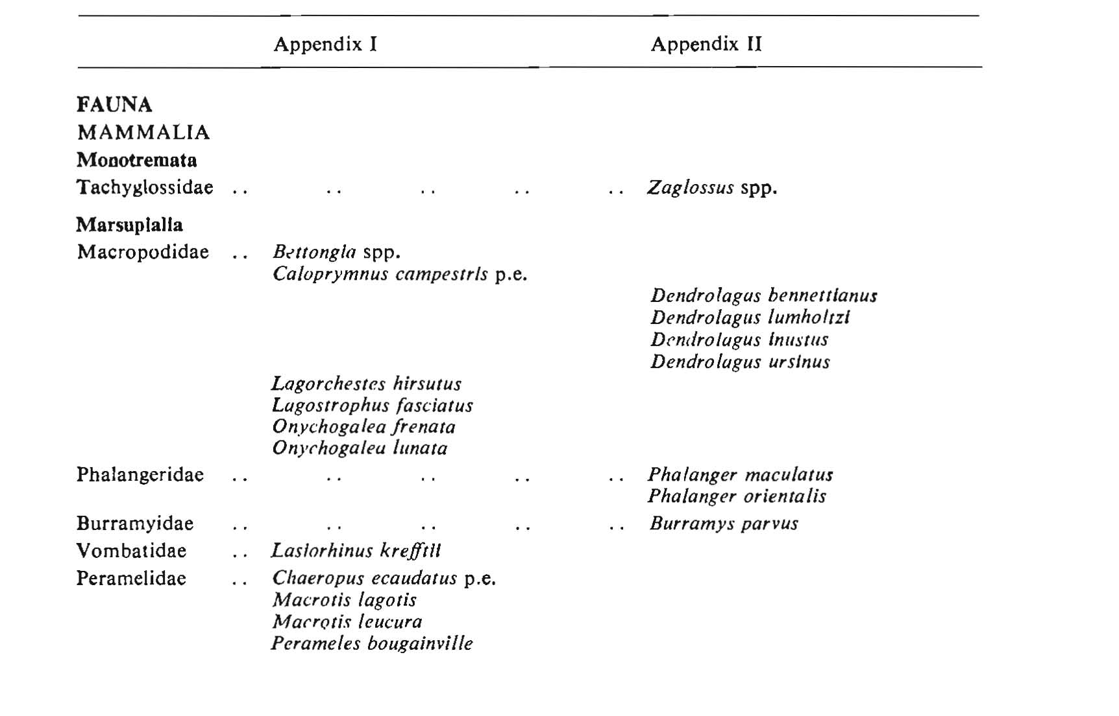
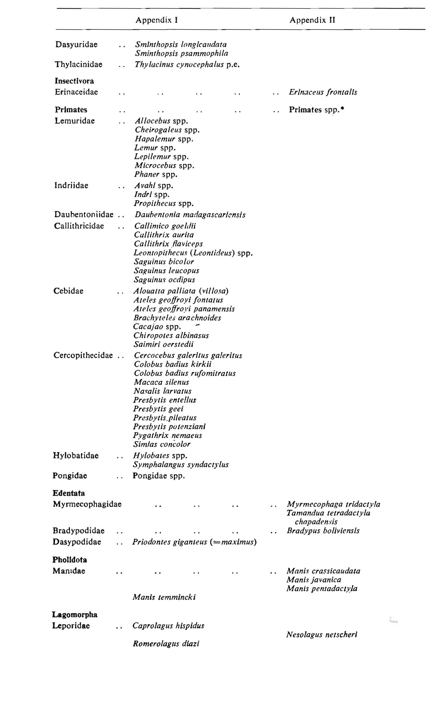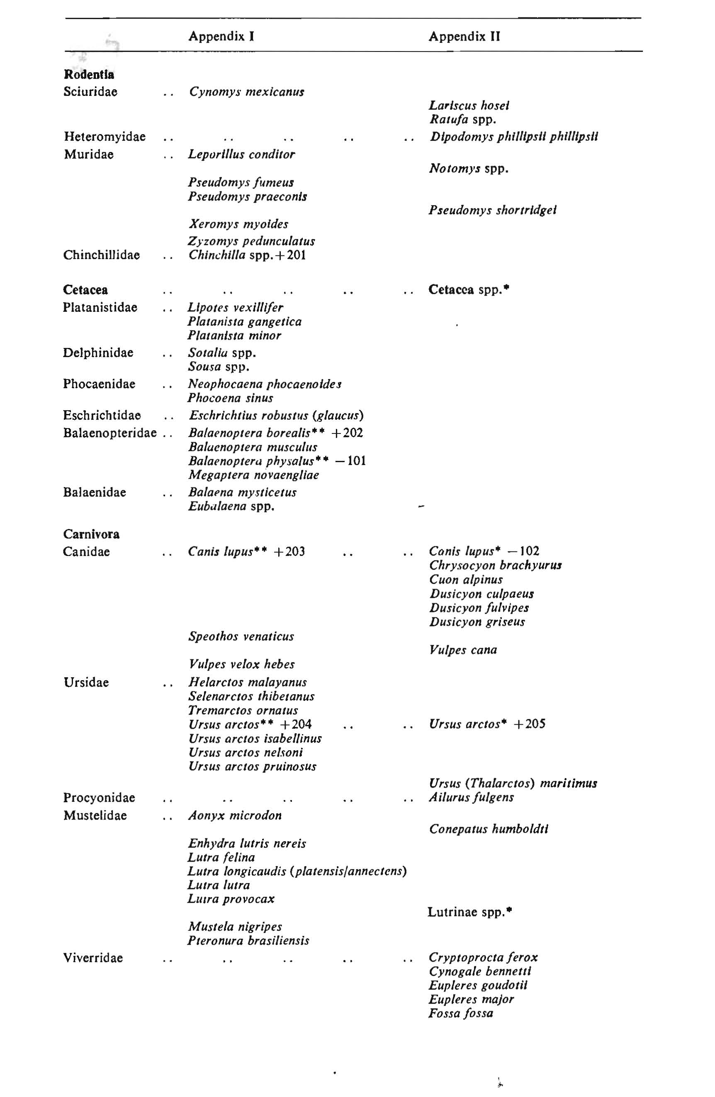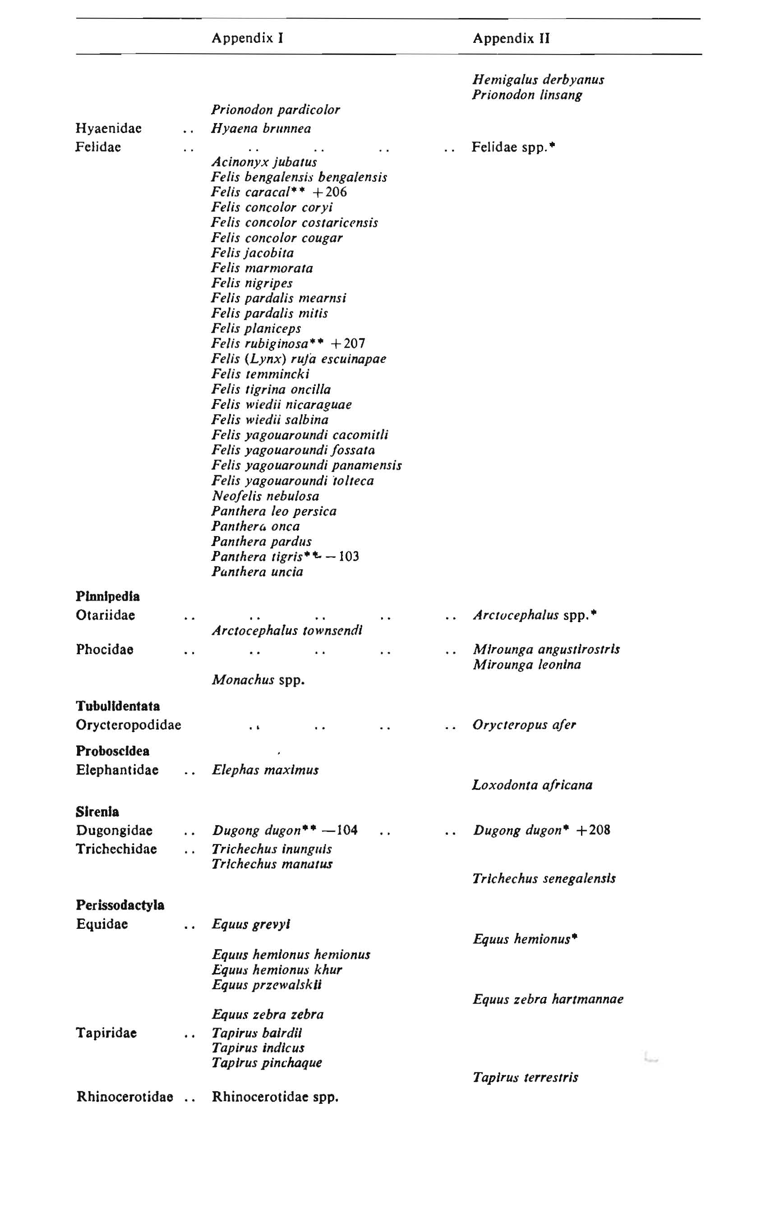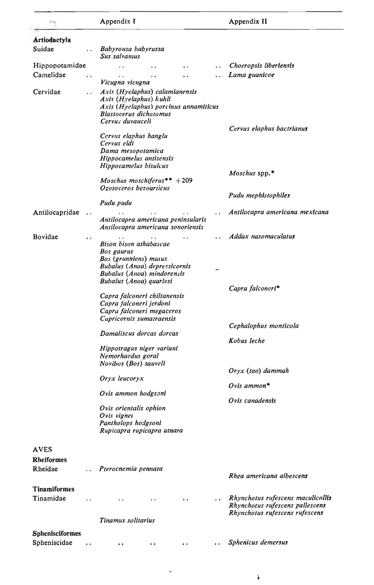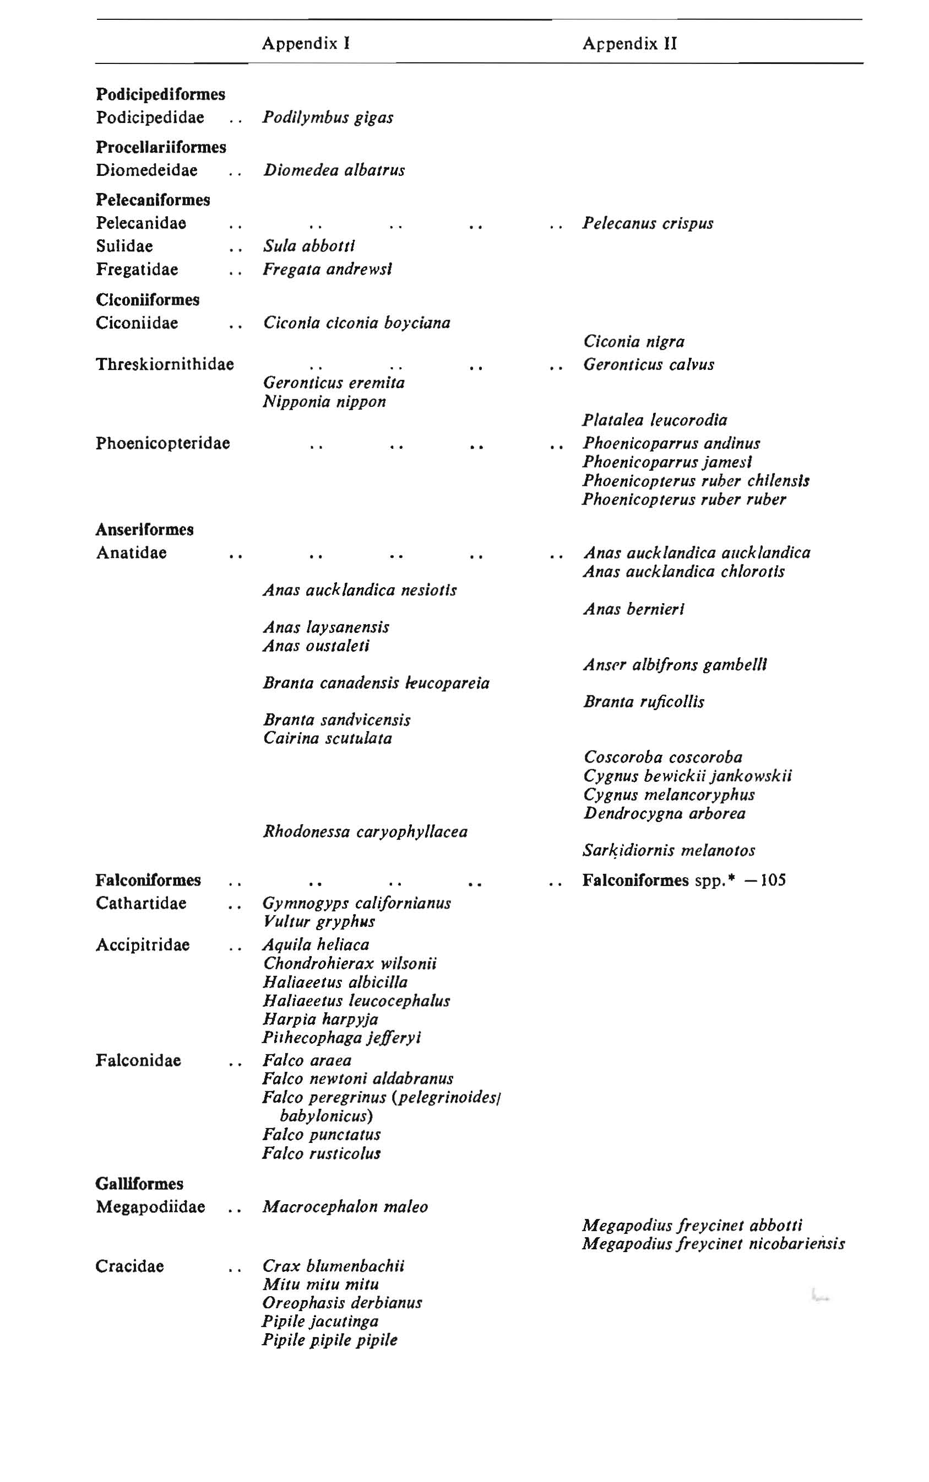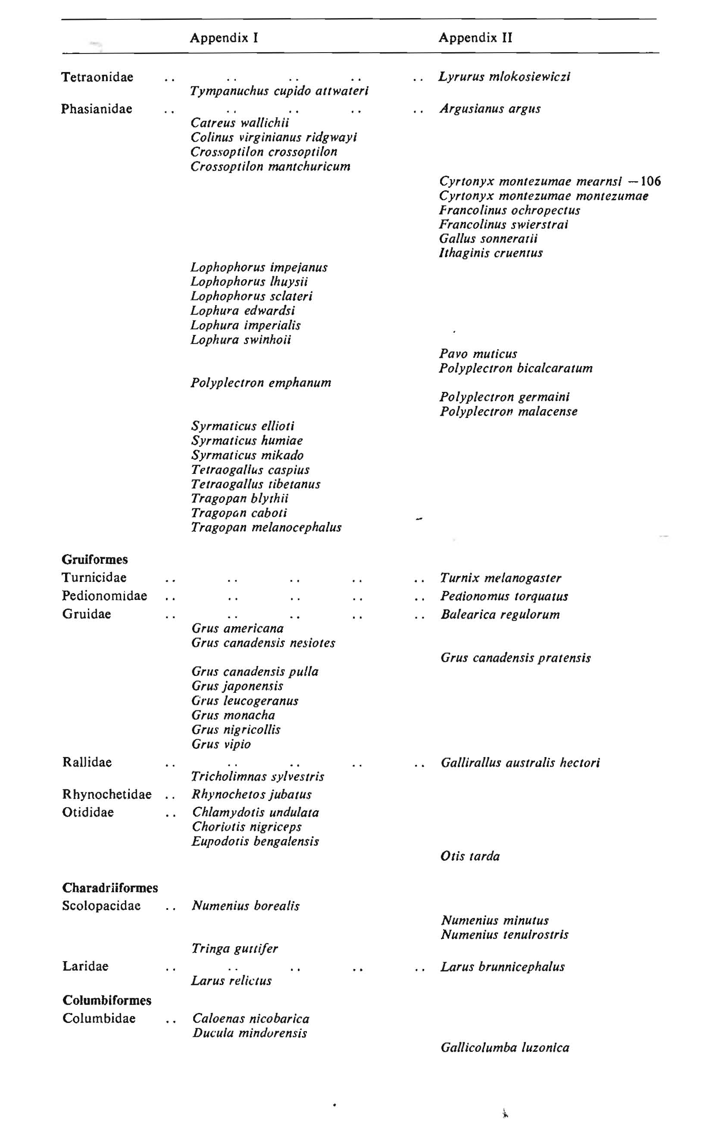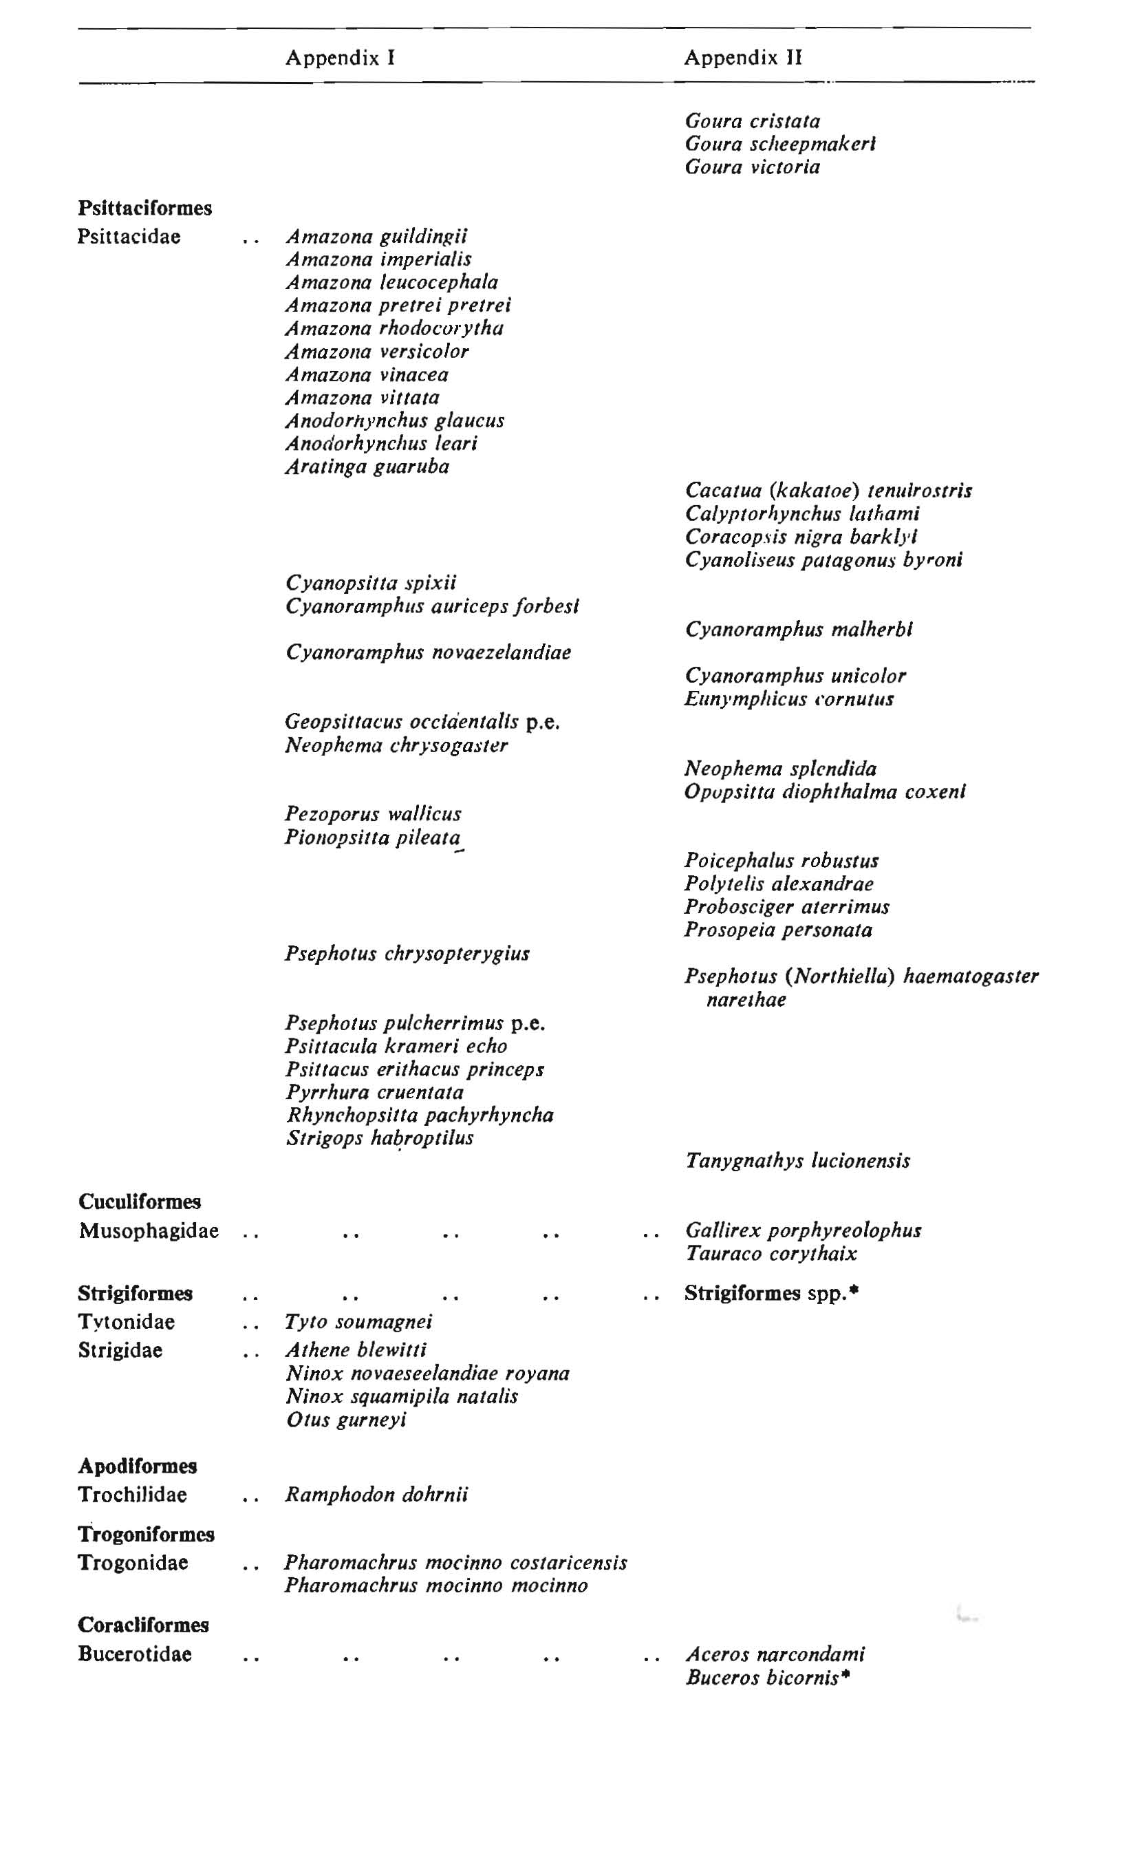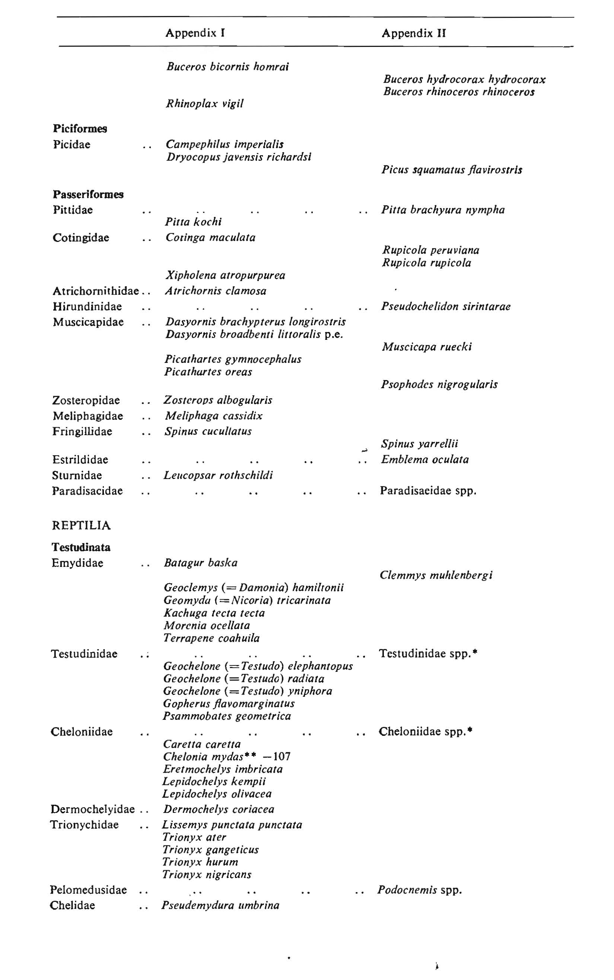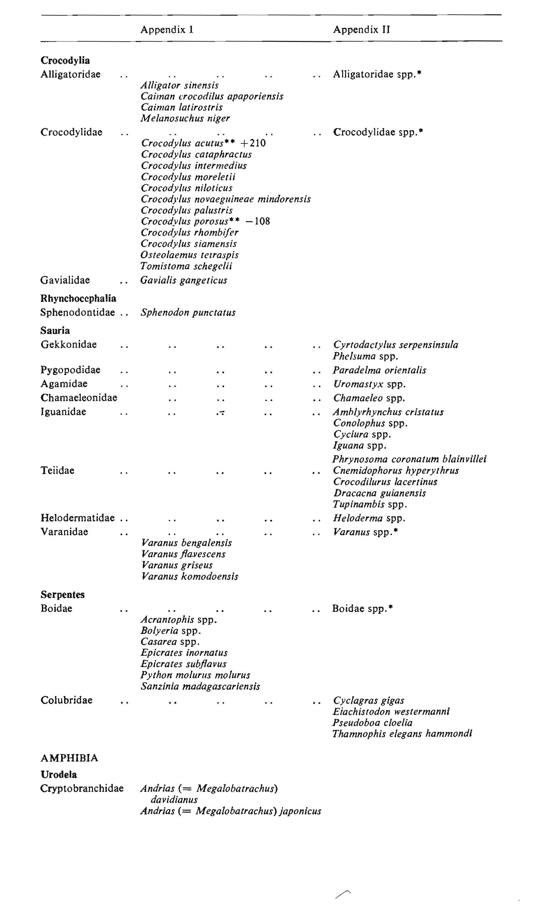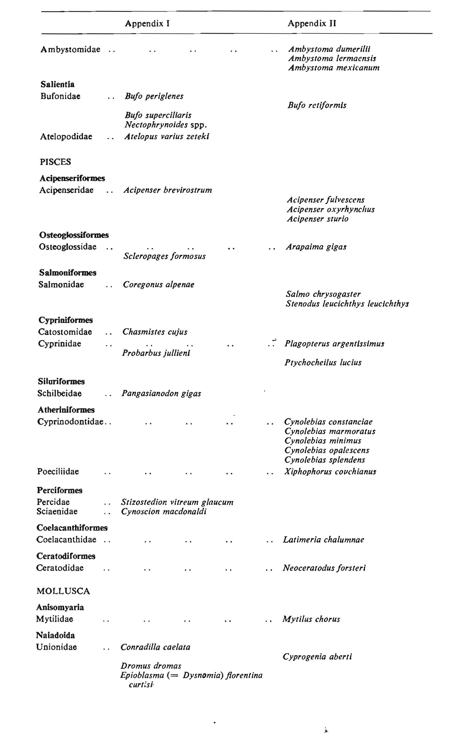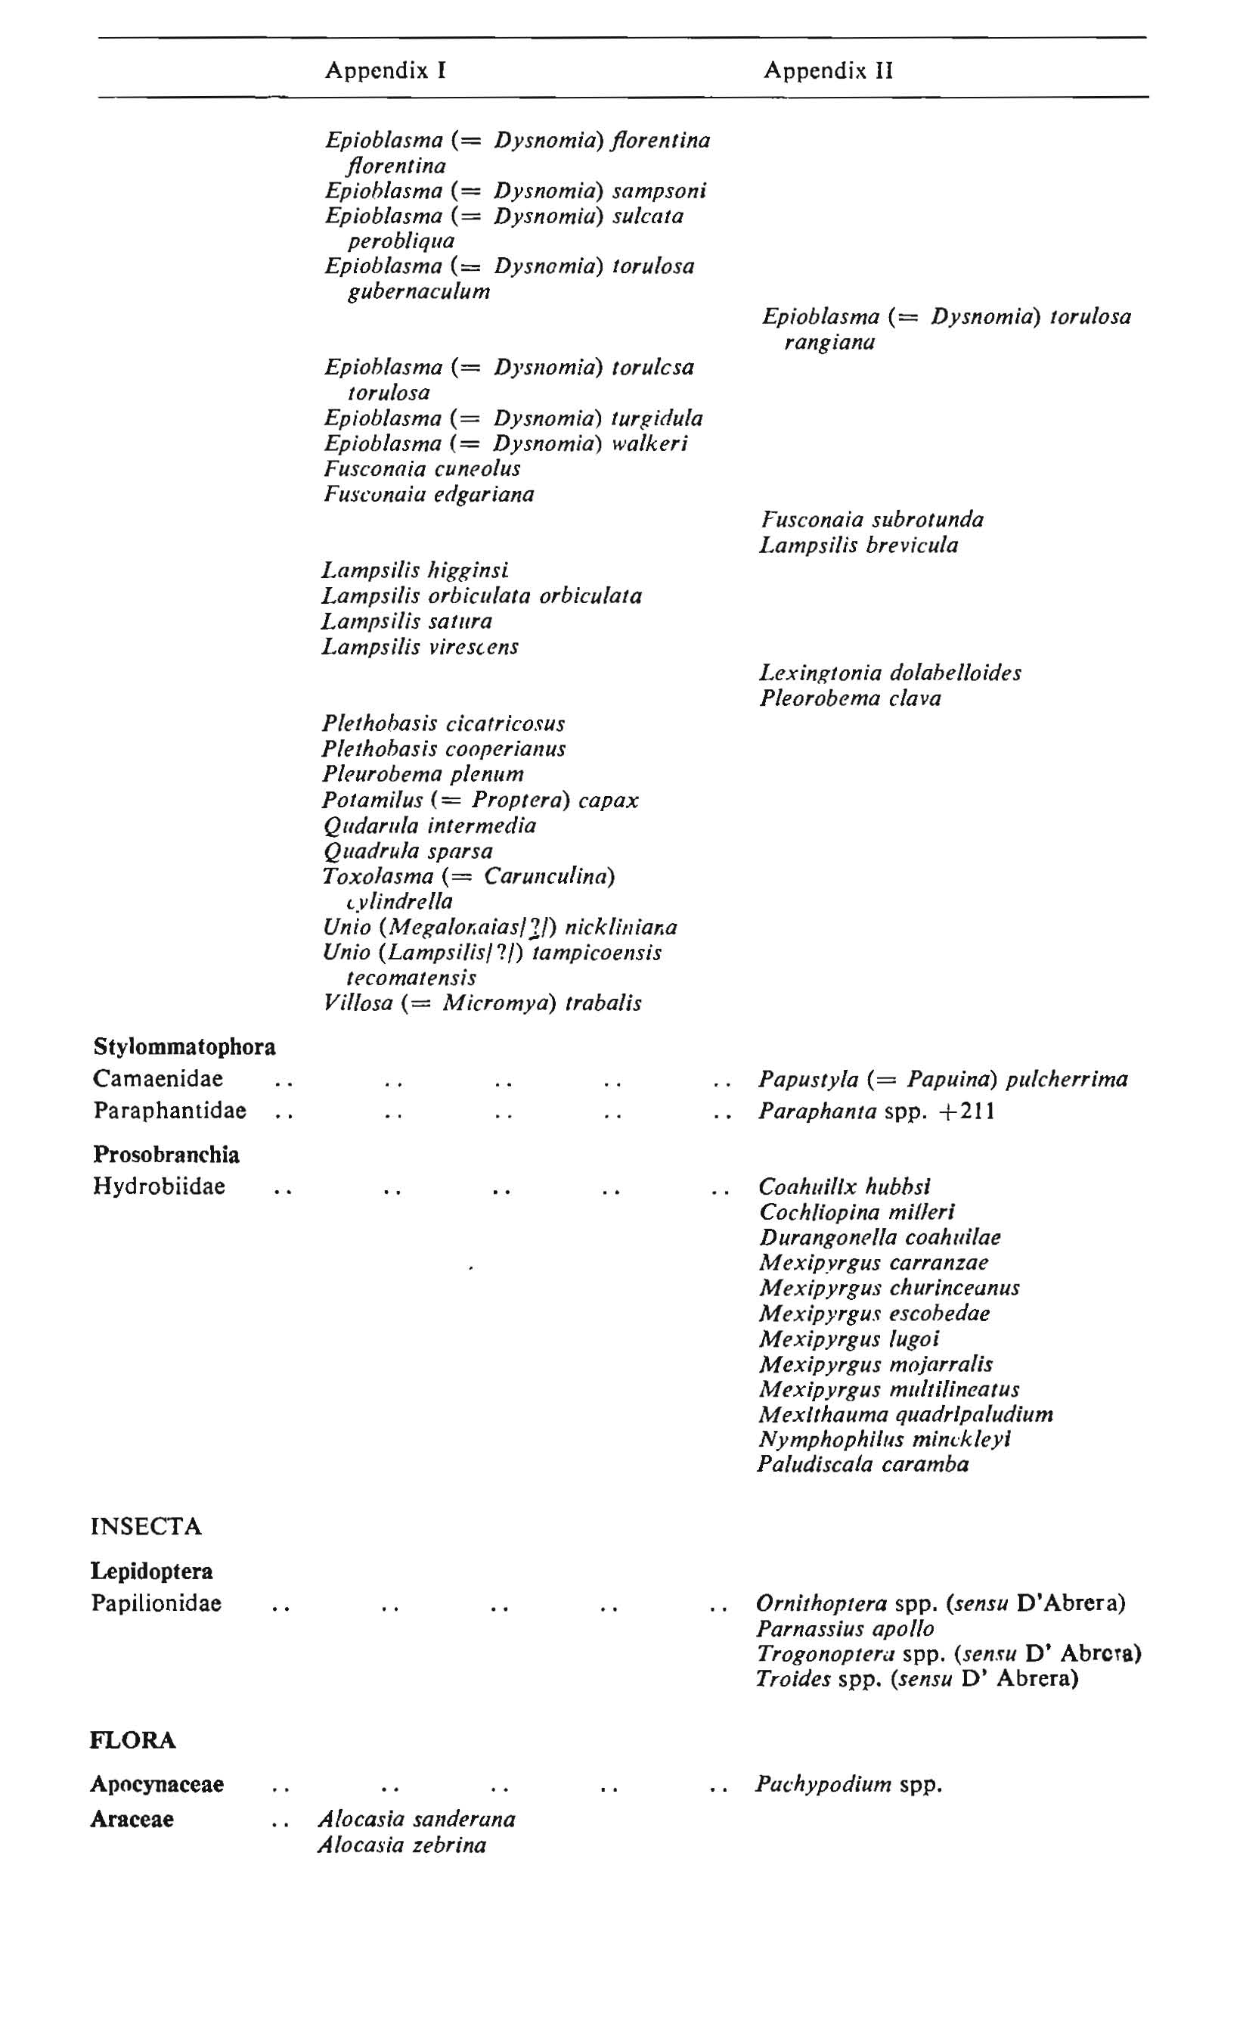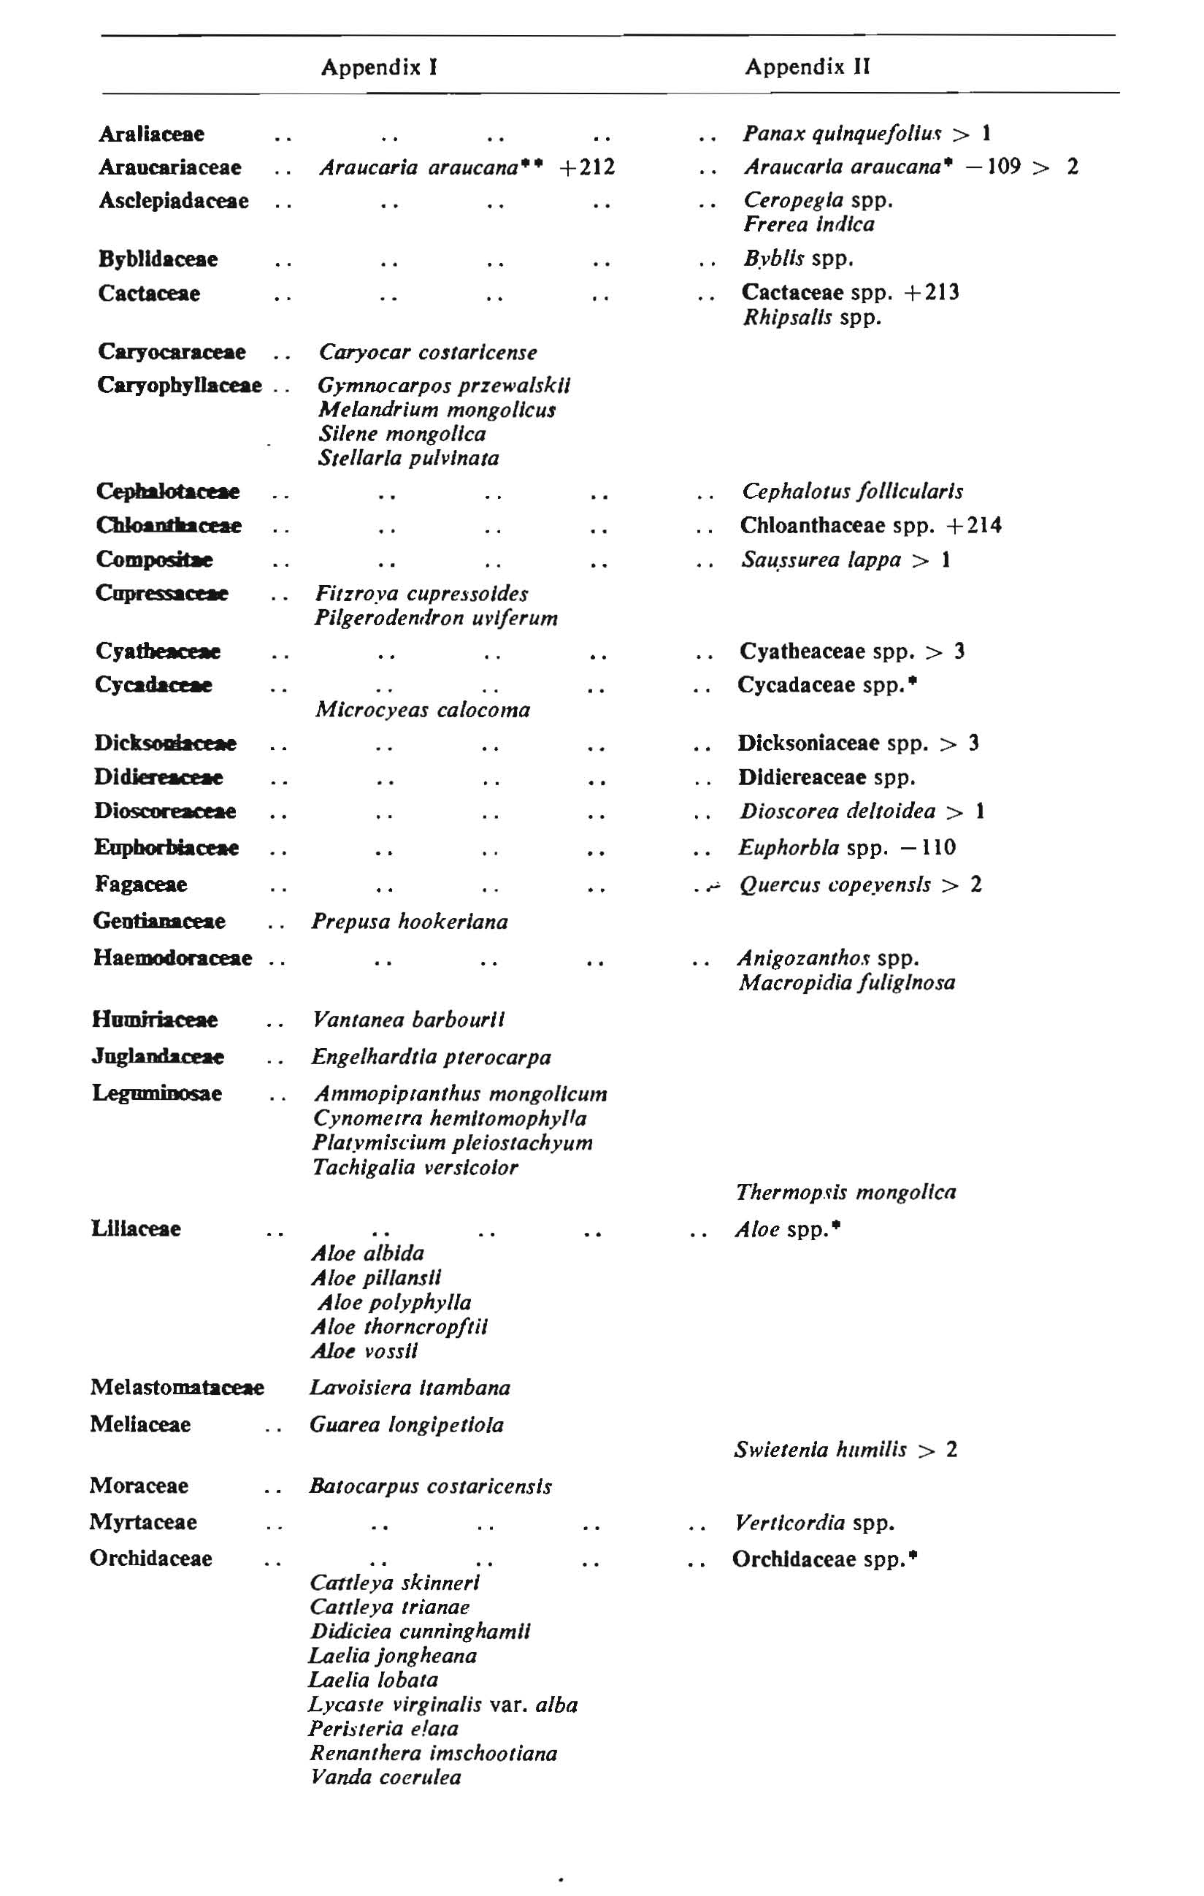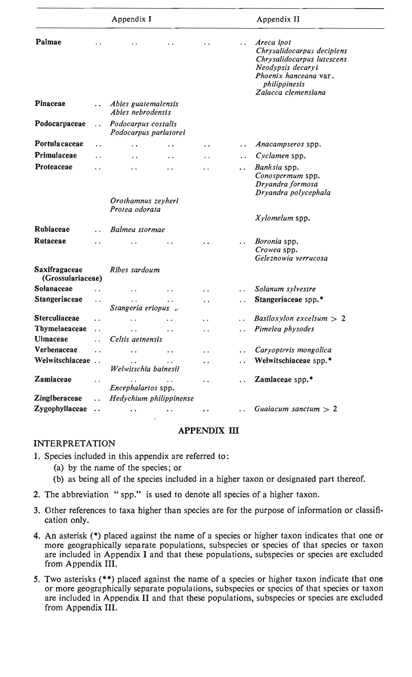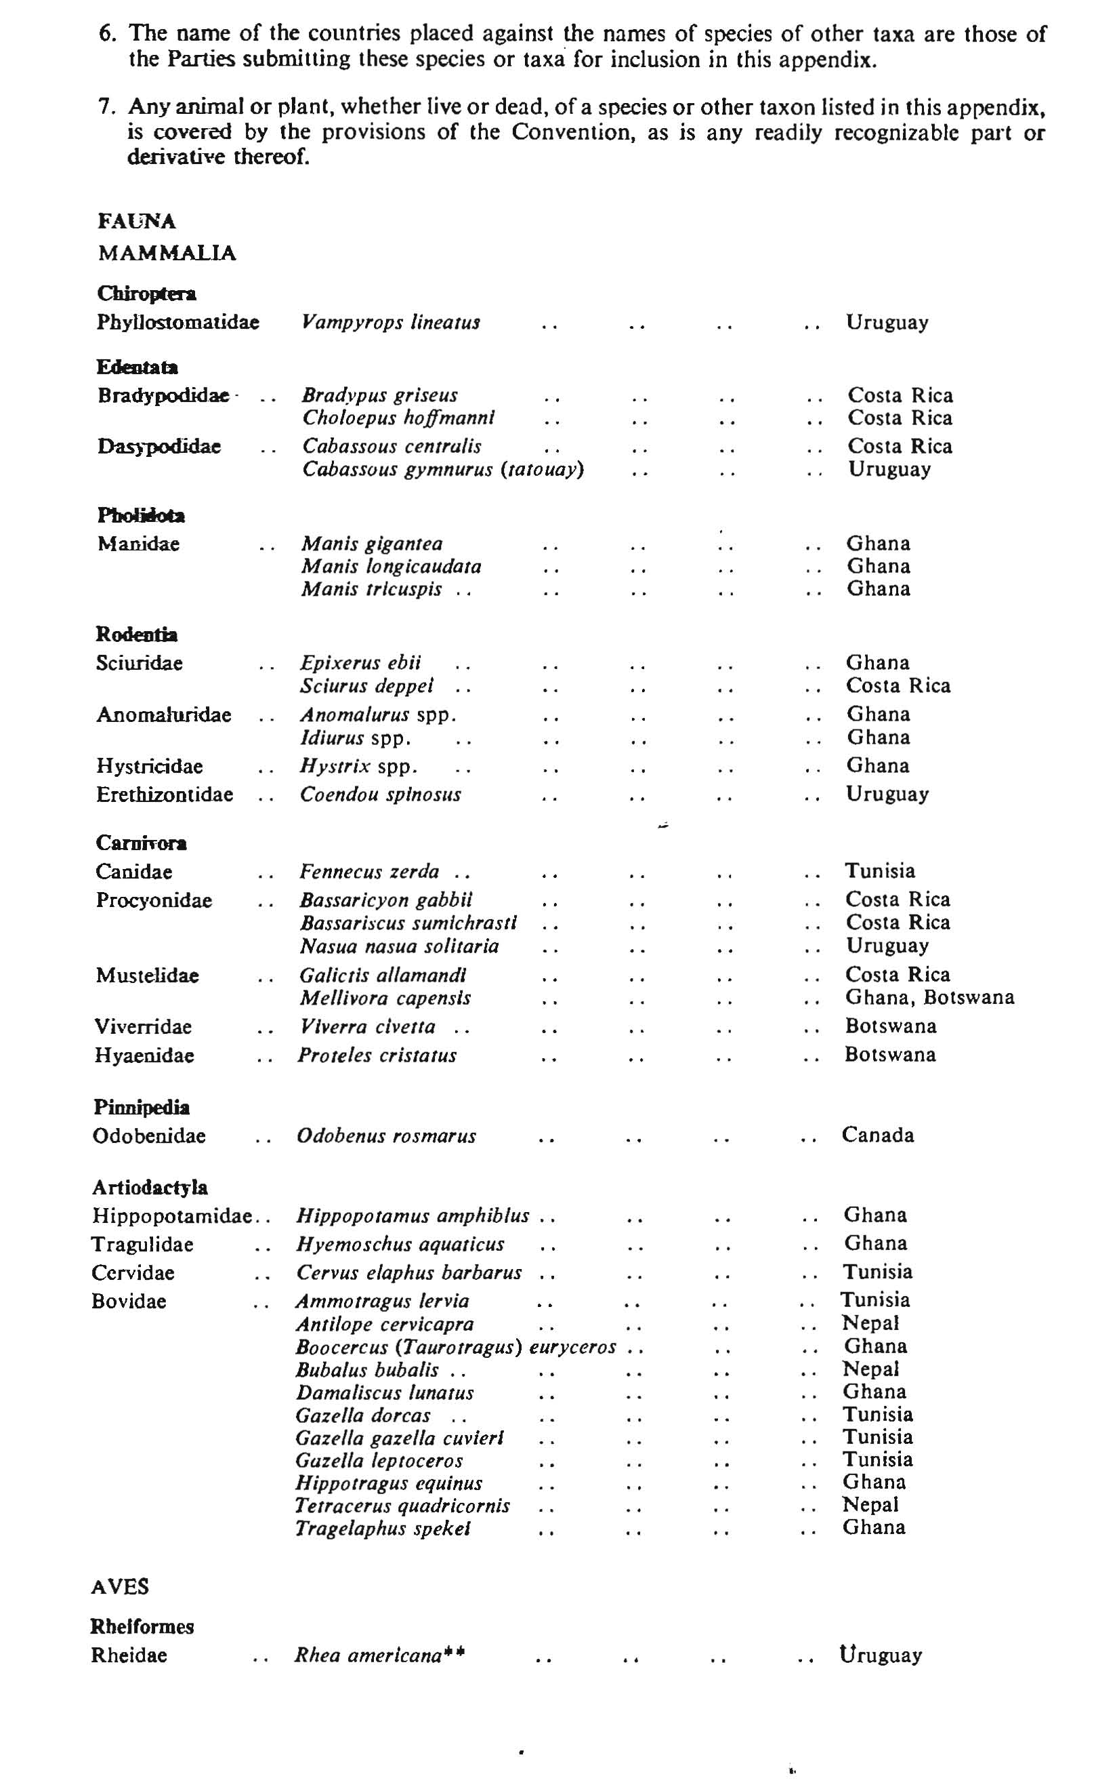

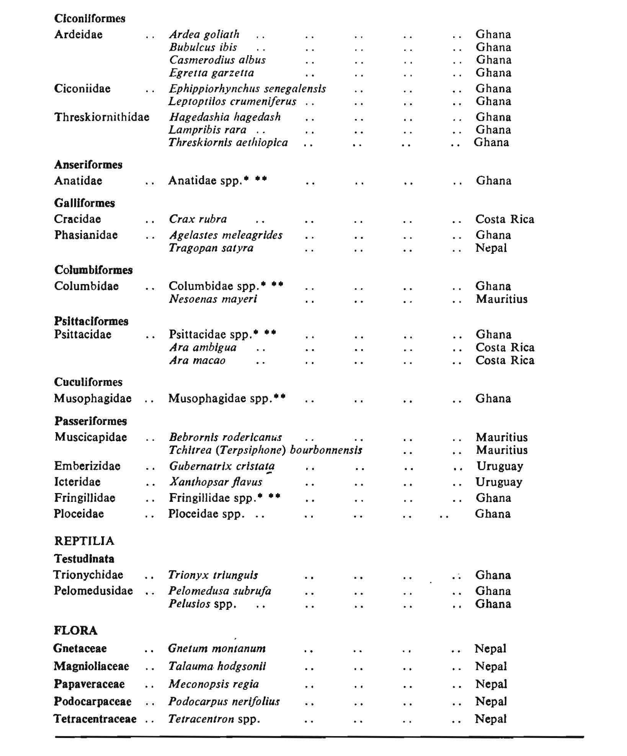
_______________________________________________________________________

NOTES
The Endangered Species Act 1980 as shown in this consolidation comprises Act No. 24 of 1980 and amendments as indicated in the Tables below.
Enactment | Number and year | Date of commencement | Application saving or transitional provision
Endangered Species Act 1980 | 24, 1980 | .9.10.1980
Statute Law Revision (Penalties and Fees) Act 1984 | 9, 1985 | 13.5.1985

Table of Amendments

ad = added or inserted |  | am = amended |  | rep = repealed | rs = repealed and substituted
Provisions affected How affected
14 | am |  | 9, 1985

© Norfolk Island Government 2012
The Copyright Act 1968 of the Commonwealth of Australia permits certain reproduction and publication of this legislation. For reproduction or publication beyond that permitted by the Act, written permission must be sought from the Legislative Counsel, Administration of Norfolk Island, Norfolk Island, South Pacific 2899.

