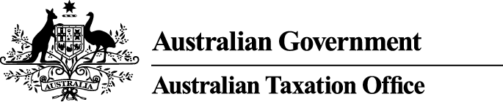

**NOTICE OF DISQUALIFICATION**

*Superannuation Industry (Supervision) Act 1993* (SISA)

To:

Brian Collyer

WINDSOR NSW 2756

I, James O’Halloran, a delegate of the Commissioner of Taxation, give you notice as required by subsection 126A(6) of the SISA, that I have disqualified you under subsections 126A(1) and 126A(3) of the SISA.

I have disqualified you as I am satisfied that you have contravened the SISA on one or more occasions and the seriousness of the contraventions provides grounds for disqualifying you.

I have also disqualified you as I am satisfied that you are not a fit and proper person to be a trustee, or a responsible officer of a body corporate that is a trustee, of a superannuation entity for the purposes of the SISA.

The disqualification takes effect on the day on which it is made.

Dated: 27 November 2015

James O’Halloran

Deputy Commissioner of Taxation

Per Michael Lazzaroni

Note 1:

In accordance with subsection 126A(7) of the SISA, particulars of this disqualification notice will be published in the *Commonwealth Government Notices* *Gazette*.

Note 2:

In accordance with subsection 126A(5) of the SISA, we may revoke this disqualification on our own initiative or on written application made by you.

Note 3:

In accordance with section 344 of the SISA, if you are a person who is affected by this decision and you are dissatisfied with it, you may ask the Commissioner to reconsider this decision. Such a request must be made in writing within 21 days after the day on which you received notice of the decision and must also give the reasons for making the request.