|  |
| --- |
| NTC-9758 |
|  |

***Maritime Transport and Offshore Facilities Security Act 2003***

**Notice of declaration of security regulated port – PORT of TOWNSVILLE**

I, **ROBERT PUGSLEY**, Director Queensland, Transport Security Operations, Office of

Transport Security, under subsection 13(1) of the *Maritime Transport and Offshore*

*Facilities Security Act 2003* (the Act):

**REVOKE** the declaration of the security regulated port of Port of Townsville published

in the *Gazette C2014G01774, 28 October 2014*; and

**DECLARE** that the area of the port of the Port of Townsville intended for use either

wholly or partly in connection with the movement, loading, unloading, maintenance or provisioning of security regulated ships, the boundaries of which are shown on the

attached map and descriptions, to be a security regulated port.

This Notice commences upon publication in the *Gazette*.

Date: 20 November 2015

Robert Pugsley

Delegate of the Secretary of the

Department of Infrastructure and Regional Development

Note:

1. *Gazette* means the *Commonwealth of Australia Gazette*
2. This Notice remains in force until otherwise revoked in writing and upon subsequent publication in the *Gazette*.

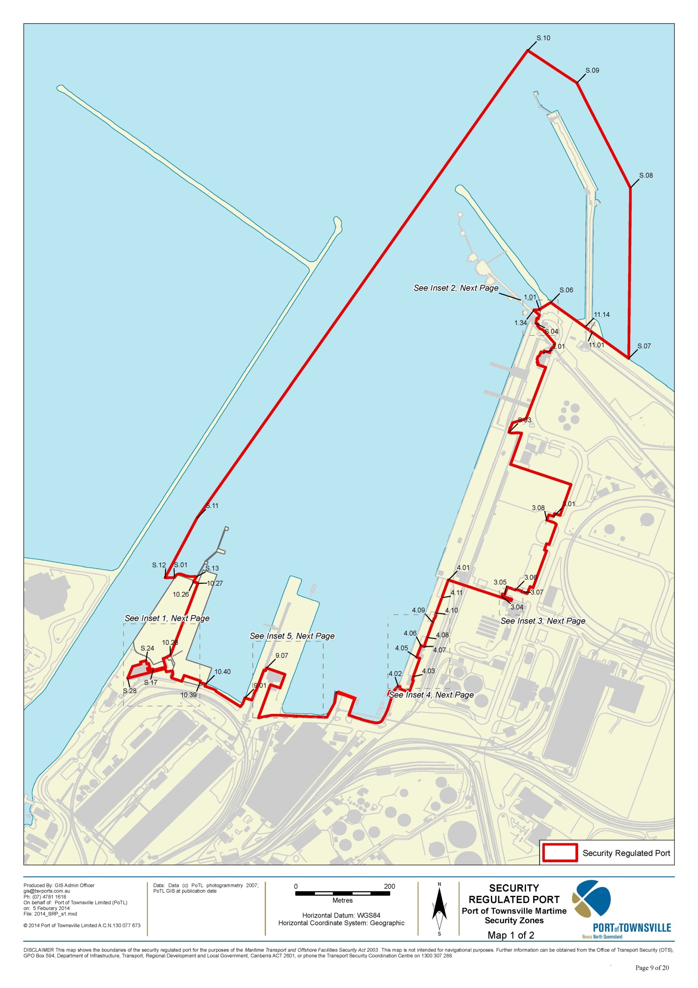

This map shows the location of the security regulated offshore facility for the purposes of the *Maritime Transport & Offshore Facilities Security Act 2003*. This map is not intended for navigational purposes. Further information can be obtained from the Department of Infrastructure and Regional Development, Office of Transport Security (OTS), GPO Box 594, Canberra ACT 2601, or phone the Transport Security Coordination Team on 1300 791 581.

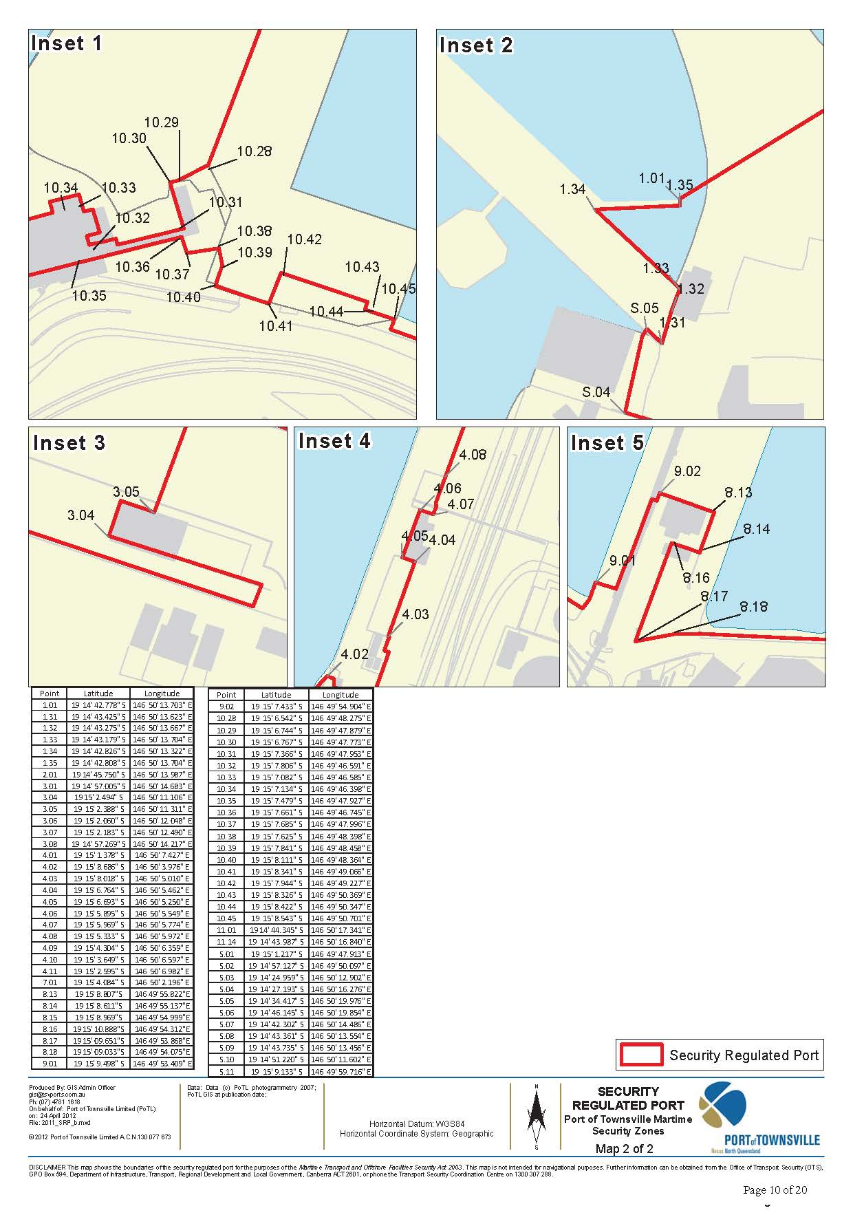

This map shows the location of the security regulated offshore facility for the purposes of the *Maritime Transport & Offshore Facilities Security Act 2003*. This map is not intended for navigational purposes. Further information can be obtained from the Department of Infrastructure and Regional Development, Office of Transport Security (OTS), GPO Box 594, Canberra ACT 2601, or phone the Transport Security Coordination Team on 1300 791 581.

**Security Regulated Port**

The Security Regulated Port of Townsville is that area of land and water contained

within and bound by a line commencing at point 19° 15' 1.203" S, 146 49’ 48.577”E (S.01)

* East (approx. 60m) along fence to point on edge of the wharf at the point closest to

19° 15' 1.157" S and 146° 49' 50.069" E (S.13);

* South for a distance of 12m following the fence line to north side of the wharf backing land behind to the point closest to 19° 15' 1.495" S and 146° 49' 49.873" E (10.26);
* SE for a distance of 9m along the fence-line to the point closest to 19° 15' 1.599" Sand 146° 49' 50.174" E (10.27);
* SWW for a distance of 162m along the fence-line separating wharf backing land wharf to the point closest to 19° 15' 6.542" S and 146° 49' 48.275" E (10.28);
* SW for a distance of 13m to the point closest to 19° 15' 6.744" S and 146° 49' 47.879" E (S.14);
* W for a distance of 3m to the point closest to 19° 15' 6.767" S and 146° 49' 47.773" E (S.15);
* S for a distance of 20m following the west side of the building to the corner at the point between second floor aero-bridge and building closest to 19° 15' 7.366" S and 146° 49' 47.953" E (S.16);
* WSW for a distance of 26m across the second floor aero-bridge to the point closest to 19° 15' 07.365" S and 146° 49' 47.964" E (S.17);
* NNW for a distance of 3m across the ground floor of the cruise terminal to the point closest to 19° 15' 7.498" S and 146° 49' 47.069" E (S.18);
* WSW for a distance of 10m across the ground floor of the cruise terminal building to the point closest to 19° 15' 7.578" S and 146° 49' 46.721" E (S.19);
* NNW for a distance of 4m across the ground floor of the cruise terminal building to the point closest to 19° 15' 7.462" S and 146° 49' 46.688" E (S.20);
* WSW for a distance of 5m across the ground floor of the cruise terminal building to the point closest to 19° 15' 7.419" S and 146° 49' 46.858" E (S.21);
* NNW for a distance of 10m across the ground floor of the cruise terminal building to the point closest to 19° 15' 7.117" S and 146° 49' 46.767" E (S.22);
* WSW for a distance of 4m across the ground floor of the cruise terminal building to the point closest to 19° 15' 7.148" S and 146° 49' 46.651" E (S.23);
* NNW for a distance of 7m across the ground floor of the cruise terminal building to the point closest to 19° 15' 6.924" S and 146° 49' 46.588" E (S.24);
* WSW for a distance of 11m across the ground floor of the cruise terminal building to the point closest to 19° 15' 7.018" S and 146° 49' 46.207" E (S.25);
* SSE for a distance of 5m across the ground floor of the cruise terminal building to the point closest to 19° 15' 7.160" S and 146° 49' 46.245" E (S.26);
* WSW for a distance of 17m across the ground floor of the cruise terminal building to the point closest to 19° 15' 7.314" S and 146° 49' 45.669" E (S.27);
* WSW for a distance of 27m across the ground floor of the cruise terminal building to the point closest to 19° 15' 8.125" S and 146° 49' 45.326" E (S.28);
* ENE for a distance of 78m across the ground floor of the cruise terminal building, up & over the aero-bridge to the second floor the berth 10 facilities, to the ground floor of berth 10 backing land point closest to 19° 15' 7.474" S and 146° 49' 47.925" E (10.31);
* SSE for a distance of 7m following the fence-line to the point 19° 15' 7.685" S and 146° 49' 47.996" E (10.32);
* East for a distance of 12m along the fence-line to the point closest to 19° 15' 7.622" S and 146° 49' 48.414" E (10.33);
* South for a distance of 7m along the fence-line to the point closest to 19° 15' 7.841" S and 146° 49' 48.458" E (10.34);
* SW for a distance of 9m along the fence-line to the point closest to 19° 15' 8.111" S and 146° 49' 48.364" E (10.35);
* SE for a distance of 22m along the fence-line to the point closest to 19° 15' 8.341" S and 146° 49' 49.066" E (10.36);
* NNE for a distance of 14m along the fence-line to the point closest to 19° 15' 7.944" S and 146° 49' 49.227" E (10.37);
* SE for a distance of 35m along the fence-line to the point closest to 19° 15' 8.318" S and 146° 49' 50.353" E (10.38);
* SW for a distance of 4m along the fence-line to the point closest to 19° 15' 8.415" S and 146° 49' 50.319" E (10.39);
* ESE for a distance of 13m across the gateway to the secondary wharf to the point closest to 19° 15' 8.543" S and 146° 49' 50.701" E (10.40) where the secondary wharf intersects with the revetment;
* East (approx. 210m) along mean high-water spring mark to intersection with fence closest the point 19° 15' 9.498" S, 146° 49' 53.409" E (9.01).
* East then north (approx. 116m) along southern and eastern edge of fence to intersection with western face of wharf closest the point 19° 15' 7.433" S, 146°49', 54.904" E (9.02).
* East (approx. 44m) along northern face of building to point closest to 19° 15' 8.807" S and 146° 49' 55.822" E (8.13)
* South (approx. 30m) along south-eastern face of building to point closest to 19° 15' 8.611" S and 146° 49' 55.137" E (8.14)
* West (approx. 20m) along front of building to point closest to 19° 15' 10.888" S and 146° 49' 54.312" E (8.16)
* South-West (approx. 76m) along fence-line to point closest to 19° 15' 9.651" S and 146° 49' 53.868" E (8.17)
* East (approx. 35m) along fence-ling to point closest to 19° 15' 9.033" S and 146° 49' 54.075" E (8.18)
* South then east (approx. 174m) along mean high-water spring mark to intersection with fence closest the point 19° 15' 9.133" S, 146° 49' 59.716" E (S.02).
* East then north (approx. 188m) along the southern then eastern edge of fence to edge of wharf closest the point 19° 15' 4.084" S, 146° 50' 2.196" E (7.01).
* South then east (approx. 388m) along north face of wharf then east face of wharf then mean high-water spring mark to intersection with fence closest the point 19°15' 8.686" S, 146° 50' 3.976" E (4.02).
* East then north (approx. 64m) along southern and eastern edge of fence to intersection with western face of concrete kerb closest the point 19°15' 8.018" S, 146° 50' 5.010" E (4.03).
* North then west (approx. 41m) along western face of concrete kerb to intersection with southern face of building closest the point 19° 15' 6.764" S, 146° 50' 5.462" E (4.04).
* West (approx. 7m) along southern face of building to south-west corner of building closest the point 19° 15' 6.693" S, 146° 50' 5.250" E (4.05).
* North (approx. 26m) along western face of building and eastern edge of fence to intersection with southern face of low block wall closest the point 19° 15' 5.895" S,146° 50' 5.549" E (4.06).
* East (approx. 7m) along low block wall to intersection with fence closest the point 19°15' 5.969" S, 146° 50' 5.774" E (4.07).
* North (approx. 26m) along western edge of fence to gate post closest the point 19° 15' 5.176" S,146° 50' 6.038" E (4.08).
* North (approx. 28m) along line painted on deck to intersection with western edge of fence closest the point 19° 15' 4.304" S, 146° 50' 6.359" E (4.09).
* North (approx. 23m) along western edge of fence to intersection with line painted on deck closest the point 19° 15' 3.649" S, 146° 50' 6.597" E (4.10).
* North (approx. 34m) along line painted on deck to intersection with northern face of wharf closest the point 19° 15' 2.595" S, 146° 50' 6.982" E (4.11).
* North (approx. 40m) along western face of wharf to intersection with fence closest the point 19°15' 1.378" S, 146° 50' 7.427" E (4.01).
* East then north then west (approx. 158m) along southern, eastern and northern edge of fence to south-west corner of building closest the point 19° 15' 2.494" S,146° 50' 11.106" E (3.04).
* North then east (approx. 10m) along outer face of building to intersection with fence closest the point 19° 15' 2.388" S, 146° 50' 11.311" E (3.05).
* North then east (approx. 34m) along eastern and southern edge of fence to intersection with western face of building closest the point 19° 15' 2.060" S,146° 50' 12.048" E (3.06).
* North then east then south (approx. 16m) along face of building to intersection with fence closest the point 19° 15' 2.183" S, 146° 50' 12.490" E (3.07).
* North (approx. 207m) along eastern edge of fence to southern end of security gate closest the point 19° 14' 57.269" S, 146° 50' 14.217" E (3.08).
* North then east (approx. 22m) along eastern edge of security gate then western face of building then northern face of building to southern end of security gate closest the point 19°14' 57.005" S, 146° 50' 14.683" E (3.01).
* North then west (approx. 311m) along eastern and northern edge of fence to intersection with western face of wharf closest the point 19° 14' 51.220" S, 146° 50' 11.602" E (S.03).
* North (approx. 221m) along southern and eastern edges of fence to north-west corner of building closest the point 19° 14' 45.750" S, 146° 50' 13.987" E (2.01).
* North (approx. 98m) along eastern edge of fence from north-west corner of building, intersection with western face of wharf closest the point 19° 14' 43.735" S, 146° 50' 13.456" E (S.04).
* North (approx. 12m) along western face of wharf to intersection with fence closest the point 19°14' 43.361" S, 146° 50' 13.554" E (S.05).
* East (approx. 3m) along western face of wharf to intersection with fence closest the point 19° 14'43.425" S, 146° 50' 13.623" E (1.31).
* North (approx. 5m) along eastern edge of fence to intersection with south- west corner of building closest the point 19° 14' 43.275" S, 146° 50' 13.667" E (1.32).
* North (approx. 3m) along western face of building to intersection with eastern face of wharf closest the point 19° 14' 43.179" S, 146° 50' 13.704" E (1.33).
* North-west (approx. 16m) along eastern face of wharf to intersection with southern edge of walkway closest the point 19° 14' 42.826" S, 146° 50' 13.322" E (1.34).
* East (approx. 11m) along southern edge of walkway to southern end of security gate closest the point 19° 14' 42.808" S, 146° 50' 13.704" E (1.35).
* North (approx. 1m) along eastern edge of security gate to northern edge of walkway closest the point 19° 14' 42.778" S, 146° 50' 13.703" E (1.01).
* North-east (approx. 27m) across surface to point on boundary of Lot 601 on
* EP1802 closest the point 19° 14' 42.302" S, 146° 50' 14.486" E (S.06).
* South-east (approx. 86m) along boundary of Lot 601 on EP1802 to point closest the point 19° 14'43.987" S, 146° 50' 16.840" E" E (11.14).
* South-east (approx. 18m) along boundary of Lot 601 on EP1802 to point closest the point 19° 14'44.345" S, 146° 50' 17.341" E (11.01).
* South-east (approx. 92m) along boundary of Lot 601 on EP1802 to point closest the point 19°4'46.145" S, 146° 50' 19.854" E (S.07).
* North (approx. 360m) to point 19° 14' 34.417" S, 146° 50' 19.976" E (S.08).
* North-west (approx. 247m) to point 19° 14' 27.193" S, 146° 50' 16.276" E (S.09).
* North-west (approx. 120m) to point 19° 14' 24.959" S, 146° 50' 12.902" E (S.10).
* South-west (approx. 1317m) to point 19° 15' 0.108" S, 146° 49' 47.081" E (S.11).
* South-west (approx. 334m) to point 19° 15' 1.217" S, 146° 49' 47.913" E (S.12)