**HEAVY VEHICLE NATIONAL LAW**

**NEW SOUTH WALES CLASS 1 HEAVY VEHICLE GRAIN AUGER COMBINATION EXEMPTION NOTICE 2015 (No.1)**

1. **Purpose**

The purpose of this Notice is to exempt grain auger combinations from the dimensions in the *Heavy Vehicle (Mass, Dimension and Loading) National Regulation,* subject to the conditions and requirements set out in this Notice.

Note- This Notice replaces the *New South Wales Class 1 Grain Auger Combination Exemption Notice 2010*, previously in force to 30 September 2015.

1. **Authorising Provision**

This Notice is made under section 117 of the Heavy Vehicle National Law (HVNL).

1. **Title**

This Notice may be cited as the *New South Wales Class 1 Heavy Vehicle Grain Auger Combination Exemption Notice 2015*.

1. **Commencement**

This Notice commences on 1 October 2015.

1. **Expiry**

This Notice expires on 30 September 2020.

1. **Definitions**

Unless otherwise stated, words and expressions used in this Notice have the same meaning as those defined in the HVNL.

1. **Application**
2. This Notice applies to a grain auger trailer in combination with a towing motor vehicle.
3. This Notice applies in New South Wales.
4. **Exemption from Prescribed Vehicle Standards**
5. A grain auger combination described in Section 7 of this Notice is exempt from the following provisions of Schedule 6, Part 2 of the Heavy Vehicle (Mass, Dimension and Loading) National Regulation, subject to the conditions in this Notice:
   1. section 3(1)(a);
   2. section 5 (1) & (2);
   3. section 6(3); and
   4. section 7.

**PART 3- CONDITIONS**

1. **Travel Conditions**
2. Combinations operating under this Notice may operate in the NSW Urban, NSW Eastern and NSW Western zones as defined in the *New South Wales Class 1 Agricultural Vehicles (Notice) 2015*, subject to:
   1. The dimension limits applicable to each zone as set out in Section 10(1) of this Notice;
   2. The pilot vehicle requirements as set out in Part 4 of this Notice; and
   3. The travel restrictions imposed as set out in Appendix 2 of the *New South Wales Class 1 Agricultural Vehicles (Notice) 2015.*
3. **Special Conditions**
4. A vehicle operating under this Notice must not exceed the dimension limits set out in Table 1, subject to Section 10(2) of this Notice.

|  |  |  |  |  |  |  |
| --- | --- | --- | --- | --- | --- | --- |
| **Table 1 Grain Auger Dimensions** | | | | | | |
| **Zone** | **A** | **B** | **C** | **D** | **E** | **F** |
| NSW Urban Zone | (up to)  7.0 m | (up to)  19.0 m | (up to)  23.0 m | (up to)  4.3 m | (up to)  0.5 m | (up to)  3.0 m |
| NSW Eastern Zone | (up to)  9.0 m | (up to)  19.0 m | (up to)  25.0 m | (up to)  4.3 m | (up to)  0.5 m | (up to)  3.5 m |
| NSW Western Zone | (up to)  10.0 m | (up to)  19.0 m | (up to)  25.0 m | (up to)  4.3 m | (up to)  0.5 m | (up to)  3.5 m |

1. The auger’s rear overhang (Dimension A) must be the lesser of:
   1. The dimension limit set out in Table 1; and
   2. 53% of the auger’s overall length (Dimension B in diagram 1)

Diagram 1 Grain Auger Dimensions

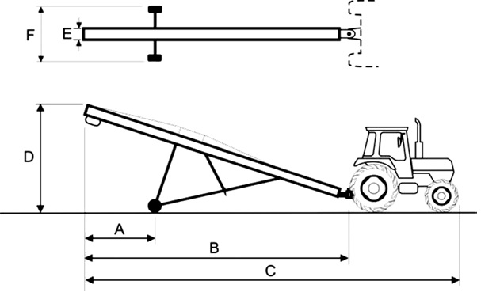

**A** means the rear overhang of the grain auger as defined in Schedule 6 of the *Heavy Vehicle (Mass, Dimension and Loading) National Regulation*

**B** means the length of the grain auger

**C** means the overall length of the grain auger in combination with the towing motor vehicle

**D** means the height of the grain auger

**E** means the width of the grain auger’s tube

**F** means the maximum width of the combination

**PART 4 – ZONAL PILOT VEHICLE REQUIREMENTS**

1. **Pilot Vehicle Requirements**
2. When a combination, to which this Notice applies, is operating in the NSW Urban Zone and the distance of dimension A exceeds 5.5m, it must be accompanied by at least one pilot vehicle.
3. A combination operating under this Notice in the NSW Eastern Zone must be accompanied by at least one pilot vehicle if:
   1. The distance of Dimension A exceeds 7.0m; or
   2. The distance of Dimension F exceeds 3.0m.
4. A combination operating under this Notice in the NSW Western Zone must be accompanied by at least one pilot vehicle if the distance of Dimension A exceeds 9.0m.

Dated 25 September 2015

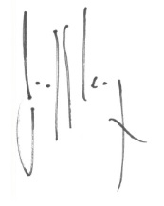

Geoff Casey

**Acting Chief Executive Officer**

National Heavy Vehicle Regulator