**Unique Identifying Number:**

EPBC303DC/SFS/2015/26

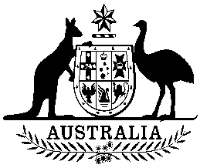

**COMMONWEALTH OF AUSTRALIA**

**Environment Protection and Biodiversity Conservation Act 1999**

**Amendment of List of Exempt Native Specimens**

I, PAUL MURPHY, Assistant Secretary, Wildlife Trade and Biosecurity Branch, as Delegate of the Minister for the Environment, pursuant to subsection303DC(1) of the *Environment Protection and Biodiversity Conservation Act 1999* (EPBC Act), hereby amend the list of exempt native specimens established under section 303DB of the EPBC Act by revoking the conditions to which the inclusion of the following item in the list on 25 September 2012 is subject:

* Specimens that are or are derived from fish or invertebrates, other than:

- specimens that belong to species listed under Part 13 of the EPBC Act, and

- specimens that belong to taxa listed under section 303CA of the EPBC Act,

taken in the Northern Territory Offshore Net and Line Fishery, as defined in the management regime in forces under the Northern Territory Fisheries Regulations and the Northern Territory *Fisheries Act 1988,*

and imposing the following conditions to which inclusion of the specimens in the list is subject:

* the specimen, or the fish or invertebrate from which it is derived, was taken lawfully, and
* the specimens are included in the list until 23 September 2016.

Dated this 18th day of September 2015

….………………Paul Murphy………………….

Delegate of the Minister for the Environment