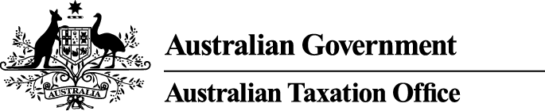

**NOTICE OF DISQUALIFICATION**

*Superannuation Industry (Supervision) Act 1993*

To:

Ms Sandra Dowdell

TANTANOOLA SA 5280

I, Alison Lendon, a delegate of the Commissioner of Taxation, give you notice as required by subsection 126A(6) of the *Superannuation Industry (Supervision) Act 1993* (SISA), that I have disqualified you under subsection 126A(1) of the SISA.

I have disqualified you as I am satisfied that you have contravened the SISA on one or more occasions and the nature, seriousness and number of the contraventions provides grounds for disqualifying you.

The disqualification takes effect on the day on which it is made.

Dated: 2 June 2015

Alison Lendon

Deputy Commissioner of Taxation

Per Michael Grivell

**Note 1:**

In accordance with subsection 126A(7) of the SISA, particulars of this disqualification notice will be published in the *Commonwealth Government Notices* *Gazette*.

**Note 2:**

In accordance with subsection 126A(5) of the SISA, we may revoke this disqualification on our own initiative or on written application made by you.

**Note 3:**

In accordance with section 344 of the SISA, if you are a person who is affected by this decision and you are dissatisfied with it, you may ask the Commissioner to reconsider this decision. Such a request must be made in writing within 21 days after the day on which you received notice of the decision and must also give the reasons for making the request.