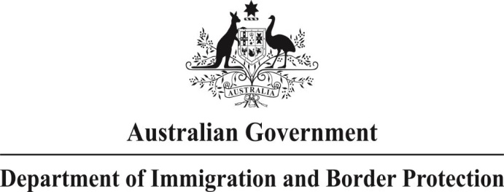

# NOTICE OF A DATA MATCHING PROGRAMME

The Department of Immigration and Border Protection (DIBP) will provide DHS – Centrelink details of visa applicants and sponsors of the onshore partner visas programme years 2012-13 and 2013–14. Matching of DIBP and DHS – Centrelink data holdings will assist in identifying instances of migration and social security fraud. DIBP will release this information under *Australian Privacy Principle* 6.2 (b) of the *Privacy Act 1988* with reference to the *Social Security (Administration) Act 1999*.

DIBP will release more than 5000 individual records to DHS–Centrelink for data matching purposes. These records will be electronically matched against DHS–Centrelink data holdings to identify non-compliance and fraud through declarations regarding relationship status and details.

DHS–Centrelink will provide results to DIBP where a match has occurred. Subsequent analysis will be used to identify non-compliance and fraud and form the basis of mitigation enforcement strategies including criminal investigations. DIBP will identify and where appropriate investigate:

* Visa applicants suspected to be involved in migration fraud in the partner visa programme.
* Centrelink customers who are failing to declare their correct relationship status to the department.
* Facilitators / organisers / professionals involved in migration fraud using the partner visa programme as a pathway for their clients to obtain permanent residency in Australia.
* Vulnerable sponsors potentially being exploited and identify intervention strategies to ensure that they are not being exploited through the partner visa programme.

Persons affected by this programme include non-citizens and sponsors who have lodged an onshore partner visa application, and whose relationship details differ to those declared to DHS–Centrelink.

DIBP has collaborated with DHS–Centrelink in the preparation of the protocol document which outlines the data matching programme. Feedback in relation to this programme can be provided by calling the Global Feedback Unit on 133 177 or at <http://www.immi.gov.au/contacts/forms/services/services-form.htm>.

Investigations Division

PO Box 25

Belconnen ACT 2616