HEAVY VEHICLE NATIONAL LAW

New South Wales Class 1 Special Purpose Vehicles Notice Amendment Notice 2015 (No. 1)

1. Purpose
2. The purpose of this notice is to make minor amendments to the *Class 1 Special Purpose Vehicles Notice 2014* published in the New South Wales Government Gazette No 15 of 7 February 2014, at pages 387 to 425.
3. Authorising Provision

This notice is made under Section 117, and Section 23 of Schedule 1, of the Heavy Vehicle National Law.

1. Period of operation
2. Subject to Subsection (2), this notice commences on the date of its publication in the Commonwealth Gazette and is in force until 9 February 2019.
3. Paragraphs 4(1)(c),(d), (f) and (g) come into force 28 days after this notice is published in the Commonwealth Gazette.
4. Amendment of 2014 Notice
5. The *Class 1 Special Purpose Vehicles Notice 2014* is amended as follows—
   1. In Table 2 (Mass limits for axles and axle groups) of Part 4 of the Schedule, the seventh row (‘with a load-sharing suspension system’), column 2, omit ‘14.0’ and insert—

16.0

* 1. In Appendix 2, omit the map at clause 1.2.6. and insert –

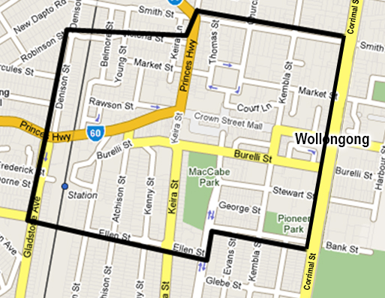

* 1. In Appendix 2 omit clause 2.3, and insert—

Week day and peak hour travel restrictions

Except where otherwise stated, a vehicle that exceeds 2.5 metres in width or 22 metres in length must not travel on the below locations contrary to the travel conditions set out in the following table:

* 1. In Appendix 2 after the final row of the table under clause 2.3, insert—

|  |  |  |
| --- | --- | --- |
| Between the M1 Pacific Motorway (6003) near Seahampton and the New England Highway (HW9) near Branxton. | Hunter Expressway | If wider than 3.2m – Monday to Friday 7.00 am to 9.00 am; and Monday to Friday 4 pm to 6 pm (except on Statewide public holidays). |

* 1. In Appendix 2 after the final row of the table under clause 2.4.2, insert—

|  |  |
| --- | --- |
| Hunter Expressway (6011) | Between the M1 Pacific Motorway (6003) near Seahampton and the New England Highway (HW9) near Branxton. |

* 1. In Appendix 2 after the final row of the table under clause 2.6, insert—

|  |
| --- |
| Hunter Expressway between the M1 Pacific Motorway (6003) near Seahampton and the New England Highway |

* 1. In Appendix 2 omit the final row of Table 2.7.1 (Limited Access Locations: Northern Ranges & North Coast NSW), and insert—

|  |  |  |  |  |
| --- | --- | --- | --- | --- |
| New England Highway southbound at Moonbi Range (defined from South of Bendemer to Moonbi) | N/A | N/A | N/A | Police escort required when width exceeds 3.5 metres.  See Part 3.1 for Police contact details. |
| New England Highway - Bolivia to Peberdy's Creek Deepwater | N/A | N/A | N/A | Police escort required when width exceeds 3.5 metres.  See Part 3.1 for Police contact details. |

* 1. In Appendix 2, Table 2.8.1 (Hunter Region), omit—

|  |  |
| --- | --- |
| BN3379 Fitzgerald Bridge | Over Hunter River, southbound New England Highway Aberdeen |

* 1. In Appendix 2, Table 2.8.4 (Southern Region), omit—

|  |  |
| --- | --- |
| BN6396 James Park Bridge | Over Crookwell River, Binda Road north west of Crookwell |

* 1. In Appendix 2, table 2.8.5 (South Western Region), omit—

|  |  |
| --- | --- |
| BN5184 Robinvale Bridge No.3 | Over Murray River approach |

**Dated: 13 April 2015**

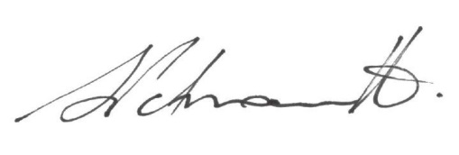

Sal Petroccitto

**Chief Executive Officer**

National Heavy Vehicle Regulator