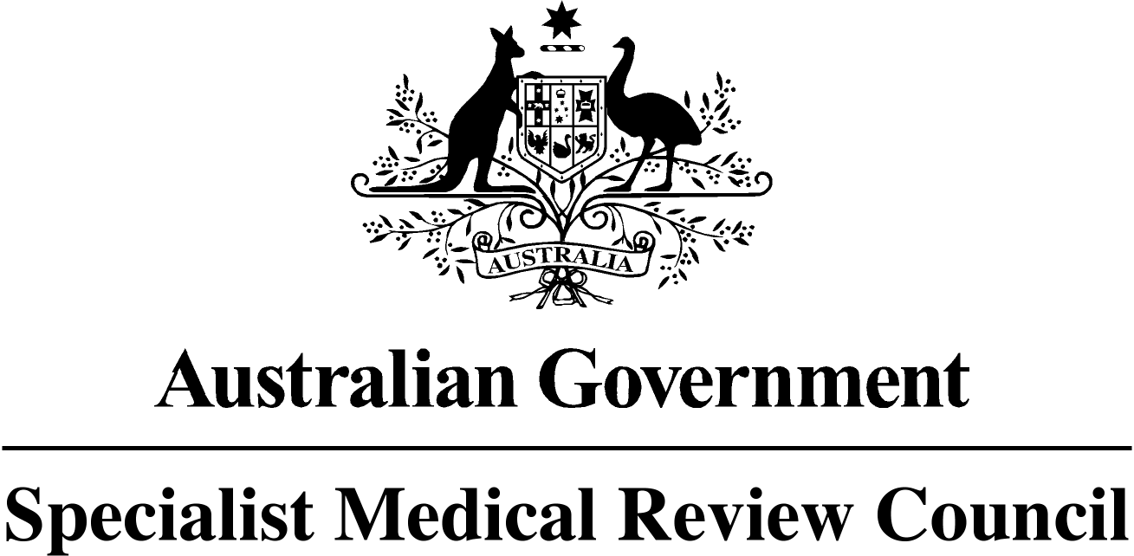

**SPECIALIST MEDICAL REVIEW COUNCIL**

***Veterans’ Entitlements Act 1986***

**Section 196ZB**

**NOTIFICATION OF AMENDED CLOSING DATE FOR**

**WRITTEN SUBMISSIONS**

The previous Gazette Notice C2014G01406 of 25 August 2014 stated that having been asked under section 196Y of the Veterans’ Entitlements Act 1986 (the Act) to review the contents of Statements of Principles Nos. 53 and 54 of 2014 made by the Repatriation Medical Authority (the RMA) in respect to **Malignant Neoplasm of the Prostate.** The Council notified, under section 196ZB of the Act its intention to carry out a review of the information all the information available to the RMA when it determined, amended or last amended Statements of Principles Nos. 53 and 54 of 2014 in respect to "**smoking cigarettes, or the** **equivalent thereof in other tobacco products**", specifically:

the possible amendment of the existing factor at clause 6(e) in Statement of Principles 53 of 2014 and/or the inclusion of new factors in the above Statements of Principles in the same or similar terms as the factors at clause 2(A) and 2(B) in Statement of Principles 77 of 2012, amending Statement of Principles 28 of 2005; and at clause 2(A) in Statement of Principles 78 of 2012, amending Statement of Principles 29 of 2005.

The previous Gazette Notice (C2014G01406 of 25 August 2014) stated that written submissions must be received by the Council by 28 November 2014. This Notice extends the period of time available to persons and organisations to make written submissions.

**Written submissions must be received by 5.00pm on Friday 3 April 2015**

The following persons or organisations are invited to make written submissions to the Council:

* The Repatriation Commission
* The Military Rehabilitation and Compensation Commission
* A person eligible to make a claim for a pension under Part II or IV of the Act
* A person eligible to make a claim for compensation under section 319 of the *Military Rehabilitation and Compensation Act 2004*; and
* An organisation representing veterans, Australian Mariners, members of the Forces, members of Peacekeeping Forces or their dependants.

For advice on the preparation of written submissions telephone the Secretariat on 07 3223 8420, or see the website www.smrc.gov.au. Send submissions to the SMRC Secretariat, PO Box 895, Woden, ACT 2606.

Charles Guest

Convener