**Unique Identifying Number:**

EPBC303DC/SFS/2014/09

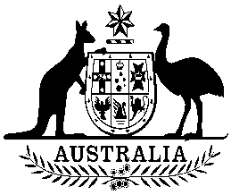

**COMMONWEALTH OF AUSTRALIA**

**Environment Protection and Biodiversity Conservation Act 1999**

**Amendment of List of Exempt Native Specimens**

I, JOANNE BEATH, A/g Assistant Secretary, Wildlife Trade and Biosecurity Branch, as Delegate of the Minister for the Environment pursuant to subsection303DC(1) of the *Environment Protection and Biodiversity Conservation Act 1999* (EPBC Act), hereby amend the list of exempt native specimens established under section 303DB of the EPBC Act by deleting from the list the following item that was included in the list on 27 February 2009 and any associated notations:

* specimens that are or are derived from fish or invertebrates, other than specimens that belong to species listed under Part 13 of the EPBC Act, taken in the New South Wales Ocean Trawl Fishery, as defined in the Fishery Management Strategy for the Ocean Trawl Fishery made under the New South Wales *Fisheries Management Act 1994*.

Dated this 20th day of June 2014

….………………………Joanne Beath…………………………

Delegate of the Minister for the Environment