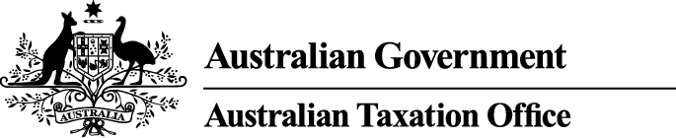

NOTICE OF DISQUALIFICATION
Superannuation Industry (Supervision) Act 1993

To:
MR DANILO CONCEPCION
QUAKERS HILL NSW 2763

I, Alison Lendon, a delegate of the Commissioner of Taxation, give you notice as required by subsection 126A(6) of the Superannuation Industry (Supervision) Act 1993 (SISA), that I have made a decision to disqualify you from being, or acting as:
- a trustee, investment manager or custodian of a superannuation entity
- a responsible officer of a body corporate that is a trustee, investment manager or custodian, of a superannuation entity.

I have disqualified you under subsection 126A(1) of the SISA as I am satisfied that you have contravened the SISA on one or more occasions and the nature, number and seriousness of the contraventions provides grounds for disqualifying you.

The disqualification order takes effect on the day on which this notice is made.
Dated: 12 June 2014

Alison Lendon
Deputy Commissioner of Taxation
Per Gerard Carney

Note 1:
In accordance with subsection 126A(7) of the SISA, particulars of this disqualification notice will be published in the Gazette.
Note 2:
In accordance with subsection 126A(5) of the SISA, we may revoke this disqualification on our own initiative or on written application made by you.
Note 3:
In accordance with section 344 of the SISA, if you are a person who is affected by this decision and you are dissatisfied with it, you may ask the Commissioner to reconsider this decision. Such a request must be made in writing within 21 days after the day on which you received notice of the decision and must also give the reasons for making the request.

