|  |
| --- |
| M01315 |
|  |

***Maritime Transport and Offshore Facilities Security Act 2003***

**Notice of declaration of security regulated port – PORT OF ABBOT POINT**

I, **ROGER VAUGHAN LONIE**, A/g Regional Director, Transport Security Operations, Office of Transport Security, under subsection 13(1) of the *Maritime Transport and Offshore Facilities Security Act 2003* (the Act):

**REVOKE** the declaration of the security regulated port of Abbott Point published in the *Gazette (No. GN 22, 2 June 2004)* on Line no. 16 of Column A (the port) and shown on the map identified as ‘16. Port of Abbott Point’ on page 1444; and

**DECLARE** that the area of the port of Abbot Point intended for use either wholly or partly in connection with the movement, loading, unloading, maintenance or provisioning of security regulated ships, the boundaries of which are shown on the attached map and descriptions, to be a security regulated port.

This Notice commences upon publication in the *Gazette*.

Date: 11 February 2014

Roger Lonie

Delegate of the Secretary of the

Department of Infrastructure and Regional Development

Note:

1. *Gazette* means the *Commonwealth of Australia Gazette*
2. This Notice remains in force until otherwise revoked in writing and upon subsequent publication in the *Gazette*.

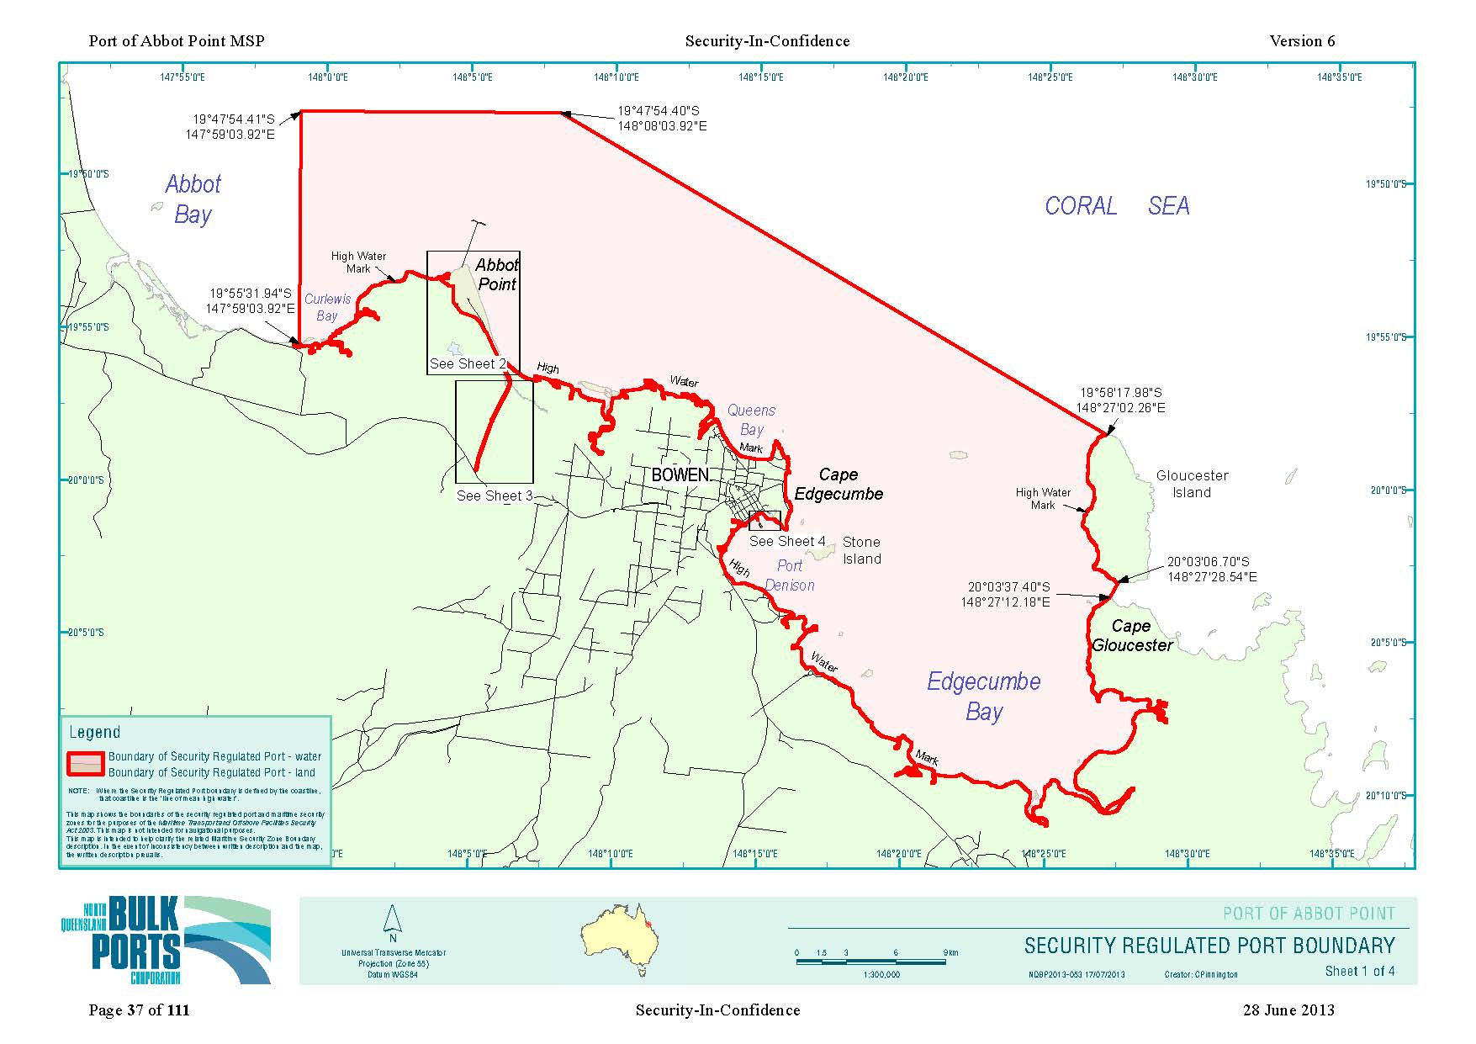

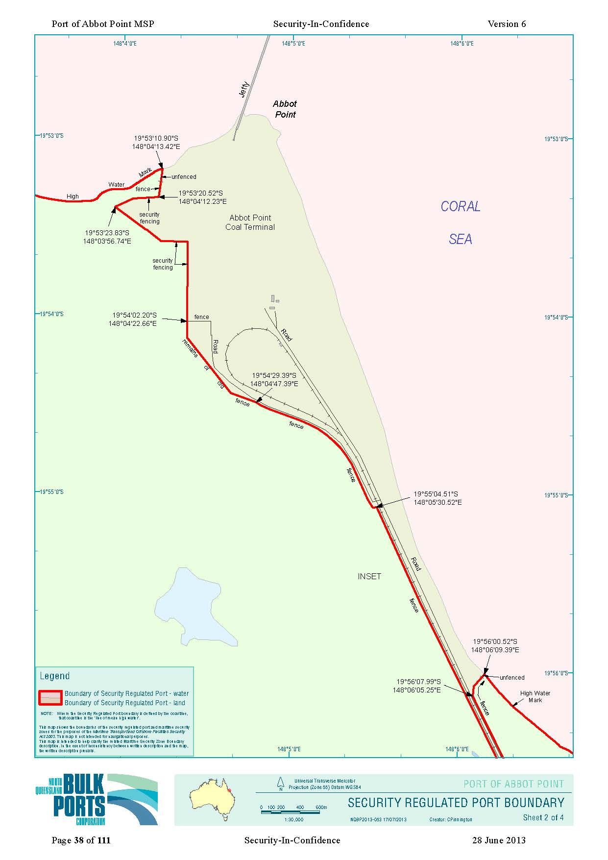

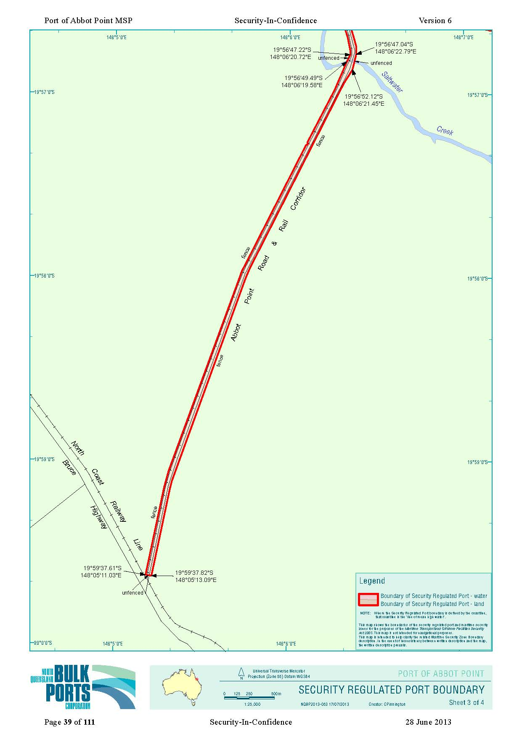

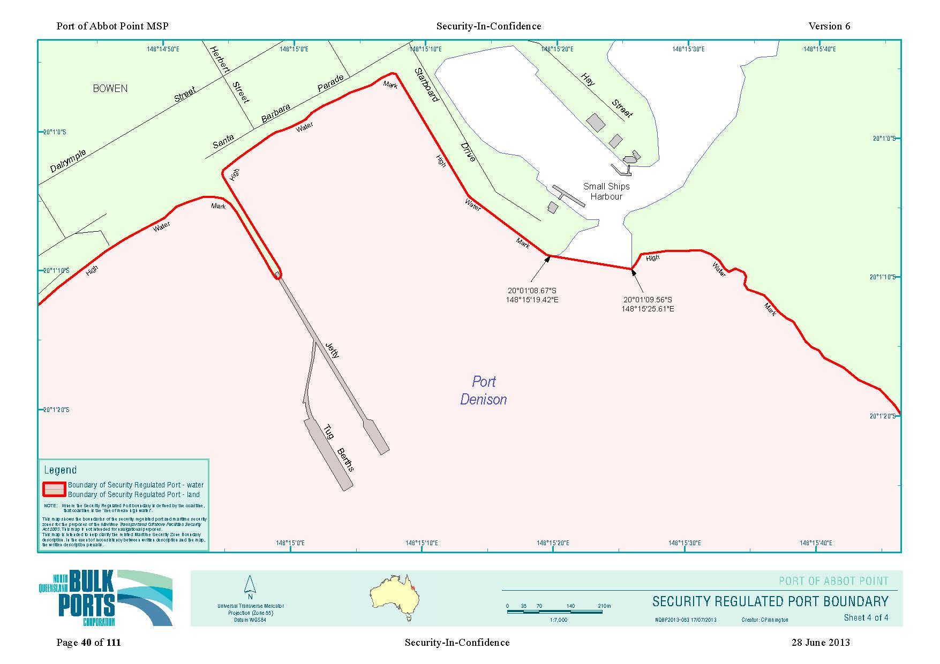

**SECURITY REGULATED PORT BOUNDARY DESCRIPTION**

**Description of Port of Abbot Point**

State: Queensland Map Number: 69900

The Security Regulated Port of Abbot Point is all of that area of land and water contained within and bounded by a line commencing at a point on the high water mark of the coastline of Queensland nearest the point of latitude 19º 55’ 31.94” south, longitude 147º 59’ 03.92” east;

thence north to the point at latitude 19º 47’ 54.41” south, longitude 147º 59’ 03.92” east;

thence easterly along the geodesic line to the point at latitude 19º 47’ 54.40” south, longitude 148º 08’ 03.92” east;

thence east-south-easterly along the geodesic line to a point on the high water mark of the coastline of Gloucester Island on Gloucester Head nearest to the point of latitude 19º 58’ 17.98” south, longitude 148º 27’ 02.26” east;

thence generally southerly along the high water mark of the western side of Gloucester Island for a distance of approximately 11 kilometres to a point on that high water mark nearest to the point of latitude 20º 03’ 06.70” south, longitude 148º 27’ 28.54” east;

thence south-south-westerly along the geodesic line to a point on the high water mark of the coastline of Queensland on Cape Gloucester nearest the point of latitude 20º 03’ 37.40” south, longitude 148º 27’ 12.18” east;

thence generally west-north-westerly but initially south-westerly along that high water mark of the coastline of Queensland for a distance of approximately 70 kilometres to a point on the high water mark of that coastline on the western side of the entrance to the marina at Bowen nearest the point of latitude 20º 01’ 08.67” south, longitude 148º 15’ 19.42” east;

thence easterly along the geodesic line across the entrance to that marina for a distance of approximately 180 metres to a point on the southern end of the breakwater on the eastern side of the entrance to the marina nearest the point of latitude 20º 01’ 09.56” south, longitude 148º 15’ 25.61” east;

thence generally north-westerly but initially generally south-easterly along the high water mark of the coastline of Queensland for a distance of approximately 40 kilometres to a point on that high water mark on the unfenced north-easterly prolongation of the fence near the north-western boundary of Lot 3 on RP737838 nearest the point of latitude 19º 56’ 00.52” south, longitude 148º 06’ 09.39” east;

thence south-westerly along that unfenced north-easterly prolongation of the fence near the north-western boundary for a distance of approximately 30 metres to the end of that fence and then generally south-south-westerly along that fence for a further distance of approximately 240 metres to the intersection of fences near the northern-most corner of Lot 2 on RP48626 on the eastern side of the access road to the Abbot Point Coal Terminal nearest the point of latitude 19º 56’ 07.99” south, longitude 148º 06’ 05.25” east;

thence generally south-south-easterly along that fence on the eastern side of the access road to the Abbot Point Coal Terminal for a distance of approximately 1.3 kilometres to the corner of that fence on the northern side of Saltwater Creek nearest the point of latitude 19º 56’ 47.04” south, longitude 148º 06’ 22.79” east;

thence south-south-westerly along the unfenced geodesic line across Saltwater Creek for a distance of approximately 160 metres to the corner of the fence on the southern side of that creek nearest the point of latitude 19º 56’ 52.12” south, longitude 148º 06’ 21.45” east;

thence generally south-south-westerly along the fence on the eastern side of the access road to the Abbot Point Coal Terminal for a distance of approximately 5.5 kilometres to a point on that fence near the south-eastern corner of Lot 51 on plan HR1931 and about 180 metres northerly of the railway line nearest the point of latitude 19º 59’ 37.82” south, longitude 148º 05’ 13.09” east;

thence westerly along the unfenced geodesic line across the access road to the Abbot Point Coal Terminal and the railway line to that terminal for a distance of approximately 60 metres to a point on the fence near the south-western corner of Lot 50 on plan HR1931 nearest the point of latitude 19º 59’ 37.61” south, longitude 148º 05’ 11.03” east;

thence generally north-north-easterly along the fence on the western side of the railway line to the Abbot Point Coal Terminal for a distance of approximately 5.5 kilometres to the corner of that fence near the north-western corner of Lot 1 on plan RP748625 on the southern side of Saltwater Creek nearest the point of latitude 19º 56’ 49.49” south, longitude 148º 06’ 19.58” east;

thence north-north-easterly along the unfenced geodesic line across Saltwater Creek for a distance of approximately 80 metres to the corner of the fence on the northern side of that creek and west of the railway line nearest the point of latitude 19º 56’ 47.22” south, longitude 148º 06’ 20.72” east;

thence generally north-north-westerly along that fence on the western side of the railway line to the Abbot Point Coal Terminal for a distance of approximately 3.5 kilometres to the corner of that fence approximately 10 metres south of the level crossing of the access road to the western entrance to the Abbot Point Coal Terminal over the railway line, nearest the point of latitude 19º 55’ 04.51” south, longitude 148º 05’ 30.52” east;

thence generally north-westerly along the fence on the south-western side of the access road to the western entrance to the Abbot Point Coal Terminal for a distance of approximately 1.7 kilometres to the intersection of that fence with the remains of an old fence nearest the point of latitude 19º 54’ 29.39” south, longitude 148º 04’ 47.39” east;

thence generally north-westerly along the remains of that old fence for a distance of approximately 1.2 kilometres to the corner of the security fence nearest the point of latitude 19º 54’ 02.20” south, longitude 148º 04’ 22.66” east;

thence generally north-westerly along that security fence for a distance of approximately 1.7 kilometres to the corner of the security fence nearest the point of latitude 19º 53’ 23.83” south, longitude 148º 03’ 56.74” east;

thence generally east-north-easterly along that security fence for a distance of approximately 470 metres to the corner of the security fence nearest the point of latitude 19º 53’ 20.52” south, longitude 148º 04’ 12.23” east;

thence northerly along that security fence and its northerly prolongation for a total distance of approximately 300 metres to the intersection of that northerly prolongation of the security fence with the high water mark of the coastline of Queensland nearest the point of latitude 19º 53’ 10.90” south, longitude 148º 04’ 13.42” east;

thence generally west-south-westerly along that high water mark for a distance of approximately 20 kilometres to the point of commencement.

**Notes:**

1. The ‘high water mark’ referred to in the Port Description and associated maps means the line of ‘mean high water’.

2. Unless otherwise stated, all coordinates are in reference to the WGS 84 geodetic datum.

3. In the event that a point of latitude and longitude which is stated to lie on the high water mark is found to lie on the landward or seaward side of the high water mark the point is to be regarded as being the point on the high water mark closest to that point of latitude and longitude.

4. Unless stated otherwise, the Security Regulated Port described above includes all water and land inside the area.

5. Unless otherwise stated the landside boundaries are fenced.

6. Unless otherwise stated the lines between coordinates are rhumb lines (loxodromes).

7. This description should be read in conjunction with the Security Regulated Port Boundary map. In the event of an inconsistency between the written description and the map, the former prevails.

8. This description and the associated maps have been compiled from field data captured in September 2009.