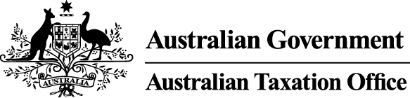

NOTICE OF DISQUALIFICATION
Superannuation Industry (Supervision) Act 1993

To:
Mr Abu Sayed M Kakan
LAKEMBA NSW 2195

I, Ivan Parrett a delegate of the Commissioner of Taxation, give you notice as required by subsection 126A(6) of the Superannuation Industry (Supervision) Act 1993 (SIS Act), that I have made a decision to disqualify you from being a trustee or a responsible officer of a body corporate that is a trustee, investment manager or custodian, of a superannuation entity.

I have disqualified you under subsection 126A(3) of the SIS Act as I am satisfied that you are not a fit and proper person to be a trustee, investment manager, custodian or a responsible officer of a body corporate that is a trustee, investment manager or custodian of a superannuation entity for the purposes of the SIS Act.

The disqualification order takes effect on the day on which this notice is made.
Dated: 5 February 2014.

Ivan Parrett
Assistant Commissioner of Taxation

Per Bernard Morrison

Note 1:
In accordance with subsection 126A(7) of the SIS Act, particulars of this disqualification notice will be published in the Gazette.
Note 2:
In accordance with subsection 126A(5) of the SIS Act, we may revoke this disqualification order on our own initiative or on written application made by you.
Note 3:
In accordance with section 344 of the SIS Act, if you are a person who is affected by this decision and you are dissatisfied with it, you may ask the Commissioner to reconsider this decision. Such a request must be made in writing within 21 days of the day on which you received notice of the decision and must also give the reasons for making the request.

