**Unique Identifying Number:**

EPBC303DC/SFS/2013/63

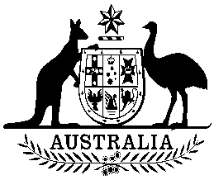

**COMMONWEALTH OF AUSTRALIA**

**Environment Protection and Biodiversity Conservation Act 1999**

**Amendment of List of Exempt Native Specimens**

I, PAUL MURPHY, Assistant Secretary, Wildlife Trade and Biosecurity Branch, as Delegate of the Minister for the Environment, pursuant to subsection303DC(1) of the *Environment Protection and Biodiversity Conservation Act 1999* (EPBC Act) hereby amend the list of exempt native specimens established under section 303DB of the EPBC Act by including in the list the following:

* specimens that are or are derived from fish or invertebrates, other than specimens that belong to species listed under Part 13 of the EPBC Act, taken in the Northern Prawn Fishery as defined in the Northern Prawn Fishery Management Plan 1995 made under the Commonwealth *Fisheries Management Act 1991*,

with a notation that inclusion of the specimens in the list is subject to the following restrictions or conditions:

* the specimen, or the fish or invertebrate from which it is derived, was taken lawfully, and
* the specimens are included in the list until 9 January 2019.

For the purposes of subsection 12(1) of the *Legislative Instruments Act 2003*, the specified day for the purposes of the commencement of this instrument is 10 January 2014.

Dated this 20th day of December 2013

……………………………………P Murphy………………………………………

Delegate of the Minister for the Environment