Unique Identifying Number: EPBC303DC/SFS/2013/52

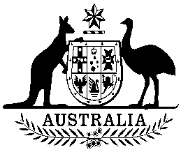
COMMONWEALTH OF AUSTRALIA

Environment Protection and Biodiversity Conservation Act 1999

Amendment of List of Exempt Native Specimens

I, PAUL MURPHY, Assistant Secretary, Wildlife Trade and Biosecurity Branch, as Delegate of the Minister for the Environment, pursuant to subsection 303DC(1) of the Environment Protection and Biodiversity Conservation Act 1999 (EPBC Act), hereby amend the list of exempt native specimens established under section 303DB of the EPBC Act by revoking the conditions to which the inclusion of the following item in the list on 10 November 2010 is subject:

- specimens that are or are derived from fish or invertebrates, other than specimens that belong to species listed under Part 13 of the EPBC Act, taken in the New South Wales Ocean Trap and Line Fishery, as defined in the New South Wales Fisheries Management (Ocean Trap and Line Share Management) Regulation 2006 in force under the New South Wales Fisheries Management Act 1994;

and imposing the following conditions to which inclusion of the specimens in the list is subject:

- the specimen, or the fish or invertebrate from which it is derived, was taken lawfully, and

- the specimens are included in the list until 6 March 2014.

Dated this 30 day of October 2013

………………………P Murphy………………………

Delegate of the Minister for the Environment

