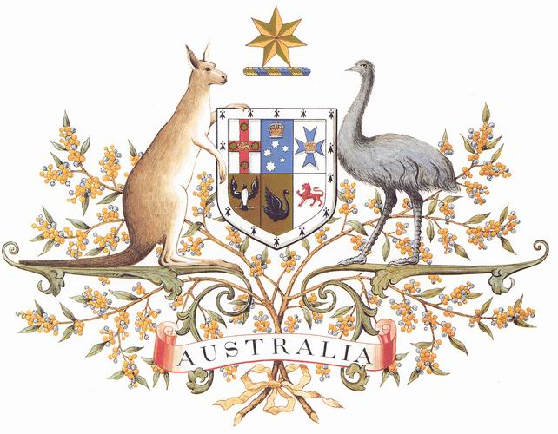

**COMMONWEALTH OF AUSTRALIA**

# *National Portrait Gallery of Australia Act 2012*

**LAND FOR THE GALLERY**

I, TONY BURKE, Minister for the Arts, under subsection 9(1) of the *National Portrait Gallery of Australia Act 2012*, HEREBY MAKE AVAILABLE to the National Portrait Gallery of Australia (the Gallery), for the purposes of the Gallery and from 1 July 2013 all of that piece or parcel of land in the Australian Capital Territory described as Block 17, Section 28, Division of Parkes and as delineated on the Deposited Plan Number 11119 held in the Registrar-Generals Office at Canberra in the said Territory, and any building, structure or other improvements on that land.

Dated 11 June 2013

[Signed by]

Tony Burke

Minister for the Arts

Note: An indicative plan of this area is attached as a Schedule to this Notice.

An indicative plan of the area made available for purposes of the National Portrait Gallery of Australia from 1 July 2013 showing all of the piece or parcel of land in the Australian Capital Territory described as Block 17, Section 28, Division of Parkes, is attached as a Schedule to this Notice.
