COMMONWEALTH OF AUSTRALIA

6 June 2013

POLICE OVERSEAS SERVICE MEDAL REGULATIONS - AMENDMENT 2013

It is notified for general information that Her Majesty The Queen has approved an amendment to the regulations for the Police Overseas Service Medal. These regulations are known as the Police Overseas Service Medal Regulations 2007.

A COPY OF THE APPROVED AMENDMENT TO THIS AWARD IS AVAILABLE ON THE GOVERNOR-GENERAL’S WEBSITE: www.gg.gov.au

By Her Majesty’s Command

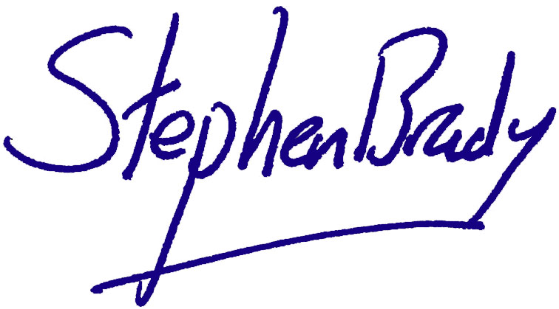

Stephen Brady
Official Secretary to the Governor-General

