Government House
CANBERRA ACT 2600

15 March 2013

ORDER OF AUSTRALIA

It is notified for general information that the Governor-General terminated the appointment of Member of the Order of Australia in the General Division made to:

Mr Clinton Edward Condon

By Her Excellency’s Command

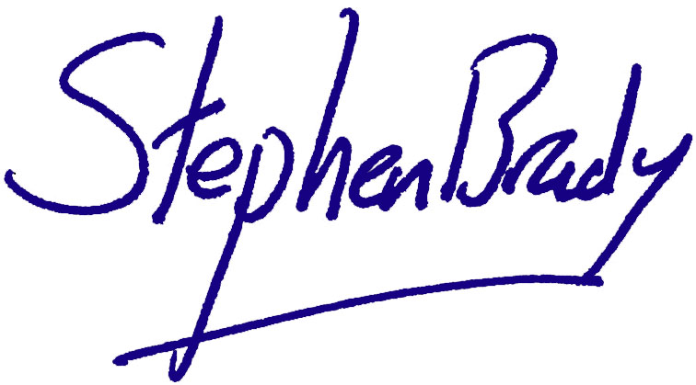

Stephen Brady CVO

Official Secretary to the Governor-General and

Secretary of the Order of Australia

