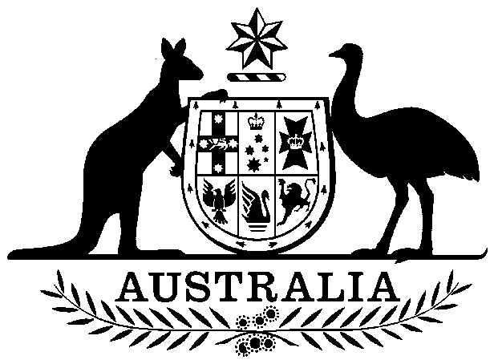
COMMONWEALTH OF AUSTRALIA

Environment Protection and Biodiversity Conservation Act 1999

Amendment of List of Exempt Native Specimens

I, NATHAN HANNA, Acting Assistant Secretary, Marine Biodiversity and Biosecurity Branch, as Delegate of the Minister for Sustainability, Environment, Water, Population and Communities, pursuant to subsection 303DC(1) of the Environment Protection and Biodiversity Conservation Act 1999 (EPBC Act), hereby amend the list of exempt native specimens established under section 303DB of the EPBC Act by including in the list the following:

- specimens that are or are derived from fish or invertebrates, other than specimens that belong to species listed under Part 13 of the EPBC Act, taken in the Western Australian Shark Bay Prawn Managed Fishery, as defined in the Shark Bay Prawn Management Plan 1993 in force under the Western Australian Fisheries Resources Management Act 1994

with a notation that inclusion of the specimens in the list is subject to the following restrictions or conditions:

- the specimen, or the fish or invertebrate from which it is derived, was taken lawfully, and

- the specimens are included in the list until 31 January 2018.

Dated this 28th day of January 2013

………………………N Hanna………………………

Delegate of the Minister for Sustainability, Environment, Water, Population and Communities

