ELIZABETH R
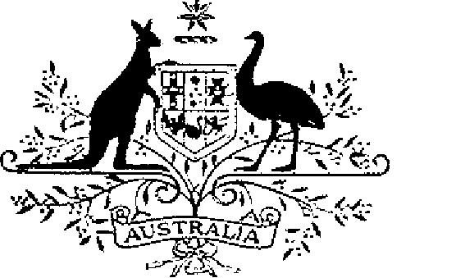

ELIZABETH THE SECOND, by the Grace of God Queen of Australia and Her Other Realms and Territories, Head of the Commonwealth:
TO ALL to whom these Presents shall come,
GREETING:
WHEREAS by Letters Patent dated 14 February 1975 We instituted certain Australian decorations for the purpose of according recognition to Australian citizens and other persons who perform acts of bravery:
AND WHEREAS, by those Letters Patent, We ordained that the award of the decorations so instituted be governed by the Regulations set out in the Schedule to those Letters Patent:
AND WHEREAS it is desirable that those Regulations be further amended:
KNOW YOU that We do, by these Presents, declare Our pleasure that the abovementioned Letters Patent dated 14 February 1975, as amended by Letters Patent dated 17 November 1987, be further amended, but without prejudice to anything lawfully done thereunder, as set out in the Schedule:
IN WITNESS whereof We have caused these Our Letters to be made Patent.
GIVEN under the Great Seal of Australia at Our Court at St. James’s on 5 March 1990

L.S..

By Her Majesty’s Command,
BOB HAWKE
Prime Minister

Schedule
Amendment of the Regulations Governing the Award of Australian Bravery Decorations
1. Regulation 2 is amended:
(a) by omitting from paragraph (d) “or”;
(b) by omitting paragraph “(e)” and substituting the following paragraphs:
“(e) the Group Bravery Citation; or
(f) except in subregulation 12 (4), a bar to an award referred to in paragraph (a), (b) or (c).”.
2. Regulation 4 is amended by adding at the end the following subregulation:
“(5) The Group Bravery Citation shall be awarded for a collective act of bravery, by a group of persons in extraordinary circumstances, that is considered worthy of recognition.”.

