ELIZABETH R
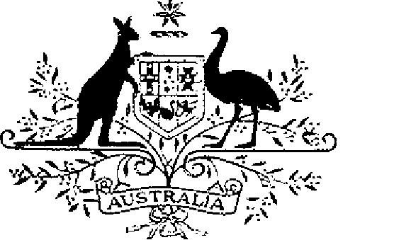

ELIZABETH THE SECOND, by the Grace of God Queen of Australia and Her other Realms and Territories, Head of the Commonwealth:
TO ALL to whom these Presents shall come,
GREETING:
WHEREAS by Letters Patent dated 14 February 1975 We instituted certain Australian decorations for the purpose of according recognition to Australian citizens and other persons who perform acts of bravery:
AND WHEREAS, by those Letters Patent, We ordained that the award of the decorations so instituted be governed by the Regulations set out in the Schedule to those Letters Patent:
AND WHEREAS it is desirable that those Regulations be amended:
KNOW YOU that We do, by these Presents, declare Our pleasure that the above-mentioned Letters Patent dated 14 February 1975 be amended, but without prejudice to anything lawfully done thereunder, as set out in the Schedule:
AND WE DO further declare that, notwithstanding the amendments to be made to the above-mentioned Regulations, a person, who, immediately before the issue of these Our Letters Patent, was a member of the Australian Decorations Advisory Committee by virtue of an appointment made under paragraph 7 (1) (c) of the Regulations shall continue to hold office until the expiration of 31 December 1987,
IN WITNESS whereof We have caused these Our Letters to be made Patent.
GIVEN under the Great Seal of Australia at Our Court at St James’s on 17 November 1987

L.S..

By Her Majesty’s Command,
BOB HAWKE
Prime Minister
Schedule
Amendment of the Regulations Governing the Award of Australian Bravery Decorations
1. Regulation 2 is amended by omitting paragraph (e) and substituting the following paragraph:
“(e) except in sub-regulation 12 (4), a bar to an award referred to in paragraph (a), (b) or (c).”.
2. Regulations 6 and 7 are revoked and the following regulations substituted:
“6. A decoration may only be awarded to a person who is not an Australian citizen —
(a) for an act done in Australia; or
(b) for an act which, though done outside Australia, merits recognition as an act in the interest of Australia.
“7. (1) There shall be an Australian Decorations Advisory Committee, hereinafter called ‘the Committee’, which shall consist of —
(a) the person for the time being occupying the office of Secretary to the Department of Defence or, if another office is prescribed for the purpose of this paragraph, the person occupying the office so prescribed;
(b) the person for the time being occupying the office of Secretary to the Department of Administrative Services or, if another office is prescribed for the purpose of this paragraph, the person occupying the office so prescribed; and
(c) not more than 10 persons appointed by the Governor-General, of whom not more than 6 shall be persons nominated by the States of the Commonwealth of Australia.
“(2) A member of the Committee referred to in paragraph (1) (c) shall hold office for a period of 2 years from the date of appointment and is eligible for re-appointment.
“(3) The Governor-General shall appoint one of the members of the Committee to be Chairman of the Committee and another member of the Committee to act as Chairman in the event of the Chairman being unavailable to act in the office.
“(4) A member of the Committee referred to in paragraph (1) (a) or (b) or who is one of the members nominated by the States of the Commonwealth of Australia may, in the event that the member is absent or unable to act in that capacity, be represented on the Committee by a person chosen, in accordance with arrangements made by the Governor-General, to act in the member’s place as a member of the Committee.”.
3. Regulation 12 is revoked and the following regulation substituted:
“12. (1) A person awarded the Cross of Valour is entitled to use the post- nominal letters “C.V.” on all occasions when the use of such letters is customary.
“(2) A person awarded the Star of Courage is entitled to use the post- nominal letters “S.C.” on all occasions when the use of such letters is customary.
“(3) A person awarded the Bravery Medal is entitled to use the post- nominal letters “B.M.” on all occasions when the use of such letters is customary.
“(4) A person awarded a bar to a decoration is entitled to use, after the letters prescribed by this regulation, the words “and Bar” or the words “and Bars”, as the case may be.”.

