ELIZABETH R
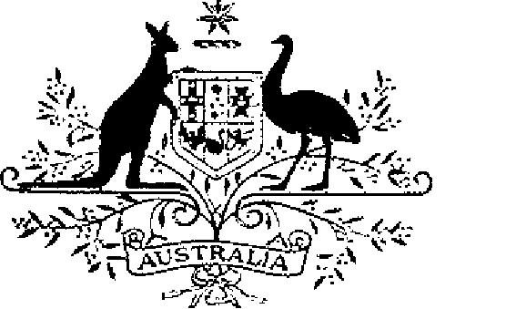

COMMONWEALTH OF AUSTRALIA
ELIZABETH THE SECOND, by the Grace of God Queen of Australia and Her Other Realms and Territories, Head of the Commonwealth:
TO ALL to whom these Presents shall come,
GREETING:
WHEREAS it is desirable that there be instituted certain Australian decorations for the purpose of according recognition to Australian citizens and other persons who perform acts of bravery:
KNOW YOU that We do by these Presents institute four decorations to be designated and styled, respectively, the Cross of Valour, the Star of Courage, the Bravery Medal and the Commendation for Brave Conduct:
AND WE DO ordain that the award of the decorations so instituted shalt be governed by the Regulations Governing the Award of Australian Bravery Decorations set out in the Schedule.
IN WITNESS whereof We have caused these Our Letters to be made Patent.
GIVEN under the Great Seal of Australia at Our Court at St. James’s on 14 February 1975

L.S..

By Her Majesty’s Command,
E.G. WHITLAM
Prime Minister

Schedule
Regulations Governing the Award of Australian Bravery Decorations
Short Title
1. These Regulations may be cited as the Australian Bravery Decorations Regulations.
Interpretation
2. In these Regulations, ‘decoration’ means —
(a) the Cross of Valour;
(b) the Star of Courage;
(c) the Bravery Medal;
(d) the Commendation for Brave Conduct; or
(e) except in sub-regulation 12 (4), a bar to an award referred to in paragraph (a), (b), (c) or (d).
Design of Decorations
3. The design of each decoration shall be as prescribed.
Conditions for Award of Decorations
4. (1) The Cross of Valour, or a bar to the Cross of Valour, shall be awarded only for acts of the most conspicuous courage in circumstances of extreme peril.
(2) The Star of Courage, or a bar to the Star of Courage, shall be awarded only for acts of conspicuous courage in circumstances of great peril.
(3) The Bravery Medal, or a bar to the Bravery Medal, shall be awarded only for acts of bravery in hazardous circumstances.
(4) The Commendation For Brave Conduct may be awarded for other acts of bravery which are considered worthy of recognition.
5. All decorations may be awarded posthumously.
6. A person shall not be awarded a decoration unless —
(a) he is an Australian citizen; or
(b) not being an Australian citizen, he has —
(i) performed in Australia an act for which a decoration may be awarded under these Regulations; or
(ii) performed outside Australia an act for which a decoration may be awarded under these Regulations, being an act that merits recognition by Australia as an act in the interest of Australia.
Australian Decorations Advisory Committee
7. (1) There shall be an Australian Decorations Advisory Committee, hereinafter called ‘the Committee’, which shall consist of —
(a) the person occupying the office of Secretary, Department of Defence, or, if the Governor-General nominates another office in place of that office, the person occupying the office so nominated;
(b) the person occupying the office of Secretary, Department of the Special Minister of State, or, if the Governor-General nominates another office in place of that office, the person occupying the office so nominated;
(c) not more than ten persons appointed by the Governor-General of whom not more than six shall be persons nominated by the States of Australia.
(2) A member of the Committee referred to in any of paragraphs (1) (a) or (1) (b) may appoint an alternate member to act in his place as a member of the Committee in the event that he is absent or unable to act in that capacity.
(3) The Governor-General shall appoint one of the members of the Committee to be Chairman of the Committee and another member of the Committee to act as Chairman in the event of the Chairman being unavailable to act in the office.
8. The Committee shall —
(a) consider, and make a recommendation to the Governor-General on, each nomination of a person for the award of a decoration; and
(b) advise the Governor-General on such other matters concerning the award of decorations as he may refer to the Committee for consideration.
9. (1) The Secretary of the Order of Australia shall be the Secretary of the Committee.
(2) The Secretary of the Committee shall maintain a Register of the names of persons to whom decorations have been awarded and such other records relating to the award of decorations as the Committee considers necessary and perform such other functions in respect of the award of decorations as the Governor-General may direct.
Awards
10. (1) The award of a decoration shall be made, with the approval of The Sovereign, by Instrument signed by the Governor-General.
(2) Nothing in these Regulations limits the right of the Governor-General to exercise all powers and authorities of The Sovereign in respect of the award of decorations.
Nominations
11. Any person or organisation may submit to the Secretary of the Committee for consideration by the Committee a nomination of a person for the award of a decoration.
Designations
12. (1) A person to whom the Cross of Valour has been awarded is entitled to have the letters ‘C.V.’ placed after his name on all occasions when the use of such letters is customary.
(2) A person to whom the Star of Courage has been awarded is entitled to have the letters ‘S.C.’ placed after his name on all occasions when the use of such letters is customary.
(3) A person to whom the Bravery Medal has been awarded is entitled to have the letters ‘B.M.’ placed after his name on all occasions when the use of such letters is customary.
(4) Where a person has been awarded a bar to a decoration, that person is entitled to have placed after letters prescribed by this regulation in respect of that decoration the words ‘and Bar’ or the words ‘and Bars’, as the case may be.
Wearing of Decorations
13. The manner of wearing of decorations shall be as determined by the Governor-General.
Cancellation and Reinstatement
14. (1) The Governor-General may cancel the award of a decoration to a person and may restore a decoration the award of which was so cancelled.
(2) Where the award of a decoration is cancelled, the name of the person to whom the decoration was awarded shall be erased from the Register maintained pursuant to regulation 9, and that person shall return the decoration to the Secretary of the Committee.
(3) Where an award that has been cancelled is restored, the Secretary of the Committee shall restore the entry in the Register maintained pursuant to regulation 9 that had been erased.

