ELIZABETH R
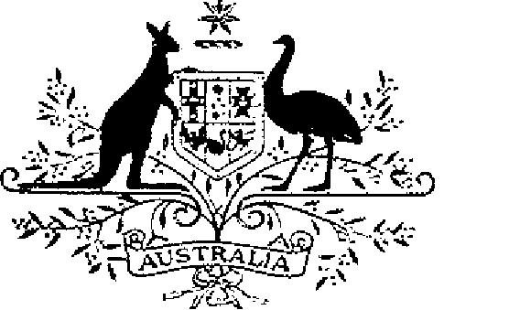

COMMONWEALTH OF AUSTRALIA
ELIZABETH THE SECOND, by the Grace of God Queen of Australia and Her other Realms and Territories, Head of the Commonwealth:
TO ALL to whom these Presents shall come,
GREETING:
WHEREAS, by Letters Patent dated 2 June 1987 given under the Great Seal of Australia, We instituted an Australian medal, designated and styled the Antarctic Medal, for the purpose of according recognition to persons who render outstanding service in connection with Australian Antarctic expeditions:
AND WHEREAS the Letters Patent ordained that the award of the Antarctic Medal be governed by the Regulations Governing the Award of the Antarctic Medal set out in the Schedule to the Letters Patent:
AND WHEREAS it is desirable that certain amendments of the Regulations be made to change the designation and style of the Medal from the Antarctic Medal to the Australian Antarctic Medal, and to provide for the designation of the holder of the Medal:
KNOW YOU that We do, by these Presents, declare Our pleasure that the Letters Patent dated 2 June 1987 be amended, but without prejudice to anything lawfully done thereunder, as set out in the Schedule.
IN WITNESS whereof We have caused these Our Letters to be made Patent
GIVEN under the Great Seal of Australia at Our Court at St James’s on 18 December 1997

L.S..

By Her Majesty’s Command,
John Howard
Prime Minister
Schedule
Amendments of the Regulations Governing the Award of the Antarctic Medal
1. Heading
1.1 Omit “Antarctic Medal”, substitute “Australian Antarctic Medal”.
2. Regulation 1 (Short title)
2.1 Omit the regulation, substitute:
“1. These Regulations may be cited as the Australian Antarctic Medal Regulations.”.
3. Regulation 2 (Interpretation)
3.1 Definition of “Medal”:
Omit the definition, substitute:
“‘Medal’ means the Australian Antarctic Medal and includes a clasp, or clasps, to that Medal;”.
4. Regulation 7 (Register of Awards)
4.1 Omit the regulation.
5. Regulation 8 (Cancellation and Reinstatement)
5.1 Omit the regulation, substitute:
“Designation of holder of the Medal
7. Recipients who are awarded the Medal after 2 June 1987 are entitled to have the letters ‘AAM’ placed after their names on all occasions when the use of such letters is customary.
“Register of Awards
8. (1) There shall be a Registrar of awards who shall be appointed by the Governor-General and shall maintain a Register of the names of persons to whom the Medal has been awarded.
(2) The Registrar shall keep such other records relating to the award of the Medal as the Governor-General directs.
9. (1) The Governor-General may cancel the award of the Medal to a person and may restore an award so cancelled.
(2) Where an award of the Medal is cancelled, the name of the person to whom the award was made shall be erased from the Register kept for the purpose of regulation 8 and that person shall return the Medal to the Registrar.
(3) Where an award that has been cancelled is restored, the Registrar shall restore the entry in the Register that had been erased under sub-regulation (2).”.

