ELIZABETH R
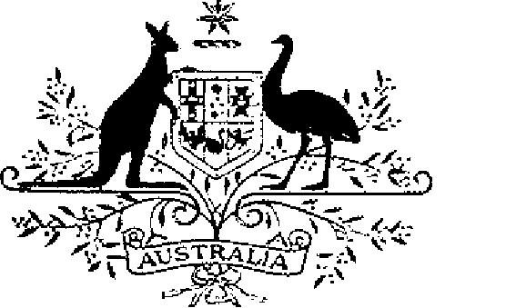

ELIZABETH THE SECOND, by the Grace of God Queen of Australia and Her other Realms and Territories, Head of the Commonwealth:
TO ALL to whom these Presents shall come,
GREETING:
WHEREAS by Letters Patent dated 15 Janaury 1991 We instituted certain decorations for the purpose of according recognition to members of the Defence Force and certain other persons who perform acts of gallantry in action:
AND WHEREAS it is desirable that certain amendments be made to the Regulations, set out in the Schedule to Our aforesaid Letters Patent, governing the award of the Star of Gallantry, the Medal for Gallantry and the Commendation for Gallantry, so as to enable each of the decorations to be awarded for an act in operations in circumstances similar to armed combat or actual operations:
KNOW YOU that We do, by these Presents, declare Our pleasure that the Gallantry Decorations Regulations set out in the Schedule to Our aforesaid Letters Patent be amended, but without prejudice to anything lawfully done thereunder, as set out in the Schedule hereto and with effect on and from 29 July 1994:
IN WITNESS whereof We have caused these Our Letters to be made Patent.
GIVEN under the Great Seal of Australia at Canberra,
17 October, 1996

By Her Majesty’s Command,
L.S..
JOHN HOWARD
Prime Minister
SCHEDULE
AMENDMENT OF THE GALLANTRY DECORATIONS REGULATIONS
1 New regulation 3A
1.1 After regulation 3, insert:
Decorations may be awarded in certain other circumstances
“3A. A decoration referred to in regulation 3 may be awarded for an act of a kind mentioned in relation to the particular decoration, although the act did not occur in action, if it occurred in circumstances similar to armed combat or actual operations and those concerned were deployed under military command.”.

