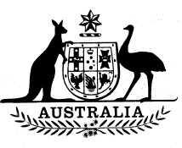
Statutory Rules 1987 No. 255¹
————————
Superannuation (Approved Authorities) Regulations² (Amendment)
I, THE ADMINISTRATOR of the Government of the Commonwealth of Australia, acting with the advice of the Federal Executive Council, hereby make the following Regulations under the Superannuation Act 1976.
Dated 29 October 1987.
J. A. ROWLAND
Administrator
By His Excellency’s Command,
PETER WALSH
Minister of State for Finance
—————
Commencement
1. These Regulations shall be deemed to have taken effect from and including 8 October 1987.
Approved authorities
2. Regulation 2 of the Superannuation (Approved Authorities) Regulations is amended by inserting:
“Aerospace Technologies of Australia Pty Ltd”
after:
“Advisory Council for Inter-government Relations”.

NOTES
1. Notified in the Commonwealth of Australia Gazette on 6 November 1987.
2. Statutory Rules 1977 No. 6 as amended to date. For previous amendments see Note 2 to Statutory Rules 1987 No. 41 and see also Statutory Rules 1987 Nos. 41, 170 and 226.

