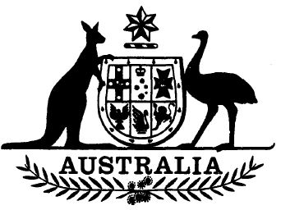
Statutory Rules 1985 No. 180¹
—————
Wool Industry (Allowances) Regulations
I, THE GOVERNOR-GENERAL of the Commonwealth of Australia, acting with the advice of the Federal Executive Council, hereby make the following Regulations under the Wool Industry Act 1972.
Dated 18 July 1985.
N. M. STEPHEN
Governor-General
By His Excellency’s Command,
JOHN KERIN
Minister of State for Primary Industry
————
Citation
1. These Regulations may be cited as the Wool Industry (Allowances) Regulations.
Travelling allowance
2. For the purposes of sub-section 14 (3) of the Wool Industry Act 1972, the following allowance payable to the member of the Australian Wool Corporation representing the Australian Government and the deputy of that member is prescribed, namely, the travelling allowance payable to a member of that Corporation appointed to represent Australian woolgrowers.

NOTE
1. Notified in the Commonwealth of Australia Gazette on 24 July 1985.

