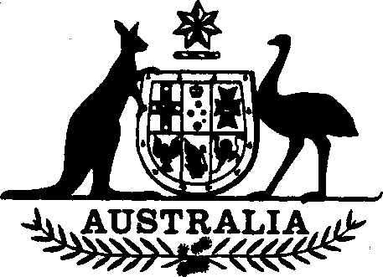

Statutory Rules 1991 No. 393¹
Superannuation (CSS) Approved Authority
Declaration No. 6
I, RALPH WILLIS, Minister of State for Finance, make the following Declaration under subsection 3 (1) of the Superannuation Act 1976.
Dated 14 November 1991.
RALPH WILLIS
Minister of State for Finance
Citation
- This Declaration may be cited as Superannuation (CSS) Approved Authority Declaration No. 6.
Commencement
- This Declaration is taken to have commenced on 1 July 1991.
Superannuation (CSS) Approved Authority
Declaration No. 6 1991 No. 393
Approved authority
- The Wool Research and Development Corporation is declared, under paragraph (a) of the definition of “approved authority” in subsection 3 (1) of the Superannuation Act 1976, to be an approved authority for the purposes of that Act.
NOTE
1. Notified in the Commonwealth of Australia Gazette on 27 November 1991.

