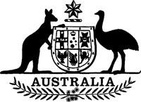
Statutory Rules 1989 No. 262¹
–––––––
Meat Chicken Levy Regulations² (Amendment)
I, THE GOVERNOR-GENERAL of the Commonwealth of Australia, acting with the advice of the Federal Executive Council and after taking into consideration the recommendation made to the Minister of State for Primary Industries and Energy by the Chicken Meat Research Council with respect to the rate of levy under the Meat Chicken Levy Act 1969, hereby make the following Regulations under that Act.
Dated 28 September 1989.
BILL HAYDEN
Governor-General
By His Excellency’s Command,
PETER COOK
Minister of State for Resources
–––––––––
Commencement
1. These Regulations commence on 1 November 1989.
Rate of levy
2. Regulation 2 of the Meat Chicken Levy Regulations is amended by omitting “0.1375” and substituting “0.15”.

NOTES
1. Notified in the Commonwealth of Australia Gazette on 6 October 1989.
2. Statutory Rules 1972 No. 108 as amended by 1986 No. 186; 1987 No. 242.

