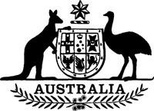
Statutory Rules 1987 No. 242¹
–––––––
Meat Chicken Levy Regulations² (Amendment)
I, THE ADMINISTRATOR of the Government of the Commonwealth of Australia, acting with the advice of the Federal Executive Council and after taking into consideration the recommendation made to the Minister of State for Primary Industries and Energy by the Chicken Meat Research Council with respect to the rate of levy under the Meat Chicken Levy Act 1969, hereby make the following Regulations under that Act.
Dated 16 October 1987.
J. A. ROWLAND
Administrator
By His Excellency’s Command,
JOHN KERIN
Minister of State for Primary Industries
and Energy
–––––––––
Commencement
1. These Regulations shall come into operation on 1 November 1987.
Rate of levy
2. Regulation 2 of the Meat Chicken Levy Regulations is amended by omitting “0.125” and substituting “0.1375”.

NOTES
1. Notified in the Commonwealth of Australia Gazette on 23 October 1987.
2. Statutory Rules 1972 No. 108 as amended by 1986 No. 186.

