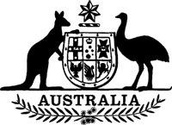
Statutory Rules 1983 No. 308¹
–––––––
Grain (Export Inspection Charge) Collection Regulations² (Amendment)
I, THE GOVERNOR-GENERAL of the Commonwealth of Australia, acting with the advice of the Federal Executive Council, hereby make the following Regulation under the Grain (Export Inspection Charge) Collection Act 1979.
Dated 8 December 1983.
N. M. STEPHEN
Governor-General
By His Excellency’s Command,
JOHN KERIN
Minister of State for Primary Industry
–––––––––
Interpretation
Regulation 2 of the Grain (Export Inspection Charge) Collection Regulations is amended by omitting the definition of “container system unit”.

NOTES
1. Notified in the Commonwealth of Australia Gazette on 16 December 1983.
2. Statutory Rules 1979 No. 100 as amended by 1980 No. 260; 1981 No. 298; 1983 No. 188.

