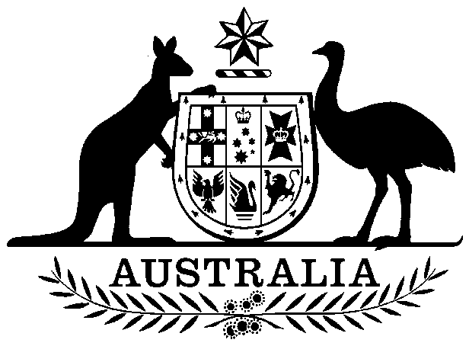

Cattle (Producers) Export Charges Act 1997

No. 212, 1997

Cattle (Producers) Export Charges Act 1997

No. 212, 1997

An Act to impose charges, payable by producers, on the export of cattle, and for purposes dealing with the imposition of the charges

Contents
1 Short title
2 Commencement
3 Definitions
4 Imposition of charges
5 Rate of charges imposed by section 4 on export of cattle
6 Charge payable by producer
7 Regulations

Cattle (Producers) Export Charges Act 1997
No. 212, 1997

An Act to impose charges, payable by producers, on the export of cattle, and for purposes dealing with the imposition of the charges
[Assented to 17 December 1997]
The Parliament of Australia enacts:

1 Short title
This Act may be cited as the Cattle (Producers) Export Charges Act 1997.

2 Commencement
This Act commences at the commencement of Part 3 of the Australian Meat and Live-stock Industry Act 1997.

3 Definitions
(1) In this Act, unless the contrary intention appears:
AAHC means the Australian Animal Health Council Limited, A.C.N. 071-890-956.
bobby calf means a bovine animal (other than a buffalo):
(a) which, at the time when it is exported, had or has a liveweight that did not or does not exceed 80kg; or
(b) which has not had its liveweight determined at the time when it is exported but which, in the opinion of the person responsible, in accordance with subsection (3), for sending the charge, would, if slaughtered at that time, have constituted or constitute a carcase whose dressed weight would not have exceeded or would not exceed 40kg.
cattle means bovine animals other than buffalo.
charge means a charge imposed by this Act.
chargeable bobby calf means a bobby calf to which subsection 5(3) does not apply.
dairy cattle means bovine animals that are, or, if they were not exported from Australia, would be likely to be, held on licensed dairy premises for a purpose related to commercial milk production, including but without limiting the generality of the foregoing, bulls, calves and replacement heifers.
licensed dairy premises means premises that, under the law of the State or Territory in which the premises are situated, are authorised for use as a dairy farm.
marketing body has the same meaning as in Part 3 of the Australian Meat and Live-stock Industry Act 1997.
National Cattle Disease Eradication Account means:
(a) the trust account called the National Cattle Disease Eradication Trust Account continued in existence by section 4 of the National Cattle Disease Eradication Trust Account Act 1991; or
(b) the reserve called the National Cattle Disease Eradication Reserve established by section 4 of the National Cattle Disease Eradication Reserve Act 1991.
research body has the same meaning as in Part 3 of the Australian Meat and Live-stock Industry Act 1997.
(2) Unless the contrary intention appears, a word or expression has the same meaning in this Act as it has in the Primary Industries Levies and Charges Collection Act 1991.
(3) For the purposes of the definition of bobby calf in subsection (1), if an amount equal to the amount of charge is required to be paid to the Commonwealth by a person (the relevant person) other than the person primarily liable for the payment of charge, the person responsible for sending the charge is taken to be the relevant person.

4 Imposition of charges
(1) A charge is imposed on the export from Australia after the commencement of this Act of cattle (other than dairy cattle) if levy under the Cattle Transactions Levy Act 1997 has not been paid, and is not payable, in respect of an act or transaction relating to the cattle.
(2) A charge is imposed on the export from Australia after the commencement of this Act of cattle (other than dairy cattle) if:
(a) the cattle were purchased by the exporter, whether before or after the commencement of this Act; and
(b) the period starting on the date of the purchase and ending on the date of the export is longer than the longest of the following periods:
(i) 60 days;
(ii) the period for which the cattle are required under the Quarantine Act 1908 to be held in quarantine before being exported;
(iii) the period for which the cattle are required under the law of the country to which they are being exported to be held in quarantine before being exported.

5 Rate of charges imposed by section 4 on export of cattle
(1) The rate of each of the charges imposed by section 4 on the export of each head of cattle (other than a chargeable bobby calf) is the sum of the following amounts:
(a) $2.16 or, if another amount (not exceeding $6.50) is prescribed by the regulations, the other amount, for the purpose of payment to the marketing body;
(b) 72 cents or, if another amount (not exceeding $2.00) is prescribed by the regulations, the other amount, for the purpose of payment to the research body;
(c) 17 cents or, if another amount (not exceeding $4.00) is prescribed by the regulations, the other amount, for the purpose of payment to the National Cattle Disease Eradication Account;
(d) 13 cents or, if another amount (not exceeding 50 cents) is prescribed by the regulations, the other amount, for the purpose of payment to the AAHC.
(2) The rate of each of the charges imposed by section 4 on the export of each head of cattle that is a chargeable bobby calf is the sum of the following amounts:
(a) 48 cents or, if another amount (not exceeding $1.90) is prescribed by the regulations, the other amount, for the purpose of payment to the marketing body;
(b) 16 cents or, if another amount (not exceeding 40 cents) is prescribed by the regulations, the other amount, for the purpose of payment to the research body;
(c) the prescribed amount (not exceeding 20 cents), if any, for the purpose of payment to the National Cattle Disease Eradication Account;
(d) the prescribed amount (not exceeding 50 cents), if any, for the purpose of payment to the AAHC.
(3) For the purposes of subsection (1), a cow with a calf at foot are together taken to constitute a single head of cattle.

6 Charge payable by producer
A charge payable on the export of cattle from Australia is payable by the producer of the cattle.

7 Regulations
(1) The Governor-General may make regulations prescribing matters:
(a) required or permitted by this Act to be prescribed; or
(b) necessary or convenient to be prescribed for carrying out or giving effect to this Act.
(2) The Minister may, by notice published in the Gazette, declare that the body specified in the declaration is the body whose recommendations about the amount to be prescribed for the purposes of paragraph 5(1)(a), 5(1)(b), 5(1)(d), 5(2)(a), 5(2)(b) or 5(2)(d) are to be taken into consideration under subsection (3).
(3) If a declaration is in force under subsection (2), the Governor-General’s power to make regulations prescribing an amount for the purposes of the paragraph to which the declaration relates is exercisable only on the advice of the Executive Council given after the Council has taken into consideration any recommendations about the amount made to the Minister by the body specified in the declaration in relation to that paragraph.
[Minister's second reading speech made in the⎯
House of Representatives on 1 October 1997
Senate on 29 October 1997]

(151/97)

