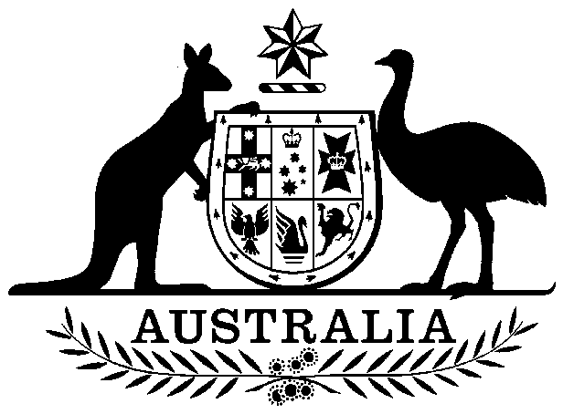

Buffalo Slaughter Levy Act 1997

No. 210, 1997

Buffalo Slaughter Levy Act 1997

No. 210, 1997

An Act to impose a levy on the slaughter of buffaloes, and for purposes dealing with the imposition of the levy

Contents
1 Short title
2 Commencement
3 Definitions
4 Imposition of levy
5 Rate of levy
6 Levy is payable by owner
7 Regulations

Buffalo Slaughter Levy Act 1997
No. 210, 1997

An Act to impose a levy on the slaughter of buffaloes, and for purposes dealing with the imposition of the levy
[Assented to 17 December 1997]
The Parliament of Australia enacts:

1 Short title
This Act may be cited as the Buffalo Slaughter Levy Act 1997.

2 Commencement
This Act commences at the commencement of Part 3 of the Australian Meat and Live-stock Industry Act 1997.

3 Definitions
(1) In this Act:
levy means levy imposed by this Act.
National Cattle Disease Eradication Account means:
(a) the trust account called the National Cattle Disease Eradication Trust Account continued in existence by section 4 of the National Cattle Disease Eradication Trust Account Act 1991; or
(b) the reserve called the National Cattle Disease Eradication Reserve established by section 4 of the National Cattle Disease Eradication Reserve Act 1991.
(2) Unless the contrary intention appears, a word or expression has the same meaning in this Act as it has in the Primary Industries Levies and Charges Collection Act 1991.

4 Imposition of levy
(1) Subject to subsection (2), a levy is imposed on the slaughter of buffaloes for human consumption at an abattoir after the commencement of this Act.
(2) Levy is not imposed:
(a) on the slaughter of buffaloes whose carcases are, under a law of the Commonwealth or of a State or Territory, condemned or rejected as being unfit for human consumption; or
(b) on the slaughter of buffaloes for consumption by the owner of the buffaloes, by members of the owner’s family or by the owner’s employees.

5 Rate of levy
The rate of levy on the slaughter of each head of buffaloes is the sum of the following amounts:
(a) $4.60 or, if another amount (not exceeding $18.00) is prescribed by the regulations, the other amount, for the purpose of payment to the Rural Industries Research and Development Corporation;
(b) 73 cents or, if another amount (not exceeding $4.00) is prescribed by the regulations, the other amount, for the purpose of payment to the National Cattle Disease Eradication Account.

6 Levy is payable by owner
Levy payable on the slaughter of buffaloes is payable by the person (including a State or Territory or an authority of a State or Territory) who owns the buffaloes when the slaughter takes place.

7 Regulations
The Governor-General may make regulations prescribing all matters:
(a) required or permitted by this Act to be prescribed; or
(b) necessary or convenient to be prescribed for carrying out or giving effect to this Act.

[Minister's second reading speech made in the⎯
House of Representatives on 1 October 1997
Senate on 29 October 1997]

(152/97)

