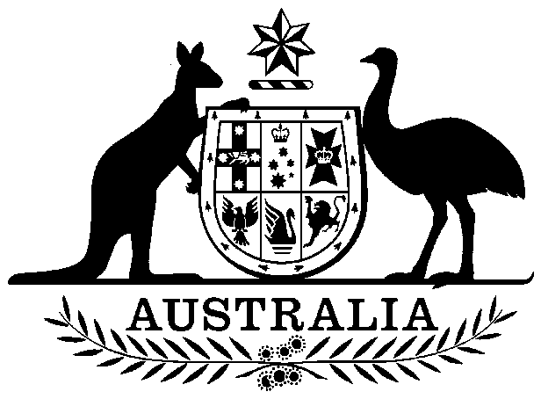

Australian Animal Health Council (Live-stock Industries) Funding Amendment Act 1997

No. 83, 1997

An Act to amend the Australian Animal Health Council (Live-stock Industries) Funding Act 1996

Contents
1 Short title
2 Commencement
3 Schedule(s)
Schedule 1—Amendment of the Australian Animal Health Council (Live-stock Industries) Funding Act 1996

Australian Animal Health Council (Live-stock Industries) Funding Amendment Act 1997
No. 83, 1997

An Act to amend the Australian Animal Health Council (Live-stock Industries) Funding Act 1996
[Assented to 23 June 1997]
The Parliament of Australia enacts:

1 Short title
This Act may be cited as the Australian Animal Health Council (Live-stock Industries) Funding Amendment Act 1997.

2 Commencement
This Act commences on the day on which it receives the Royal Assent.

3 Schedule(s)
Each Act that is specified in a Schedule to this Act is amended or repealed as set out in the applicable items in the Schedule concerned, and any other item in a Schedule to this Act has effect according to its terms.

Schedule 1—Amendment of the Australian Animal Health Council (Live-stock Industries) Funding Act 1996
1 Section 3 (definition of Australian Animal Health Council levy, after table item 2)
Insert:
2A | Dairy Produce Levy (No. 1) Act 1986 | subsection 9(1), so far as it relates to paragraph 5(1)(g)

[Minister’s second reading speech made in—
House of Representatives on 5 March 1997
Senate on 15 May 1997]

(23/97)

I HEREBY CERTIFY that the above is a fair print of the Australian Animal Health Council (Live-stock Industries) Funding Amendment Bill 1997 which originated in the House of Representatives and has been finally passed by the Senate and the House of Representatives.

Clerk of the House of Representatives

IN THE NAME OF HER MAJESTY, I assent to this Act.

Governor-General
1997

