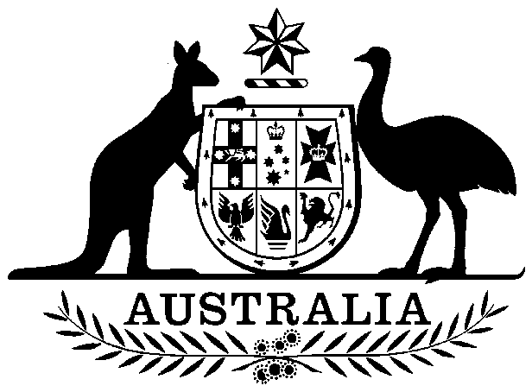

Civil Aviation Amendment Act 1997

No. 14, 1997

An Act to amend the Civil Aviation Act 1988

Contents
1 Short title
2 Commencement
3 Schedule(s)
Schedule 1—Amendment of the Civil Aviation Act 1988

Civil Aviation Amendment Act 1997
No. 14, 1997

An Act to amend the Civil Aviation Act 1988
[Assented to 20 March 1997]
The Parliament of Australia enacts:

1 Short title
This Act may be cited as the Civil Aviation Amendment Act 1997.

2 Commencement
This Act commences on the day on which it receives the Royal Assent.

3 Schedule(s)
Each Act that is specified in a Schedule to this Act is amended or repealed as set out in the applicable items in the Schedule concerned, and any other item in a Schedule to this Act has effect according to its terms.

Schedule 1—Amendment of the Civil Aviation Act 1988
1 Subsection 3(1)
Insert:
Deputy Chairperson means the Deputy Chairperson of the Board.
2 Subsection 3(1) (definition of member)
Omit “Chairperson”, substitute “Chairperson and the Deputy Chairperson”.
3 After paragraph 33(1)(a)
Insert:
(aa) a Deputy Chairperson; and
4 Paragraph 33(1)(c)
Omit “3”, substitute “4”.
5 Subsection 38(1)
Omit “appoint a member”, substitute “appoint the Deputy Chairperson or another member”.
6 After subsection 38(1)
Insert:
(2) The Minister may appoint a member (other than the Director) to act as the Deputy Chairperson:
(a) during a vacancy in the office of Deputy Chairperson, whether or not an appointment has previously been made to the office; or
(b) during any period, or during all periods, when the Deputy Chairperson is acting as the Chairperson, is absent from duty or from Australia or is, for any other reason, unable to perform the duties of the office.
7 Paragraph 38(3)(b)
After “Chairperson”, insert “or the Deputy Chairperson”.
8 Paragraph 39(2)(b)
Repeal the paragraph, substitute:
(b) must convene a meeting if he or she receives a written request signed by at least 2 members.
9 After subsection 39(4)
Insert:
(4A) If the Chairperson is not present at a meeting, the Deputy Chairperson must preside.
10 Subsection 39(5)
Omit “is not present”, substitute “and the Deputy Chairperson are not present”.
11 Subsection 39(6)
Repeal the subsection, substitute:
(6) At a meeting, a quorum consists of the number of members that constitutes a majority of the members for the time being holding office

[Minister’s second reading speech made in—
House of Representatives on 22 May 1996
Senate on 28 June 1996]

(43/96)
.

I HEREBY CERTIFY that the above is a fair print of the Civil Aviation Amendment Bill 1997 which originated in the House of Representatives as the Civil Aviation Amendment Bill 1996 and has been finally passed by the Senate and the House of Representatives.

Clerk of the House of Representatives

IN THE NAME OF HER MAJESTY, I assent to this Act.

Governor-General
1997

(43/96)

