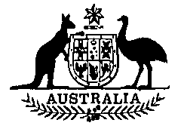
Meat Chicken Levy Amendment (AAHC) Act 1996
No. 52, 1996.
An Act to amend the Meat Chicken Levy Act 1969, and for related purposes

Contents
1 | Short title | 1515
2 | Commencement | 1515
3 | Schedule(s) | 1516
Schedule 1—Amendment of the Meat Chicken Levy Act 1969 |  | 1517

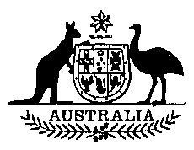
Meat Chicken Levy Amendment (AAHC) Act 1996
No. 52, 1996

An Act to amend the Meat Chicken Levy Act 1969, and for related purposes
[Assented to 25 October 1996]
The Parliament of Australia enacts:
1 Short title
This Act may be cited as the Meat Chicken Levy Amendment (AAHC) Act 1996.
2 Commencement
This Act commences on the day on which it receives the Royal Assent.

3 Schedule(s)
Each Act that is specified in a Schedule to this Act is amended or repealed as set out in the applicable items in the Schedule concerned, and any other item in a Schedule to this Act has effect according to its terms.

Schedule 1—Amendment of the Meat Chicken Levy Act 1969
1 Subsection 4(1)
Insert:
AAHC means the Australian Animal Health Council Limited, A.C.N. 071-890-956.
2 Paragraph 7(1)(b)
Repeal the paragraph, substitute:
(b) such amount, not more than 0.05 cent, as is prescribed (for the purpose of payment to the AAHC).
3 Subsections 7(3) and (4)
Repeal the subsections, substitute:
(3) Before making regulations prescribing an amount for the purposes of paragraph (1)(b), the Governor-General must take into consideration any recommendations about the amount to be prescribed made to the Minister by:
(a) the Australian Chicken Meat Federation; or
(b) if a declaration under subsection (4) is in force, the body specified in the declaration.
The regulations must not prescribe an amount greater than the amount last recommended to the Minister by the Australian Chicken Meat Federation or the body specified in the declaration, as the case requires.
(4) The Minister may, by notice published in the Gazette, declare a body specified in the notice to be the body representing the Australian chicken meat industry for the purposes of this section.
——————————————————————————————————————————
[Minister’s second reading speech made in—
House of Representatives on 26 June 1996
Senate on 19 September 1996]

