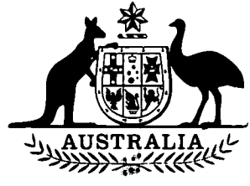

**Agricultural and Veterinary Chemicals  
(Administration) Amendment Act 1994**

**No. 76 of 1994**

**An Act to amend section 58 of the *Agricultural and  
Veterinary Chemicals (Administration) Act 1992***

[*Assented to 21 June 1994*]

The Parliament of Australia enacts:

**Short title etc.**

**1.(1)** This Act may be cited as the *Agricultural and Veterinary Chemicals (Administration) Amendment Act 1994.*

**(2)** In this Act, **“Principal Act”** means the *Agricultural and Veterinary Chemicals (Administration) Act 1992*1.

**Commencement**

**2.(1)** Subject to subsection (2), this Act commences on the same day as the *Agricultural and Veterinary Chemical Products (Collection of Interim Levy) Act 1994.*

**(2)** If the *Agricultural and Veterinary Chemical Products (Collection of Interim Levy) Act 1994* is repealed by subsection 2(2) of that Act, this Act is repealed on the same day as that Act.

**Appropriation of money**

**3.** Section 58 of the Principal Act is amended by inserting before paragraph (2)(b) the following paragraph:

“(ab) any amounts of levy or late payment penalty paid into the Consolidated Revenue Fund under section 16 of the *Agricultural and Veterinary Chemical Products (Collection of Interim Levy) Act 1994*;and”.



**NOTE**

1. No. 262, 1992, as amended. For previous amendments, see No. 94, 1993; and No. 37, 1994.

[*Minister’s second reading speech made in*—

*House of Representatives on 12 May 1994*

*Senate on 1 June 1994*]