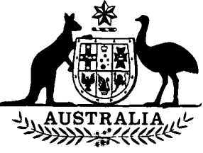

**Agricultural and Veterinary Chemical  
Products Interim Levy Imposition  
(Excise) Act 1994**

**No. 75 of 1994**

**An Act to impose the levy payable under *the Agricultural  
and Veterinary Chemical Products (Collection of  
Interim Levy) Act 1994*,so far as that levy is a duty of excise**

[*Assented to 21 June 1994*]

The Parliament of Australia enacts:

**Short title**

**1.** This Act may be cited as the *Agricultural and Veterinary Chemical Products Interim Levy Imposition (Excise) Act 1994.*

**Commencement**

**2.(1)** Subject to subsection (2), this Act commences on the same day as the *Agricultural and Veterinary Chemical Products (Collection of Interim Levy) Act 1994.*

**(2)** If the *Agricultural and Veterinary Chemical Products (Collection of Interim Levy) Act 1994* is repealed by subsection 2(2) of that Act, this Act is repealed on the same day as that Act.

**Imposition**

**3.(1)** The levy that is payable under the *Agricultural and Veterinary Chemical Products (Collection of Interim Levy) Act 1994* is imposed by this section.

**(2)** This section imposes the levy only so far as the levy is a duty of excise within the meaning of section 55 of the Constitution.

**Act does not impose levy on property of a State**

**4.(1)** This Act does not impose a levy on property of any kind belonging to a State.

**(2)** In this section, **“property of any kind belonging to a State”** has the same meaning as in section 114 of the Constitution.



[*Minister’s second reading speech made in*—

*House of Representatives on 12 May 1994*

*Senate on 1 June 1994*]