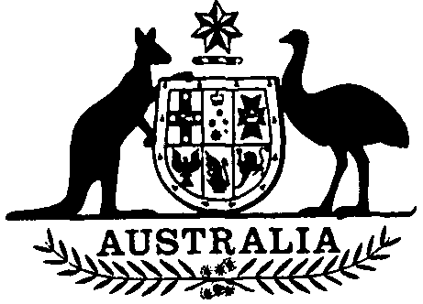

Coal Mining Industry (Long Service Leave)
Payroll Levy Act 1992
No. 62 of 1992
An Act to impose a levy in respect of wages paid to certain employees employed in the black coal mining industry, and for related purposes
[Assented to 26 June 1992]
The Parliament of Australia enacts:
Short title
1. This Act may be cited as the Coal Mining Industry (Long Service Leave) Payroll Levy Act 1992.
Commencement
2.(1) Subject to subsection (2), this Act commences on a day to be fixed by Proclamation.
(2) If this Act does not commence under subsection (1) within the period of 12 months beginning on the day on which it receives the Royal Assent, it commences on the first day after the end of that period.

Incorporation
3. The Coal Mining Industry (Long Service Leave) Payroll Levy Collection Act 1992 is incorporated, and is to be read as one, with this Act.
Imposition of levy
4. Levy is imposed on eligible wages paid to eligible employees after the commencement of this Act.
Rate of levy
5. The rate of the levy is the prescribed percentage of the eligible wages paid.
Person liable
6. Levy on eligible wages paid to eligible employees is payable by the person who paid those wages.
Purpose of levy
7. Levy is imposed for the purpose of funding payments made to eligible employees in respect of long service leave.
Regulations
8.(1) The Governor-General may make regulations prescribing a percentage for the purposes of section 5.
(2) Before making a regulation under subsection (1), the Governor-General is to take into consideration any advice given to the Minister by the Corporation under the Funding Act.
[Minister’s second reading speech made in—
House of Representatives on 30 April 1992
Senate on 27 May 1992]

