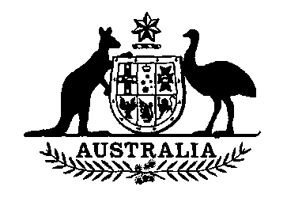

**Honey Levy (No. 2) Amendment Act 1991**

**No. 154 of 1991**

**An Act to amend the *Honey Levy Act (No. 2) 1962***

[*Assented to 21 October 1991*]

The Parliament of Australia enacts:

**Short title etc.**

**1.(1)** This Act may be cited as the *Honey Levy (No. 2) Amendment Act 1991.*

**(2)** In this Act, **"Principal Act"** means the *Honey Levy Act (No. 2) 1962*1*.*

**Commencement**

**2.** This Act commences on the day on which it receives the Royal Assent.

**Rates of levy**

**3.** Section 5 of the Principal Act is amended by omitting from paragraph (1)(b) "0.50 cent" and substituting "0.75 cent".

**NOTE**

1. No. 107, 1962, as amended. For previous amendments, see Nos. 73 and 142, 1965; No. 188, 1973; No. 148, 1980; Nos. 5 and 103, 1985; No. 32, 1988; No. 17, 1990; and No. 26, 1991.

[*Minister's second reading speech made in—*

*House of Representatives on 21 August 1991*

*Senate on 5 September 1991*]