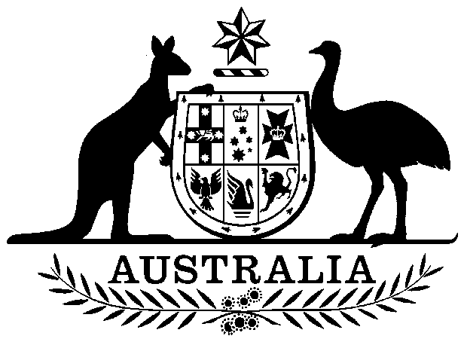

Fisheries Agreements (Payments) Act 1991

No. 151, 1991

An Act relating to payments under certain fisheries agreements

Contents
1 Short title 1
2 Commencement 2
3 Interpretation 2
4 Effect of section 5 or 6 2
5 Payments under fisheries agreements entered into with the government of another country 2
6 Payments under fisheries agreements entered into otherwise than with the government of another country 3

Fisheries Agreements (Payments) Act 1991

No. 151, 1991

An Act relating to payments under certain fisheries agreements

[Assented to 21 Oct 1991]
The Parliament of Australia enacts:

1 Short title
This Act may be cited as the Fisheries Agreements (Payments) Act 1991.

2 Commencement
(1) Sections 1 and 2 commence on the day on which this Act receives the Royal Assent.
(2) Subject to subsection (3), the remaining provisions of this Act commence on a day to be fixed by Proclamation.
(3) If a provision mentioned in subsection (2) does not commence under that subsection within the period of 6 months commencing on the day on which this Act receives the Royal Assent, it commences on the first day after the end of that period.

3 Interpretation
In this Act, unless the contrary intention appears:
AFMA means the Australian Fisheries Management Authority.
licence means a foreign fishing licence granted under Part 3 of the Fisheries Management Act 1991.

4 Effect of section 5 or 6
Section 5 or 6 has effect only so far as that section is a law imposing taxation or dealing with the imposition of taxation within the meaning of section 55 of the Constitution.

5 Payments under fisheries agreements entered into with the government of another country
(1) If:
(a) there is in force an agreement between the Commonwealth and the government of another country; and
(b) the agreement contains a provision under which licences are agreed to be granted if an amount specified in the provision is paid to the Commonwealth (whether or not that amount or any part of that amount is to be paid before the grant of any of the licences);
AFMA must, in determining whether or not to grant any of the licences to which the provision relates, have regard only to the terms of the agreement.
(2) Where:
(a) an agreement that contains a provision of a kind mentioned in subsection (1) is in force; and
(b) a licence to which the provision relates has been granted; and
(c) the whole or part of an amount specified in the provision is not paid to the Commonwealth in accordance with the terms of the provision;
AFMA may suspend the licence by written notice given to the holder of the licence.
(3) Where AFMA has suspended a licence under subsection (2) and the amount concerned is fully paid, AFMA must revoke the suspension by written notice given to the holder of the licence.

6 Payments under fisheries agreements entered into otherwise than with the government of another country
(1) Where:
(a) AFMA has entered into an agreement with a person other than the government of another country or with persons none of whom is the government of another country; and
(b) the agreement contains a provision under which licences are agreed to be granted if an amount specified in the provision is paid to the Commonwealth;
AFMA must, in determining whether or not to grant licences to which the provision relates, have regard only to the terms of the agreement.
(2) AFMA must not grant any of the licences to which the provision relates unless the amount specified in the provision has been paid to the Commonwealth in accordance with the terms of the provision.

